Name of the Faculty- ASHISHA KUMAR MOHANTY
Photo  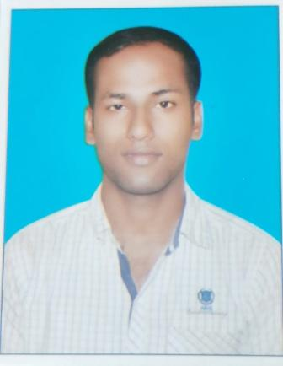 | Name ASHISHA KUMAR MOHANTY  Designation: ASSISTANT PROFESSOR  Email: asis.unix3@gmail.com  Area of Specialization: ELECTRONIC COMMUNICATION ENGINEERING  Affiliation: Department of Electronic Communication Engineering, Einstein Academy of Technology & Management, Khordha, Bhubaneswar, Odisha

Personal Details:
Date of birth: 08/07/1992
Marital status: MARRIED
Permanent address: AT-MIRZAPUR POST-LANKAPARA PS-TIRTOL DIST-JAGATSINGHPUR PIN-754134
E-mail: asis.unix3@gmail.com
Contact Nos.:8249775364
Skype ID: NA
Scopus ID: NA
ISTE Membership No:

Education:

Degree | Specialization | University / Institute
Ph.D | NA | NA
ME / M.Tech | ELECTRONIC COMMUMNICATION ENGINEERING | BPUT ODISHA
BE / B.Tech | CENTURION UNIVERSITY OF TERCHNOLOGY AND MANAGEMENT | CUTM ODISHA

Academic Experience: 5 YEARS TEACHING EXPERIENCE

Current Job As ASSISTANT PROFESSOR IN ECE AT EATM KHURDHA ODISHA Since 2018 to till date.
- Previous Job. 2 YEARS WAS DOING AS A LECTURER IN BIET DHENKANAL From 2016-2018.

Research Experience: NIL
Industrial Experience: Gupta Power, Cuttack (6 MONTH)
Subjects Handled:
U.G.
1.BASIC ELECTRONIC
2. DIGITAL ELECTRONIC
3.MICROPROCESSOR AND MICROCONTROLLER
4.COMMUNICATION ENGINEERING
5.SENSORS AND TRANSDUCERS
6.MOBILE COMMUNICATION
Research Interests: COMMUNICATION SYSTEM.
Patents Filed / Awarded: NIL
Funded Projects:
Title
Funding Agency:
Year: 2020

International Journals:1
- Chinmayee Panda, Sambit Patnaik, K. Pitambar Patra, Asutosh Padhy, Ashisha Kumar Mohanty and Sumit Kumar Choudhary,: “QPSK Modulated Li Fi in Wireless Medium,” : International Journal of Engineering Research & Technology (IJERT), 2020Journal 2
Conference Papers:
- Paper 1
- Paper 2

Conferences / STTPs / FDPs / Seminars Organized:

STTPs / FDPs / Seminars / Workshops Participated:
- Attended FDP on the topic “HOW TO PUBLISH PUBLISHABLE MANUSCRIPT” at EATM,BBSR on 20/05/2016.
- Attended workshop on “ CMOS, Mixed signal & Radio frequency VLSI design” MHRD, Govt. of India at GIFT, BBSR between 30TH JAN 2017 to 4TH FEB 2017.
- Attended International Webinar on” MACHINE LEARNING IN CYBER PSYCHOLOGY STUDIES, at GIET, Baniatangi on 29th May 2020.
Attended International Webinar on “ FUTURE ENERGY CHALLENGES IN GREEN TECHNOLOGY” organized by GIET, Baniatangi ON 9th June 2020.Achievements and

Awards:
- Achievement 1
- Award 1
Professional Society Memberships:

