RADHESHYAM HOTA
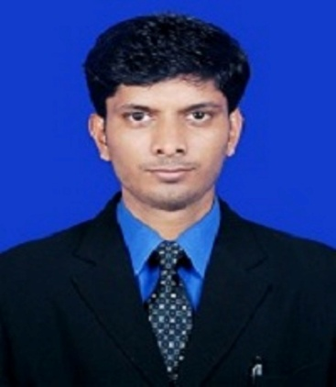 | Name : Radheshyam Hota  Designation: Asst. Professor  Email: radheshyamhota@eatm.in  Area of Specialization: Structural Engg.  Affiliation: Department of Civil Engineering, Einstein Academy of Technology & Management, Khordha, Bhubaneswar, Odisha

Personal Details:
Date of birth: 01st July 1990
Marital status: Unmarried
Permanent address: At/po : Sarbahal, Jharsuguda, odisha,768201
E-mail: radheshyamhota@eatm.in
Contact Nos.: 9778612081
Skype ID:
Scopus ID:
ISTE Membership No:

Education:
Degree | Specialization | University / Institute
Ph.D
ME / M.Tech | Structural Engg. | IGIT, SARANG
BE / B.Tech | Civil Engg. | BPUT, Rourkela

Academic Experience:
- Current Job: Working as Asst. Professor in Einstein Academy of Technology and Management, BBSR from 2017.
- Previous Job
Research Experience:
Industrial Experience:
Subjects Handled:

U.G. (Civil Engg.) | P.G. (Structural Engg.)
- Estimating Costing & Professional practice  - Hydrology and Irrigation Engineering  - Structural Analysis-1  - Design of Concrete Structure | - Advance Construction Materials  - Matrix Method of Analysis of Structure
Research Interests: Composite materials used in advanced construction technology.
Patents Filed / Awarded:
Funded Projects:
Title
Funding Agency:
Year: 2020

International Journals:
- Journal 1
- Journal 2
Conference Papers:
- Paper 1
- Paper 2
Conferences / STTPs / FDPs / Seminars Organized:
- Organised two days national seminar on Transportation & Traffic Engineering (T & TE- 2019) at E.A.T.M, BBSR from 18th jan -19th jan 2019.

STTPs / FDPs / Seminars / Workshops Participated:
- Participated one week Workshop on “Automation and Robotics in Construction (ARC-2021)” conducted by Department of Civil & Production Engineering IGIT, SARANG during March 15th-19th, 2021.
- Participated one day seminar on “Geospatial Data Science for Water Resources Management” conducted by Department of Civil Engineering, IGIT,SARANG on 25th January 2021.
- International Conference on Materials for Energy Application (ICME-18) during December 6-8, 2018 at S. S. Jain Subodh PG (Auto.) College, Jaipur.

Achievements and Awards:
- Innovative Technologist and Dedicated Teaching Professional Award In the year 2022.

Professional Society Memberships: Life time member of Institute for Engineering Research and Publication (IFERP) India. (PMIN42516780)

