Name of the Faculty
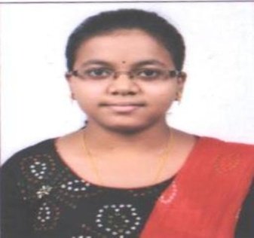 | Name : Subhashree priyadarsini  Designation: Asst. professor  Email: spriyadarsini59@gmail.com  Area of Specialization:  Affiliation: Department of Civil Engineering, Einstein Academy of Technology & Management, Khordha, Bhubaneswar, Odisha

Personal Details:
Date of birth: 23/06/1995
Marital status: Unmarried
Permanent address: At-ISHANIBERHMAPUR PO- KHENTALO PS-KISHANNAGAR PIN- 754131 DIST-CUTTACK
E-mail: spriyadarsini59@gmail.com
Contact Nos.: 9777786725
Skype ID:
Scopus ID:
ISTE Membership No:

Education:
Degree | Specialization | University / Institute
Ph.D
ME / M.Tech | Structural Engineering | EATM, BBSR
BE / B.Tech | CIVIL Engineering | BPUT

Academic Experience:
- Current Job - Working as Asst. Professor in Einstein Academy of Technology and Management, BBSR from 2021.
- Working as Trainer in INNODUST, Vani Bihar BBSR in 2017.
- Working as Lecturer in Oxford College of Engineering & Management, BBSR from 2017-2019.
- Working as Lecturer in ABIT, CUTTACK from 2019-2020
Research Experience:
Industrial Experience:
Subjects Handled:
U.G. | P.G. (Thermal Engineering)
- Survey  - Ground Improvement Technique  - Transportation Engg.  - Water Resource Engg. | - Subject 1  - Subject 2  - Subject 3
Research Interests:
Patents Filed / Awarded:
Funded Projects:
Title
Funding Agency:
Year: 2020

International Journals:
- Journal 1
- Journal 2
Conference Papers:
- Paper 1
- Paper 2
Conferences / STTPs / FDPs / Seminars Organized:
- Seminar/STTP/FDP 1
- Seminar/STTP/FDP 2

STTPs / FDPs / Seminars / Workshops Participated:
- Seminar/STTP/FDP 1
- Seminar/STTP/FDP 2
Achievements and Awards:
- Achievement 1
- Award 1
Professional Society Memberships:

