Name of the Faculty : Neelamani Samal
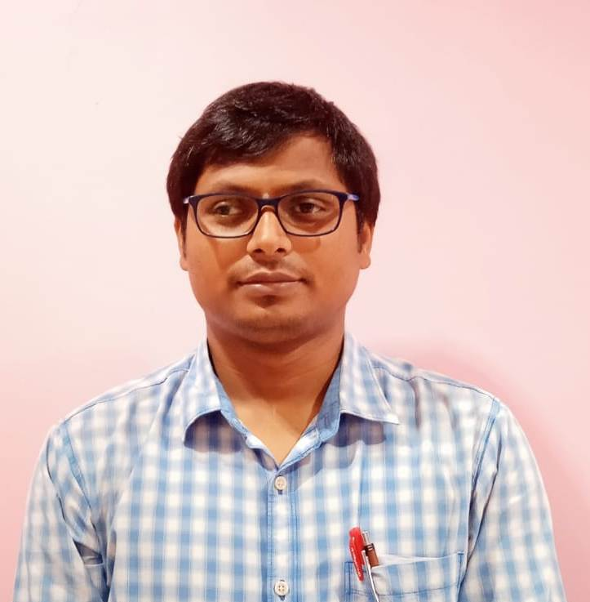
Name : Neelamani Samal
Designation: Asst. Prof.
Email: neelamani.samal@eatm.in
Area of Specialization: OS, JAVA, PYTHON
Affiliation: Department of Computer Science and Engineering, Einstein Academy of Technology & Management, Khordha, Bhubaneswar, Odisha

Personal Details:
Date of birth: 02/07/1988
Marital status: Married
Permanent address: Hemabati Residency, Tamando, Bhubaneswar
E-mail: neelamani.samal@eatm.in
Contact Nos.: 9778717797
Skype ID:
Scopus ID:
ISTE Membership No: LM – 135105
CSI Membership ID: 4036220001

Education:
Degree | Specialization | University / Institute
Ph.D | Contd.. | SOA, Bhubaneswar
ME / M.Tech | IT | BPUT, Odisha
BE / B.Tech | CSE | BPUT, Odisha

Academic Experience:
- Faculty, Department of Computer Science & Engineering, Einstein Academy of Technology and Management (EATM ), Odisha, India Since March 2016
- Faculty, Department of Computer Science & Engineering, Gandhi Institute for Education and Technology (GIET), Odisha, India From Aug 2012 to March 2016
- Faculty, Department of Computer Science & Engineering , Bhubaneswar Engineering College (BEC), Odisha, India From March 2010 to March2012

Research Experience: 10 Years
Industrial Experience: NA
Subjects Handled:
U.G.  - PROGRAMMING IN C  - DATA STRUCTURE  - COMPUTER ORGANIZATION AND ARCHITECTURE  - PYTGHON PROGRAMMING  - OPERATING SYSTEM  - SOFTWARE ENGINEERING  - CLOUD COMPUTING | P.G.
Research Interests: Machine Learning
Patents Filed / Awarded:
- Awarded 2nd position at National COVID-19 Innovation Challenge organized by ICT ,Mumbai
- Awarded 7th position at International COVID19 Congress (ICC 2020), IEEE, Bangladesh Chapter
Funded Projects:
Title
Funding Agency:
Year: 2020

International Journals:
- The Techniques And Applications Of data mining, UGC CARE, 2018
- Using Machine Learning eras Extraction Of Information Classification Of Speech , UGC CARE, 2019
- Analytical Evaluation Of Structured To Unstructured Database For Large Volume Of E-Commerce Dataset , UGC CARE, 2020
Conference Papers:
Conferences / STTPs / FDPs / Seminars Organized:
- Seminar/STTP/FDP 1
- Seminar/STTP/FDP 2

STTPs / FDPs / Seminars / Workshops Participated:
- Seminar/STTP/FDP 1
- Seminar/STTP/FDP 2
Achievements and Awards:
- Achievement 1
- Award 1
Professional Society Memberships:

Computer Society of India
Membership ID: 4036220001

