Name of the Faculty
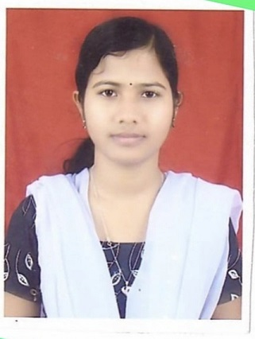 | Name : DIPTIMAYEE DAS  Designation: Assistant Professor in Mathematics  Email: dipti160692@gmail.com  Area of Specialization: mathematics  Affiliation: Department of Basic Science and Humanities, Einstein Academy of Technology & Management, Khordha, Bhubaneswar, Odisha

Personal Details:
Date of birth: 16/06/1992
Marital status: Married
Permanent address: At/po- Taraboi, dist-khordha,Pin-752055,Odisha
E-mail: dipti160692@gmail.com Contact No.: 7978167893

Education:
Degree | Specialization | University / Institute
M.Sc | MATHEMATICS | Berhampur University
B.Sc | MATHEMATICS | Utkal University,Prannath Autonomous college, Khordha

Academic Experience:
- I have one year teaching exeperience as lecture in Mathematics under Basic science and Humanitics Deparatment in Gandhi Institute of technology and management (GITAM), from Dt-28th Aug 2015 to 2nd Dec 2016
- I have 2year teaching exeperience as lecture in Mathematics under Basic science and Humanitics Department In Spintronic Technology Advanced and Researched(STAR)10th aug. 2017 to 1st july 2019.
- Now I am working in EINSTEIN ACADEMY OF TECHNOLOGY AND MANAGEMENT (EATM) from 22july 2019
Subjects Handled:
U.G.
- Mathematics-I
- Mathematics-II
- Mathematics-III
- Discrete Mathematics
- Optimization Engineering

