Mr. RAJAKISHOR MOHAPATRA
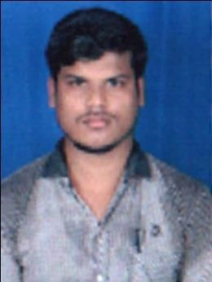Mr. RajakishorMohapatra
Personal Details:

Asst..Prof. Dept. of MATHEMATICS
Email id: rajmohapatra81@gmail.com
Area of Specialization: Mathematics
Affiliation :Department of Mathematics,Einstein Academy of Technology & Management, Khordha, Bhubaneswar, Odisha

Date of birth: 06.05.1995
Marital status: Unmarried
Permanent address: At-Kanhapur,PO-Khalakatapatana ,Dist-Puri, Pin-752111 ,Odisha
E-mail: rajmohapatra81@gmail.com
Contact Nos.: 9348015480

Education: Area of Specialisation/Research Name of the Institute
M.Sc MATHEMATICS Berhampur Universiy
B.Sc MATHEMATICS Utkal University
Academic Experience:
Current Job: I have appointed as assistant professor in Einstein Academy of Technology &Management, Khordha, Bhubaneswar, Odisha in mathematics department of BSH since 15 July 2019.
Subjects Handled:
U.G. level
• Mathematics -I
• Mathematics -II
• Mathematics -III
• Discrete Mathematics

