Name of the Faculty
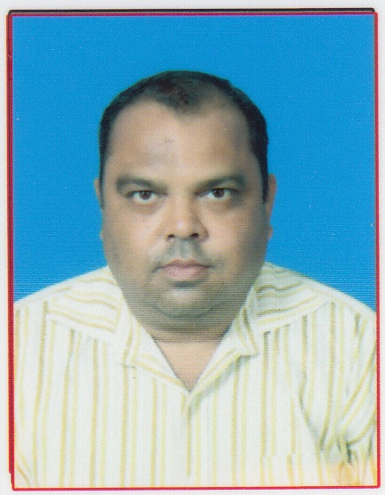 | Name  Designation: Sandip Kumar Bala  Email: sbala@eatm.in  Area of Specialization: Computer Engineering  Affiliation: Department of computer Engineering, Einstein Academy of Technology & Management, Khordha, Bhubaneswar, Odisha

Personal Details:
Date of birth: 13 /01/1976
Marital status:married
Permanent address: plo no-pp-18, pandav nagar ,tankapani road, b.b.s.r-18
E-mail: sbala@eatm.in
Contact Nos.: 9777178102
Skype ID: no
Scopus ID: no
ISTE Membership No:no

Education:
Degree | Specialization | University / Institute
Ph.D | no | no
ME / M.Tech | Computer engineering | Jadavpur university
BE / B.Tech | Computer sc and engg. | North orissa university

Academic Experience:
- Current Job Einstien Acdamy Of Technology And Magement
- Previous Job Seemanta Engineering College
. Research Experience: Automated Test Data Generation
Industrial Experience: Erricssion Switch Bharati Telicom For 1 Year
Subjects Handled:
U.G. operating sustem | P.G. (compiler design)
- D.B.M.S
- NETWORKING
- AUTOMATA THEORY
Research Interests:
Image processing
Patents Filed / Awarded:
no
Funded Projects:
Title: Route Relay Interloking For Indian Railwyas
Funding Agency: Jadavpur University
Year: 2020

International Journals:
- Minimization Hand Of Latancy Gps System Acesses Point Method
Conference Papers:
- Paper 1image inhancement
- Paper 2 robotics vision by artificial inteligence
Conferences / STTPs / FDPs / Seminars Organized:
- Seminar/STTP/FDP 1water marking of image processing
- Seminar/STTP/FDP 2 test data generation automated for image processing

STTPs / FDPs / Seminars / Workshops Participated:
- Seminar/STTP/FDP 1no
- Seminar/STTP/FDP 2no
Achievements and Awards:
- Achievement 1no
- Award 1no
Professional Society Memberships: no

