
MANDATORY DISCLOSURE

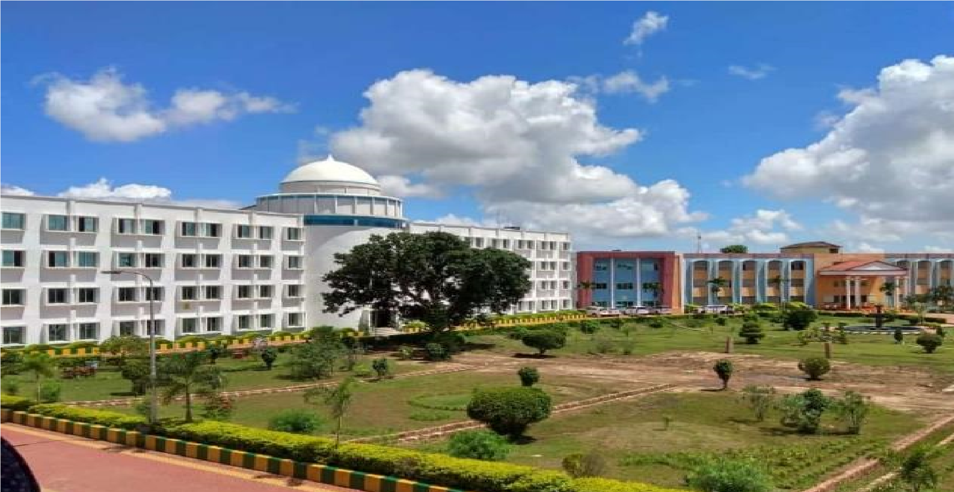

EINSTEIN ACADEMY OF TECHNOLOGY AND MANAGEMENT BANIATANGI, KHORDHA-752060

Mandatory Disclosure

- NAME OF THE INSTITUTION: -

EINSTEIN ACADEMY OF TECHNOLOGY AND MANAGEMENT (EATM)

Village: | BANIATANGI | STD Code: | 06755
Taluka : | BAJAPUR | Phone No: | 06755-243623
District: | KHORDHA | Website: | www.eatm.in
State: | ODISHA | Fax No.: | 06755- 243623
Pin Code: | 752060 | E-mail: | principal@eatm.in, info@eatm.in

- NAME & ADDRESS OF THE PRINCIPAL: -

Name:  Address: | Prof. (Dr.) Ajit Kumar Senapati  Einstein Academy of Technology and Management  At:BaniaTangi  Po:Bajpur  District: Khordha  Pin: 752 060 | 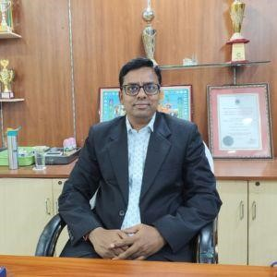

Longitude: 85, 37, and 16, Latitude: 20, 07, and 55

Telephone No : 06755-243623
Fax No : 06755- 243623
Office hours at the Institution: 9:00 AM to 5:00 PM.
E-mail: info@eatm.in
Website: www.eatm.in
Nearest Railway station (Dist in km): Khurda – 22 km
Nearest Airport (dist in km)-: Bhubaneswar-42 km
03.
Type of Institution:  Category (1) of the Institution:  Category (2) of the Institution: | Private-Self Financed  Non minority  Co-Education

04.
Name of the Organization running the Institution: | Udayanath Educational and Charitable Trust N4/145, Nayapalli, Bhubaneswar
Type of the organization: | Self-Sustained and Non-profitable
Address of the organization: | Udayanath Educational and Charitable Trust  Plot No.: 297/4002, Jayadev Vihar,  PS: Nayapalli, Bhubaneswar, Pin:751013 (Odisha)
Registered with: | Society
Registration date | 31/03/2008
Website of the organization | www.eatm.in

05. NAME OF THE AFFILIATING UNIVERSITY: -

Biju Patnaik University of Technology (BPUT)
Chhend Colony, Rourkela, Odisha-769004,
Phone: (0661) 2482556, Fax: (0661) 2482562
Website: www.bput.ac.in

06.
Name of Principal: | Prof. (Dr.) Ajit Kumar Senapati
Exact Designation: | Principal
Phone number with STD Code: | 9437783220
Fax number with STD Code: | 06755- 243623
E-mail : | principal@eatm.in, info@eatm.in
Fax No.: | 06755- 243623

07. Governing Board Members:

Sl. No. | Name | Designation
1) | Sri Basant Kumar Bisoi  Chairman , UEACT, BBSR | Chairman
2) | Sri Krushna Chandra Bisoi Secretary , UEACT, BBSR | Secretary (Ex-Officio)
3) | Sri Monoranjan Bisoi Trustee, UEACT,BBSR | Member
4) | Smt Runu Bisoi  Social Worker, Bhubaneswar | Member
5) | Smt Binodini Bisoi  Social Worker, Bhubaneswar | Member
6) | Smt Atosi Bisoi  Social Worker, Bhubaneswar | Member
7) | Director (Ex-Officio), EATM, BBSR | Member
8) | Principal (Ex-Officio), EATM, BBSR | Member
9) | HOD (Ex-Officio) CSE, EATM, BBSR | Member
10) | Dr. Kedarnath Biswal, Educationist | Member
11) | Administrative Officer, EATM, BBSR | Member
12) | Dept. Dealing with Technical Education | Member (To be Nominated)
13) | Nominee of Central Govt./ Ministry/ An industrialist or educationist nominated by EASTERN region (AICTE) Kolkata | Member (To be Nominated)
14) | Representative from BPUT, BBSR | Member (To be Nominated)
15) | Representative from State Govt. | Member (To be Nominated)

IV. GOVERNANCE: -

- Member of the Board and their brief background: -

UDAYNATH EDUCATIONAL AND CHARITABLE TRUST

- Chairman  - Secretary | Sri Basant Kumar Bisoi  Social Worker  N4/145, IRC Village,  Nayapalli, Bhubaneswar  PIN-751015  Sri Krushna Chandra Bisoi  Social Worker  N4/145, IRC Village,  Nayapalli, Bhubaneswar  PIN-751015

Governing Body

Sl. No. | Name
1) | Sri Basant Kumar Bisoi, Chairman , UEACT, BBSR
2) | Sri Krushna Chandra Bisoi, Secretary , UEACT, BBSR
3) | Sri Monoranjan Bisoi, Trustee, UEACT, BBSR
4) | Smt Runu Bisoi, Social Worker, Bhubaneswar
5) | Smt Binodini Bisoi, Social Worker, Bhubaneswar
6) | Smt Atosi Bisoi, Social Worker, Bhubaneswar
7) | Principal(Ex-Officio), EATM, BBSR
8) | Director (Ex-Officio), EATM, BBSR
9) | Dr. Kedarnath Biswal, Educationist
10) | Administrative Officer, EATM, BBSR
11) | Dept Dealing with Technical Education
12) | Nominee of Central Govt./Ministry/An industrialist or educationist nominated by EASTERN region(AICTE) Kolkata
13) | Representative from BPUT, BBSR
14) | Representative from State Govt.

- Member of Academic Advisory Body: -

    - Prof. (Dr.) Ganapati Panda, Professor IIT, Bhubaneswar
    - Prof. (Dr). Ajit Kumar Senapati, Principal, Mechanical Engineering
    - Prof. (Dr.) Rati Ranjan Sabat, Director, EGI, Bhubaneswar
    - Prof. (Dr.) Biswajit Nayak, Dean (Academics), EATM, Bhubaneswar
    - Prof. (Dr) Dushmanta kumar Padhi Dean (CSE), EATM, Bhubaneswar

- Frequency of the Board Meetings and Academic Advisory Body: - Twice a year

- Organizational Chart and process: - Enclosed in Annexure - I

- Nature and Extent of involvement of faculty and students in academic affairs/ improvements: -
  - Academic Information System (AIS) is installed for developing and delivering teaching materials in academic affairs.
  - State of Art Technology is installed for conducting class to enhance the quality of teaching.
  - Visuals and teaching aids on important courses, containing lecturers delivered by eminent professors are procured for the students.

- Mechanism / Norms & procedure for Democratic/ Good Governance: -
Under the guidance of Trustees, Governing Council, Academic Advisory Body, the day-to-day operations of EATM is managed by Principal, Dean, and Vice-Principal with help from HOD’s and Faculty members with individual responsibility.

- Student Feedback on Institutional Governance/faculty performance: -
Semester wise feedback system, regular faculty development program & faculty appraisal helps for the assessment of the performance of the faculty members.

- Grievance redressed mechanism for faculty, staff and students: -
Complaints/Suggestion boxes are available at Library/Hostels. Student’s interaction with Principal and a separate grievance cell meeting on weekly basis to discuss the various day to day issues.

V. PROGRAMMES: -

i) Name of the programs approved by the AICTE: -

Under Graduate Courses (B. Tech)
  - Civil Engineering
  - Computer Science & Engineering
  - Computer Science and Engineering (Data Science)
  - Electrical Engineering
  - Electrical & Electronics Engineering
  - Electronics & Communication Engineering
  - Mechanical Engineering
Post Graduate Courses
  - M.Tech in Mechanical Systems Design
  - M.Tech. in Structural Engineering
  - Master of Business Administration (MBA)
  - Master of Business Administration (Finance)
  - Master of Business Administration (HR)
  - Master of Business Administration (Marketing)
  - Master of Business Administration (FMH)
  - Master of Computer Applications

Diploma Courses
  - Automobile Engineering
  - Civil Engineering
  - Computer Science Engineering
  - Electrical Engineering
  - Mechanical Engineering

- Name of the Programs accredited by the AICTE: -Nil-

- For each Program the following details are given: -

A) B. Tech.
Name  Number of seats  Duration  Cut of mark/rank for admission  during the last three years  Fee  Placement facilities  Campus placement in last three Years with | Bachelor of Technology  660 per year  4 years  Centralized counseling conducted by (Qualified students from JEE, Orissa/AIEEE) and SCTE&VT  73,000/- (per year)  Yes  995 (Students till 2024)

Minimum salary Maximum salary and Average salary | 2.5 Lakhs Per annum (Approx.) 6.5 Lakhs Per annum (Approx.)  3.5 Lakhs Per annum (Approx.)
B) M. Tech
Name  Number of seats  Duration  Cut of mark/rank for admission  during the last three years  Fee  Placement facilities  Campus placement in last three years with Minimum salary,  Maximum salary  Average salary | Master of Technology  36  2 Years  Centralized counseling conducted by (Qualify students from GATE JEE Main and from OJEE)  74,000/- (Per Year)  Yes  17 Students till 2024  --  --  --
C) MBA
Name  Number of seats  Duration  Cut of mark/rank for admission  during the last three years  Fee  Placement facilities  Campus placement in last three years with Minimum salary,  Maximum salary  Average salary | Master of Business Administration  360  - Years  Centralized counseling conducted by (Qualify students from JEE Main and from OJEE)  74,000/- (Per Year)  Yes  89  2.5 Lakhs Per annum (Approx.) 6.0 Lakhs Per annum (Approx.)  3.0 Lakhs Per annum (Approx.)
D) MCA
Name  Number of seats  Duration  Cut of mark/rank for admission  during the last three years  Fee  Placement facilities  Campus placement in last three years with Minimum salary,  Maximum salary  Average salary | Master of Computer Applications  120  - Years  Centralized counseling conducted by (Qualify students from JEE Main and from OJEE)  78,000/- (Per Year)  Yes  62  2.5 Lakhs Per annum (Approx.) 6.0 Lakhs Per annum (Approx.)  3.0 Lakhs Per annum (Approx.)
E) Diploma
Name  Number of seats Duration | Diploma in Engineering  480  3 Years
Cut of mark/rank for admission  during the last three years  Fee  Placement facilities  Campus placement in last three years with Minimum salary,  Maximum salary  Average salary | Pass in 10th examination and Pass in ITI  examination as lateral entry  35,000/- (Per Year)  Yes  453  1.8 Lakhs Per annum (Approx.) 3.0 Lakhs Per annum (Approx.)  2.4 Lakhs Per annum (Approx.)

VI. FACULTY: -

- Branch wise list of faculty Members: - No of Permanent Faculty: 151
Visiting Faculty: Nil
Adjunct Faculty: Nil
Guest Faculty: Nil
Permanent Faculty: Student Ratio: 1:20 (Approximate)

- Number of faculty employed (E) and left (L) during the last three years: -

2021-2022 |  | 2022-2023 |  | 2023-24 |  | 2024-25
E | L | E | L | E | L | E | L
09 | 09 | 17 | 11 | 12 | 06 | 15 | 08

VII. PROFILE OF PRINCIPAL WITH QUALIFICATION, TOTAL EXPERIENCE, AGE AND DURATION OF EMPLOYMENT AT THE INSTITUTE CONCERNED: -

(i)

Name:  Date of Birth:  Age:  Academic qualifications (Field of specialization):  Details of Experience (Academic / Industrial):  Area of specialization: | Prof. (Dr.) Ajit Kumar Senapati  15.04.1981 44 yrs  PhD in Mechanical Engineering M. Tech in Industrial Engineering,  Member, Academic Council, BPUT, Rourkela  Life member of Institution of Engineers, American Society of  Mechanical Engineers, Indian Institute of Welding, Computer society of India & ISTE.  Teaching: 22 Years, Research: 7 years  Production Engineering
Subject Teaching at Under Graduate Level:  Subject Teaching at PG Level:  No of paper published  Projects carried out:  No of M. Tech Guided:  No of PhD Guided: Date of the appointment in the present institution: | Basic Manufacturing Process, Machining science and Technology Mechanics, Modern Manufacturing Process, Production and operation management, Engineering Drawing  Advanced Production planning and Inventory control, Decision  Modeling, Project management  International Journals: (36 No.)  National Journals: (12 No.)  Conferences: (34 Nos.)  Seven  36  04  03.02.2025

(ii) For each faculty give a page covering:
Note: - Enclosed in Annexure – II

VIII. FEE: -
(i) Details of fee, as approved by State Fee Committee, for the Institution: - For B. Tech:
 First Year: -
Tuition Fee 73,000
Transport Fees 18,000
Placement Training 0
Staff and Student Welfare 0
Cost of Uniform, Blazer, Tie, Crest, Hanger, T-shirt
5,000
& Uniform (One time charge)
Refundable Security Deposit 0
Total 96,000

Hostel
The college has its own hostel for boys and girls in campus, furniture, electrical fittings, News Paper, Magazines, TV, Telephone, Aqua Guard, Salary to mess staff, doctor ward boys, ad manager, sweepers, scavengers and cost of disinfectants, detergents, acids vacuum cleaning and cost of maintenance of electrical gadgets besides tube lights, fans motor pumps and host of other incidental expenses related to maintenance of hostels.

- Time scheduled for payment of fee for the entire program: -
Institute is providing two options for payment of fees i.e.
    - Yearly at the beginning of the academic year or
    - In the beginning of each semester i.e. twice in a year

- Criteria for fee waivers/scholarship: -
  - Income certificate of his father or his family member.
  - On merit basis secured in Joint Entrance Test (Rank holders)
  - Carrier meritorious students (Academic 10th and +2)
  - Position secured in the University Examinations

Estimated cost of boarding and lodging in hostels: -Rs. 45,000/- P.A + 3000/- caution money (1-time payment.)

- ADMISSION: -

  - Number of seats sanctioned with the year of approval: - 240
File No with date of first approval: F. No: 760-82/(NDEG)/ET/2009/05) dt. 15/01/2009

  - Number of students admitted under various categories each year in the last four years: -

 | Courses | 2024-25 |  | 2023-24 |  | 2022-23 |  | 2021-22
UG (FT) B. Tech. |  | Sancti oned intake | Actual admis sion | Sancti oned intake | Actual admis sion | Sancti oned intake | Actual admis sion | Sancti oned intake | Actual admis sion
UG (FT) B. Tech. | Computer Sc. & Engg. | 280 | 285 | 180 | 192 | 180 | 205 | 120 | 116
UG (FT) B. Tech. | Computer Sc. & Engg. (DS) | 60 | 60 | 60 | 27 | - | - | - | -
UG (FT) B. Tech. | Electronics & Comm. Engg. | 60 | 49 | 60 | 24 | 60 | 55 | 60 | 38
UG (FT) B. Tech. | Electrical & Electr. Engg. | 60 | 20 | 60 | 05 | 60 | 38 | 60 | 19
UG (FT) B. Tech. | Mechanical Engg. | 120 | 45 | 120 | 25 | 120 | 85 | 120 | 109
UG (FT) B. Tech. | Electrical Engg. | 60 | 24 | 60 | 06 | 60 | 42 | 60 | 20
UG (FT) B. Tech. | Civil Engg. | 60 | 32 | 60 | 64 | 60 | 48 | 120 | 87
PG (FT)  M. Tech | Mechanical Engg. | 18 | 04 | 18 | 02 | 18 | 05 | 18 | 06
PG (FT)  M. Tech | Civil Engg. | 18 | 21 | 18 | 18 | 18 | 19 | 18 | 18
Diploma | Automobile Engg. | 60 | 56 | - | - | - | - | - | -
Diploma | Civil Engg. | 120 | 129 | 60 | 62 | 60 | 45 | 60 | 38
Diploma | Computer Sc. & Engg. | 60 | 68 | - | - | - | - | - | -
Diploma | Electrical Engg. | 120 | 134 | - | - | - | - | - | -
Diploma | Mechanical Engg. | 120 | 138 | 60 | 63 | 60 | 60 | 60 | 60
 | Finance | 120 | 74 | 120 | 106 | 60 | 43 | 60 | 56
PG (FT)  MBA | Marketing | 60 | 35 | 60 | 26 | 60 | 29 | 60 | 43
PG (FT)  MBA | HR | 60 | 71 | - | - | - | - | - | -
PG (FT)  MBA | FMH | 60 | 72 | - | - | - | - | - | -
PG (FT)  MBA | MBA | 60 | 71 | - | - | - | - | - | -

- ADMISSION PROCEDURE: -
    - Mention the admission test being followed, name and address of Test Agency and its
URL(website) :-
JEE (Joint Entrance Examination, Odisha), J.E.E. Complex, BPUT, Gandamunda, Bhubaneswar, Odisha, www.bput.org, www.jeeorissa.com

    - Number of seats allotted to different Test Qualified candidates separately [AIEEE/ CET (State conducted test/University tests)/ Associated conducted test]:-
70% of the total seats is filled through JEE counseling, Odisha, 15% seats are filled from NRI Quota and remaining 15% seats will be filled from AIEEE quota.

    - Calendar for admission against management/vacant seats :-
        - Last date for request for applications :
As per the guideline of admission rules/procedure prescribed by Joint Entrance
Examination (Odisha)
        - Last date for submission of application:
As per the guideline of admission rules/procedure prescribed by Joint Entrance
Examination (Odisha)
        - Date of announcing final results :
As per the guideline of admission rules/procedure prescribed by Joint Entrance
Examination (Odisha)
        - Release of admission list (main list and waiting list should be announced on the same day):
As the seats are being filled through the central counseling conducted by JEE (Odisha) the institution has no such list of its own. Details are available at www.jeeorissa.com
        - Date for acceptance by the candidate (time given should in no case be less than 15 days) :
As per the guidelines of Industries Department and Joint Entrance Examination
(Odisha)
        - Last date for closing of admission :
As per the guideline of admission rules/procedure prescribed by Joint Entrance
Examination, (Odisha)
        - Stating of the Academic session: Last week of August of every year
        - The waiting list should be activated only on the expiry of date of main list: As the admissions are through JEE central counseling, hence no waiting list is being maintained by the institute.
        - The policy of refund of the fee, in case of withdrawal, should be clearly notified:
The Institute is refunding the fees after receiving seat cancellation letter from the student/parent and the same is communicated to the University as per the guidelines of JEE, Odisha.

- CRITERIA AND WEIGHTAGES FOR ADMISSION: -

    - Describe each criteria with its respective weight ages i.e. Admission Test, marks in qualifying examination etc:-
For admission process the Institute follows the guideline of admission rules/procedure prescribed by Joint Entrance Examination, Orissa for its regular courses. The candidates not qualified in JEE/AIEEE shall not be allowed for admission.
    - Mention the minimum level of acceptance, if any: -
Passed + 2 science with (PCM), required to submit a rank from (JEE (Odisha) /AIEEE Test)
    - Mention the cut-off levels of percentage & percentile scores of the candidates in the admission test for the last three years: -
-Not Applicable- (As the admissions are through central counseling JEE (Odisha)
    - Display marks scored in Test etc. and in aggregate for all candidates who were admitted: -
-Not Applicable- As the admissions are through central counseling JEE (Odisha)

- APPLICATION FORM: -
(i) Downloadable application form, with online submission possibilities: -
JEE-Orissa reserves all rights for selling of the application forms. The same application forms are available in bank counters or all over Orissa state on payment basis.

- LIST OF APPLICANTS: -
(i) All the applications are received by J.E.E., Orissa and the admission is undertaken through central counseling based on JEE/ AIEEE ranks.

- RESULTS OF ADMISSION UNDER MANAGEMENT SEAT/VACANT SEATS: -
    - Candidates having valid JEE/ AIEEE ranks are eligible for admission under vacant NRI seats. The Institute invites applications from such candidates and prepares a merit list of candidates in branch wise and submit to the JEE counseling for such verification and approval for admission.
15% of the allotted seats are reserved under NRI/Management quota as per the notification given by Govt. of Orissa 2008.
    - Score of the individual candidates admitted arranged in order of merit.
The merit lists have been prepared as per the JEE, Orissa norms.
    - List of candidates who have been offered admission.
- Not applicable- (As the Students Counseling is continuing)
(iv) Waiting list of the candidates in order of merit to be operative from the last date of joining of the first list candidates.
- Not applicable- (Institute is following the admission rules & procedure of JEE Counseling Orissa)
(v) List of the candidates who joined within the date, vacancy position in each category before operation of waiting list.
The vacancy position in each category before admission is not available in the Institute. However, the Institute is following the admission rules & procedure of JEE, Counseling Orissa.

- INFORMATION ON INFRASTRUCTURE AND OTHER RESOURCES AVAILABLE: -
(i) LIBRARY
      - Number of Library books/ Titles/ Journals available: -
Volumes - 29632 Nos
Titles (Engg.) - 5793

      - List of online National/International Journals subscribed: -
National Journals - 48
International Journals - 16
      - E-Library facilities: - Yes
Total Number of Books  No. of Titles  No. of Print Journals Subscribed  Number of E-Journals Subscribed  Number of Magazine Subscribe  Number of Newspaper  Number of Reference Book  Seating Capacity  Name of Library Software Used Name of I.S.P.  CD/DVDs | 500  500  61  42526  23  10  8147  200  SOFTLIB  RAILTEL  1002

  - LABORATORY: - Details of Laboratories & Workshops
Sl.  No  . | Name of the  Course | Name of the laboratory/ workshop | Major equipment

1 | Computer Science | Computer laboratories | - 285 no’s Desktop with 10 Intel dual Core  Due Processor, 160 GB HDD, 4GB RAM, 2.8  GHz  - 1Desktop 18.5 inch (Monitor)1TB , HDD,4  GB RAM,i3 Processor, GHz
2 |  | Computer Centre | 40 Nos. Desktop with Intel Core 2 Duo  Processor, 160 GB HDD, 1GB RAM, 2.20 GHz  LCD-, Projector: 06, head Phone: 60, Video  Camera: 01, Podium: 02
3 | Electronics  &  Communicat  ion  Engineering | Basic Electronics Analog Electronics Circuit lab.  Digital Electronics Circuit lab.  MPMC Lab. SS Lab DSP Lab  EMT Lab.  CE Lab. | - 8086 Trainer Kit.  - 8051 Microcontroller Trainer Kit  - Amplitude Modulation and D-Modulation Trainer Kit  - Frequency Modulation and D-Modulation Trainer Kit  - CRO 20 MHz – 12 nos  - Trainer kits for diode, rectifier, FET gate etc.  – 14 nos  - Function generator – 05 nos  - Accessories
4 | Electrical &  Electronics  Engineering | Basic Electrical  Network Device Lab  Control System Lab  Power Electronics Lab  Power System Lab  PSOC Lab  Electrical Machine Lab | - Voltmeter – 15 nos  - Squirrel cage induction motor -03 nos  - Ammeter – 15 nos  - Wattmeter – 07 nos  - DOL starter – 02 no  - Varriac – 07 nos  - M.G. set – 08 nos  - Fan motor – 01 nos  - Loading Rheostat – 10 nos  - Transformer – 04 nos
5 |  | Workshop | - Welding machine – 03 nos  - Milling machine -01  3.MIG welding machine – 01  - Drilling machine -03  - Shaping machine (Shaper) – 02  - Bench grinding machine – 3nos  - Lathe machine – 4 nos  - Power hacksaw machine-1 NO  - 3 jaw chuck for lathe machine – 03
6 |  | Drawing Hall (02) | Drawing Tables – 120nos

7 | Physics | Physics Lab | - Bar pendulum – 03 nos  - Ultrasónico Interferómetro – 03nos  - Newton’s ring apparatus – 01 nos  - Grating with spectrometer – 02 no  - Na-vapor lamp with spectrometer - 03 nos  - Searle’s apparatus – 02 nos  - Rigidity apparatus – 03 nos  - Lee’s apparatus – 02 nos  - Surface tension app – 02 nos  - B.J.T. app -02 nos  - P.N. junction app -03 nos 12) Sonometer app – 02 nos 13.) Meter bridge -01 no.  14) RC circuit -02 Nos.)
8 | Chemistry | Chemistry Lab | - Digital Spectro photo meter 01 sets  - PH meter – 01 sets  - Double pan balance – 02 nos  - Redwood Viscometer – 03 nos  - Pensky-marten’s closed cup flashpoint apparatus – 02 nos  - Distilled water plant – 01 no  7)Hot air Oven -01  8)Electronic Balance -01
9 | English | Language Lab | - Desktop – 31 nos  - Video camera – 01 no  - L.C.D – 01 no  - Communicate Head Phone– 30 No  - Presentation & Public speak – 01  6)Wall Mount projector :01  7)Projector screen :01  - Podium :01  - Globarena (soft ware) :30 units  10)Collar Microphone:01  11)Laser light Pointer :01

10 | ECE | ACT LAB./MPMC.  Lab. | 1.8085 Microprocessor Trainer (Micro-85.LC)  2.Channel DAC, Interface Borrad (VBMB-002)  3.Stepper Motor controller with(VBMB-013ª) 4. Generate square wave on all line of 8255 with different frequencies, Mode-0, Mode-1, BSR mode operation of 8255 VBMB-008. 5.8085 Microprocessor Trainer Kit Model (cicro-85 lcd, Micro85 EBLCD.  6.Study of stepper motor and its operation  (stepper motor controller)VBMB 013ª 7.Study of Traffic Light controller(Traffic light control systems) TRAF  8.Elevator Simulator interface(VBMB-022)  9.8051 Microcontroller CMCS Family  Microcontroller Trainer(Micro-51EB)  - Thermometer Kit  - ACL-02, Amplitude Receiver Kit.  12.ACL-03, FM Tx Kit  13.ACL-04, FM Rx Kit  14.Filter/Noise  - Sampling Reconstruction Kit.  - DCL-03, PCM kit
11 | ECE | AEC LAB | - Resistance of different values.  - Transistors.  - FETs.  - Connecting wares.  - Soldering Irons.  - ICs.  - 4-Bit Binary Ripple Counter [DB-14]  - BNC to BNC Cable [BNC].  - BNC to Crocodile Cable (BNC-CRO).  - Multimeter (VC97)  82, 85, 86,78,58,87

12 | ECE | DEC LAB. | 1. Binary order / Subs tractor. [DB-08]. 2. Multiplexer/Demultiplexer. [DB-10]  - Flip flops. [DB-11].  - Shift Register [DB-12].  - 4-BIT Synchronous Binary Counter.  - FG-02 2Mhz. Function Generator with frequency Counter.  - DMM-10 3 ¾ Digital Low cost Handelled Multimeter.  - DSO - 025C1 - 0316, 0390  25 Mhz. 100 MS/s Col

13 | EEE | E.M LAB. | 1.2-Pole MCB 20ª- 2nos.  2.3 –Pole MCB 10ª-01 no.  - 3- Pole MCB 16ª-01 no.  - D.O.L. Starter For 3Hp SQIM-01 no.  - Rectifier Unit-80ª, Variable Type)-220 Vpc.  – 01 Set.  - Ramson DC Shunt Motor 5 Hp Coupled 3Kva Alter motor- 01 Set.  - Ramson DC Shunt motor 5Hp, coupled 3 KvA Alter Motor.- 01 Set.  - Control panel for synchronization Panel – 01 Set.  - Field Regulator 600*600- 04 no., Field Regulator 600*400 – 02 no.  - Digital Techno meter – 3 no.  - Panel frame me1 -3, Motor-1 – 4 no.  - Mg BASE-3, Motor BASE-1 – 4 no.  - Ramson DC Shunt Motor 5Hp coupled with DC shunt Generator 2 KW. - 01 Set.  - Ramson-SCIM 5HP. - 01 no.  - Varivolt 3-Phase variac 15ª (closed)- 02 no.  - Transformer 3/3KVA. 415/120V/120V (closed).- 01 no.  - Control Panel for MG set- 01 no.  - Control Panel for Alternador- 02 no.  - Control Panel so. Cage. Ind.Motor- 01 no.  - AC Voltmeter – 150/300/600 V. - 7 no.  - AC Ameter-1/2ª-01 no.  - AC Ameter-5/10ª-05 no.  - AC Ameter-5/10/25ª- 01 no.  - AC Ameter-1/3/10ª-01 no.  - DC Voltmeter-300V-08 no.  - DC Ameter-10/20ª- 03 no.  - VPF (Wattmeter) 2.5/5ª 150/300/600v.-03 no.  - LPF (Wattmeter)2.5/5ª-75/150/300V.
14 | ME | MT LAB | - Universal Testing Machine -01nos  - Hardness Testing Machine-01nos 3. Fatigue Testing Machine-01nos  - Load indicator, Load Cells.  - Strain gauge.  - Stress measurement using strain rosette.

15 | ME | MAM LAB | 1.Gyroscopic test rig-01nos  2.Universal governor-01nos  3.Static & dynamic balancing apparatus-01nos  4.Cam analysis apparatus-01nos  5. Vibration measuring equipment-01nos  6.Fuel injection system of diesel engine-01nos  7.Transmission gear box model-01nos
16 | ME | FMHM LAB | 1.Metacentric height measurement apparatus-  01nos  2.C_{v &} Cd of orifice experiment apparatus-01nos  3.Impact of jets experiment apparatus-01nos  4.Pelton turbine test rig-01nos  5.Francis turbine test rig-01nos  6.Centrifugal pump test rig-01nos  7.Reciprocating pump test rig-01nos  8.Verification of Bernoulli’s theorem apparatus-01nos
17 | ME | ETD LAB | 1. Desktop (Acer veriton M200-H61, Corei3,500GB HDD, 15’’ Monitor,104keys, optical mouse)-30 nos  1.Thermal conductivity of composite slab apparatus-01nos  2.Surface emissivity measurement apparatus-  01nos  3.Parallel flow & counter flow heat exchanger apparatus-01nos  4.Effiency & effectiveness of fins-01nos  5.Gear pump performance apparatus-01nos  6.Study of steam power plant model-01nos  7.Reciprocating air compressor test rig-01nos

18 | CE | GTE LAB | 1.Blains air permeability-1 no  2.Digital Balance-1no  3.Brass Sieve (8 inch Dia)-14 nos  4.Digital Oven (18*18)-1no  5.Spatula-4 nos  6.Sample Container-0.5ltr-1 no  - Sample Container-1 ltr-1 no  - Sample Container-2 ltr-1 no  - Sample Container-5 ltr-1no  10.Physical Balance-2 nos  11.Desiccator Vaccum type-1no  12.Desiccator Glass-3 nos  13.Liquid Limit Kit (motorisesd)-2 nos  14.Permeability-1 no  15.Rammer-2.5kg-2 nos  16.Tools-2nos  17.Consolidation Machine-2nos  18.Vane Shear Motorised-1 no  19.proctor compaction-2 nos  20.split mould(s)-1 no  21.Split Mould(l)-1 no  22.Pan of conical sitting-1 no  23.Hydrometer-1 no  24.Soil Cone Penetrometer-2 nos  25.Compaction Test Apparatus-1 no  26.Hand operated Extractor(100&150)-1 no  27.Samplimp Tube-38/200-1no  28.Lateral Pressure Assembly-1 no  29.Direct Shear Apparatus(hand operated)-1 no  30.Pippete (25mm)-3 nos  31.Picnometer-4 nos  32.CBR Apparatus With All Accessories-1 no  33.Core Cutter With Dolly With Rammer-2 nos  34.Water Measuring jar (big & small)-1 no  35.Enamel Tray(12*18)-1 no  36.Aluminium Tin Container-20 nos  37.Thermometer-1 no  38.Specific Gravity Bottle(50 ml)-1no  39.Vane Shear (hand operated)-1 no  40.Shrinkage Limit-1 no  41.Liquid Limit & Plastic Limit-1 no  42.Pipeete Soil Sedimentation-1 no  43.Sand Pouring Cylinder-1 no

 |  |  | 44.Tri axial Shear Machine-1 no
19 | CE | SURVEYING LAB | 1.Gunter Chain-1 no  2.Engineers Chain-1 no  3.Metric Chain(20m &30m)-4 nos  4.Arrow-50nos  5.Wooden Peg-10nos  6.Ranging Rod-10 Nos  7.Measuring Tape(30M &15M)-4 nos  8.Line Ranger-2 nos  9.Offset Rod-5 nos  10.Prismatic Compass With Stand-3 nos  11.Surveyor Compass With Stand-3 nos  12.Clinometer Compass-3 nos  13.Plane Table With Accessories-3 nos  14.Telescope with Alidade-2 nos  15.Dumpy level(9 inch) With Stand-2 nos  16. Dumpy level(12 inch) With Stand-2 nos  17.Levelling staff(4mtr)-2 nos  18. Leveling staff(6mtr)-2 nos  19.Autolevel With Stand-1 no  20.Vernier Theodolite-2 nos  21.Ghat Tracer-2 nos
20 | CE | CSE LAB | 1.Vibrating Machine-1 no  2.Vibrating Table-1 no  3.Compression Machine (1000kn)-1 no  4.Concrete Mixture-1 no  5.Slump Cone-3 nos  6.Cube Mould- 3 nos  7.Water Bath-1 nos  8.Cylindrical Mould-1 no  9.Brequette tensile machine-1 no  10. Enamel Tray (18*24)-1 no  11.Le-Chatelier Mould-1 no  12.Digital Balance-1 no  13.Gauging Trowel-2 nos  14.Flakiness Index& Elongation Index-2 nos  15.Vicat Apparatus With Needle-1 no  16.Stopwatch-1 no
21 | CE | TE LAB | 1.Sieve Shaker Motorised-1 no  2.Aggregate crushing value-1 no  3.Aggregate Impact Value-1 no  4.Loss Angles Abrasion Machine-1 no  5.G.I Sieve-12 inch Dia-04 nos  6.G.I Sieve-300mm Dia-2 nos  7.Automatic Bitumen Extractor-1 no  8.Mould With Tamping Road-1no  9.Steel Bulb(Los Angles)-12 nos

  - COMPUTING FACILITIES: -

        - Number of configuration of systems: -
Desktop
a) Desktop with Intel Core i3 Processor, 500 GB HDD, 4GB RAM, 3.40 GHz =
120 Nos
b) Desktop with Intel Core i5 Processor, 250 GB SSD, 8GB RAM, 3.40 GHz =
114 Nos
- Desktop with Core 2 Duo Processor, 256 GB HDD, 2GB RAM, 2.4 GHz
=120 Nos
- Desktop 18.5 inch (Monitor) 1TB hard Disc HDD,4 GB RAM,i3 Processor, GHz = 354 Nos
Printer – 24 Nos
HP Scanner – 07 no, Canon Scaner- 06
Xerox – 04 no
Color Xerox - 02
Cisco router- 08 no.

        - Total number of systems connected by LAN: - 354
        - Total number of systems connected to WAN: - 354
        - Internet bandwidth: -300 Mbps: Line form Reliance Jio
        - Major software packages available :-
          - Windows 98, Windows 2012 server, Microsoft windows 10 windows7
          - MSDN Academic Alliance Ver-7 Full Pack, Borland C++, MS Office 2007, Oracle -10, Oracle-8, Adobe Photoshop-7, Matlab-7, Java-3.0, Tally-9.0, Autocad-2011.-2012.
f) Special purpose facilities available: Yes
(iv) List of facilities available: -
Gym /Music Club: yes
ATM (PNB): Yes
Games and Sports facility: Yes
Extra Curriculum Activities: Yes
Soft Skill Development Facilities: Yes
(V) CLASS ROOM:
Number of Classrooms and size of each: 47 (73.96 Sq. m.)
Number of Seminar Hall: 05 (162.34Sqm)
Number of Tutorial rooms and size of each: 10 (35 Sq. m.)
Number of Laboratories and size of each: 52 (71 Sq. m. Appx.)
Number of drawing halls and size of each : 02 (134.00 Sq. m)
Number of Computer Center with capacity: 01 (60 Number of computer, 180 Sq. m) Number of computer Lab: (with Computers) 08 (78.73 Sq. m. Approx.) Each 36 computers
Nos. of Computers in E-library = 15
Examination Facility: 30 Number of classrooms equipped with CC TV cameras are available for conducting examinations
07 ICT Hall (66.32sqm)
(Located in 4 floors are Converted into examination Halls during examination time based on availability)

(VI) Teaching Learning Process: -

  - Curricula and syllabi for each of the programmed as approved by the University:
Yes Available on www.bput.ac.in
  - Academic Calendar of the University: Yes Available on www.bput.ac.in
  - Academic Time Table: Yes
  - Teaching Load of each Faculty:
Lecturer /Assistant Professor: 16 hours per week
Associate Professor: 12 hours per week
Professor: 08 hours per week
  - Internal Continuous Evaluation System in Place: Yes
  - Student’s assessment of Faculty, System in place: Yes

(vi) FOR EACH POST GRADUATE PROGRAMME GIVE FOLLOWING:

Note: There are 04 Post Graduate Programme (s) running in our Institute.
- ME -18 seat (Mechanical System Design)
- CE-18 seat (Structural Engineering)
- MBA – 360
- MCA - 160
NOTE: Suppression and/or misrepresentation of information would attract appropriate penal action.

Prof. (Dr.) Ajit Kumar Senapati
Principal

Teaching and Non-Teaching Staff of EINSTEIN Academy of Technology and Management, Bhubaneswar

Appendix-2
Faculty Members
Name of Programme/  Course | Professor | Associate Professor | Assistant Professor
B. Tech (Computer Science) | 4 | 6 | 18
B. Tech (Computer Science)  (Data Science) | 1 | 0 | 4
B. Tech (Electrical) | 1 | 2 | 4
B. Tech. (Electronics & communication) | 0 | 3 | 8
B. Tech (Civil) | 1 | 0 | 10
B. Tech (Mechanical) | 4 | 7 | 16
B. Tech (Electrical & Electronics) | 2 | 0 | 5
BS&H | 2 | 2 | 32
MBA | 0 | 3 | 33
MCA | 0 | 0 | 12
Total | 15 | 23 | 138

Non-Teaching Staff
 | Number
Lab Asst | 28
Sys. Admin | 02
Accountant | 08
PRO | 01
Executive | 16
Librarian | 04
Attendant | 08
Electrician | 5
Dev. Officer | 1

Principal

Faculty Details

S.No. | Name | Gender | Designation | Appointment  Type | Course | Aadhaar  Number | Address | Email Id | Date of  Joining
1 | Mr.DIPAK  RANJAN  SATAPATHY | male | Assosiate professor | Regular | Humanities and  Science | 701623236141 | AT/PO-  BAULABAND HA PS-  BANPURKhur da 752034 | dipaksatapath  y@eatm.in | 02/08/2016
2 | Mrs.PUSPITA  ACHARYA | female | Assosiate professor | Regular | Humanities and  Science | 621117811989 | Flat no-401, Datttrayas cave view  Apartment,  Khanadagiri,  Bhubaneswar  GhatikiaKhur da 751003 | puspitaachary  a@eatm.in | 08/09/2015
3 | Mr.Jitansu  Patra | male | Assistant Professor | Regular | CSE | 579551309074 | Patrapada  Khurda | jitanshushpatr  a@gmail.com | 01/09/2018
4 | Dr.Biswajit  Nayak | male | Professor | Regular | ME | 381714278915 | 955/5128 Phase-III  Sidheswar Nagar  Jagamara  Khurda  751030 | biswajitgy@g mail.com | 05/03/2020
5 | Mr.RADHESHY  AM HOTA | male | Assistant Professor | Regular | CIVIL | 837978233055 | at/po-  sarbahal,distjharsuguda,  pin - 768201 at/po-  sarbahal,dist-  jharsuguda,  pin -  768201Jhars uguda (N.D)  768201 | radheshyamh  ota@eatm.in | 22/07/2017
6 | Mr.ASHISHA  KUMAR  MOHANTY | male | Assistant Professor | Regular | ECE | 331273592544 | AT-  MIRZAPUR,  PO-  LANKAPADA  DISTJAGATSING  HPURJagatsi nghpur  754134 | asis.unix3@g mail.com | 07/02/2018
7 | Mr.SUMIT  KUMAR  CHOUDHARY | male | Assistant Professor | Regular | ECE | 209738133335 | "FLAT NO5E, BLOCK-8 METROCITY  APPARTMEN  T, PHASE-2  NAYAPALLIK hurda  751012 | sumit22iacr@  gmail.com | 08/09/2017
8 | Mr.Riyaz Uddin  Khan | male | Assosiate professor | Regular | CSE | 634885784152 | Pipili  PuriKhurda  752104 | rukhan@eat  m.in | 02/05/2009
9 | Mr.SATYAJEE  T NAYAK | male | Assistant Professor | Regular | ME | 708109655709 | QR.NO.  CTA/6  SECTOR-  20Sundargar h (N.D)  769005 | nayak.satyaje et99@gmail.c om | 26/03/2018
10 | Mr.BIDYUTKA  NTA SAHU | male | Assosiate professor | Regular | ME | 736928910674 | DURGAPUR  JARAPADAA ngul 759127 | bidyutkanta19  87@gmail.co m | 20/12/2016
11 | Mr.Sanat Rout | male | Assosiate professor | Regular | MBA(MARKETI  NG &  FINANCE) | 319015622265 | 19,  Budhanagar  BhubanswarK hurda  751006 | dean.mba@e atm.in | 17/02/2021
12 | Mr.K  PITAMBAR  PATRA | male | Assosiate professor | Regular | ECE | 936944890104 | AT-  PANCHABHU  TI PO-  PANCHABHU  TIGanjam  (S.D) 761121 | kpitambarpatr a@gmail.com | 01/09/2015
13 | Mr.MD ADIL  AKHTRA | male | Assistant Professor | Regular | Humanities and  Science | 405499194005 | DANOGAHIR  DIST-PURI  PIPILIPuri 752104 | mdadilakhtar1  2@gmail.com | 15/02/2018
14 | Mr.Subash  Chandra  Mishra | male | Assosiate professor | Regular | ELE | 217419411727 | Canal Road,  Ultra Lane  JagatpurCutta ck 754021 | subu00002@  gmail.com | 05/04/2022
15 | Mr.SMRUTI  SWAGAT ROY  MOHAPATRA | male | Assistant Professor | Regular | ME | 897654320834 | Kamakhya nagar DhenkanalDh enkanal (N.D)  753208 | ssroymohapat  ra@eatm.in | 03/08/2020
16 | Mr.ARUPA NANDA  MOHANTY | male | Assistant Professor | Regular | ME | 711943749723 | AT-  BANIATANGI  ,POBAJAPUR  AT/PODANARA,AN  GULAngul  753109 | arupa_2007  @yahoo.com | 18/04/2011
17 | Mr.BISWAJIT  PANY | male | Assistant Professor | Regular | ME | 232756178408 | AT-  BANIATANGI  BAJAPUR  AT-  BANIATANGI BAJAPURKh urda 752060 | bpany@eatm. in | 07/09/2018
18 | Mr.Biswajit  Mohapatra | male | Assistant Professor | Regular | ELE | 632042737233 | C/o- Bigyan  Mohapatra , plot no4242/9239  Pandav nagar,  Badagarh brit colony,  Bhubaneswar  Khurda  751018 | biswajitmoha  patra@eatm.i n | 17/08/2020
20 | Mr.Kunal  Pradhan | male | Assistant Professor | Regular | CIVIL | 209772643122 | At-Jharabahal  Barkote,Deog arhDeogarh  (N.D) 768110 | kunalpradhan  .9298@gmail. com | 10/12/2022

21 | Mr.Ashutosh  Mangaraj | male | Assistant Professor | Regular | Humanities and  Science | 284466269148 | At-  Khuntiabanap ur  Olhan,PuriPur i 752019 | ashutoshman garaj4179@g mail.com | 18/10/2022
22 | Mr.Biswajit  Tripathy | male | Assistant Professor | Regular | ECE | 582646307311 | Naya Bazar,  Cuttack,  Odisha,  Khurda  751030 | biswajittripath y82@gmail.c om | 05/08/2018
23 | Mr.RAJENDRA  KUMAR  RAUTARAY | male | Assistant Professor | Regular | CIVIL | 305608128105 | Barkul,  Balugaon  KhurdhaKhur da 752030 | rajendra1219  1@gmail.com | 02/01/2022
24 | Mrs.BANAHAN  SI MOHANTY | female | Assistant Professor | Regular | Humanities and  Science | 912928450523 | BHUBANES WAR MC  BARAMUND A  COLONYKhu rda 751003 | banahansim  @gmail.com | 14/02/2017
25 | Mrs.SIMITA RANI  PRADHAN | female | Assistant Professor | Regular | ECE | 933230385309 | vishakpatna  vishakpatnaG  anjam (S.D)  530048 | simran1023@  gmail.com | 09/09/2017
26 | Mr.DEEPAK  KUMAR  BISWAL | male | Assistant Professor | Regular | CSE | 320687868049 | SORO  SOROBalaso re (CD)  756046 | dbiswal16@g mail.com | 17/11/2023
27 | Mr.RATI  RANJAN  SAHOO | male | Assosiate professor | Regular | CSE | 539552861667 | RAJGANGPU  R  RAJGANGPU  RSundargarh  (N.D) 770017 | r.r.sahoo.odis  hs@gmail.co m | 13/07/2015
28 | Mrs.JHARANA  PAIKRAY | female | Assistant Professor | Regular | CSE | 616784880595 | JATANI  JATANIKhurd a 752031 | jharanaray@  gmail.com | 21/07/2017
29 | Mr.SIDHARTH  SAMANTARA | male | Assistant Professor | Regular | ELE | 570851295002 | SASTRINAG  AR Khurda  751003 | sidharth1oct  @gmail.com | 01/03/2024
30 | Dr.BIJAY  KUMAR  MOHAPATRA | male | Professor | Regular | ELE | 533506609344 | SARANAKUL  SARANAKUL  Nayagarh  (CD) 752080 | bijaya87@gm ail.com | 18/04/2022
31 | Mrs.Sucheta  Hota | female | Assistant Professor | Regular | ECE | 716822988036 | At/Po Gurujanga  GurujangaKh urda 752055 | suchetahota  @eatm.in | 18/08/2023
32 | Mr.SATYAJIT  NAYAK | male | Assistant Professor | Regular | ELE | 587070359964 | Plot No  LIH858,  Kalingagark4 Subudhipur,  BBSRKhurda  751019 | satyajitnayak  @eatm.in | 23/12/2023

33 | Mr.SUKANTA  KUMAR  BISWAL | male | Assosiate professor | Regular | ECE | 460293722523 | Plot No-12,  Kolathia,Aigin ia,  Bhubaneswar  Kolathia,Aigin ia,  Bhubaneswar  Khurda  751030 | sukanta15bis  wal@gmail.co m | 06/03/2024
34 | Dr.ABDUL  KALAM | male | Professor | Regular | Humanities and  Science | 699011274458 | KUSUMI,  SANRAUTAP ADA  KUSIMI,KHO  RDHAKhurda  752021 | abdul_003@g mail.com | 12/06/2016
35 | Mr.RUPAK KUMAR DAS | male | Assistant Professor | Regular | ME | 954950429432 | AT/PO-  BAJAPUR,KH  ORDHA  AT/POBAJAPURKh urda 752060 | rupak.kumard  as99@gmail. com | 04/03/2022
36 | Mr.CHINMAYA  PRADHAN | male | Assistant Professor | Regular | ME | 572145960285 | ANGAPADA, ANGUL  ANGAPADAA ngul 759126 | chinmayaprad  han95@gmail  .com | 26/09/2024
37 | Miss.ROJALINI  SAMANTASIN  GHAR | female | Assistant Professor | Regular | CIVIL | 403931288164 | AT-  BAJRAKOT,  PO-  BAUNSAGAR  H,NAYAGAR  H AT-  BAJRAKOT,  PO-  BAUNSAGAR  H,NAYAGAR  HNayagarh  (CD) 752026 | samantasingh  arrojalin@gm ail.com | 03/08/2023
38 | Miss.HARAPRI  YA PATTNAIK | female | Assistant Professor | Regular | CIVIL | 822750917138 | BAJAPUR,PA TANASAHI  BAJAPUR,KH  ORDHAKhurd a 752060 | pattanaikhara  priya44@gma  il.com | 06/07/2023
39 | Mr.BISWAJIT  CHAMPATIRA  Y | male | Assistant Professor | Regular | Humanities and  Science | 327283393393 | JAGANNATH  ROAD,  JAGANNATH  PUR  JAGANNATH  PUR,  KANASPuri  752017 | biswajitchamp  atiray@eatm.i n | 20/06/2020

40 | Mr.DURGA PRASAD  ACHARJYA | male | Assistant Professor | Regular | Humanities and  Science | 599245173103 | MADHUPUR,  DHAULIMUH  AN P H,  BRAJAMOHA  NPUR  BRAJAMOHA NPUR,  KHORDAKhu rda 752018 | durgaprasad  @eatm.in | 26/06/2024
41 | Mr.ANIL  PANDA | male | Assosiate professor | Regular | ME | 989026570164 | Adheikul,  Badakorakor  Adheikil,  Jagatsinghpur  Jagatsinghpur  754132 | anilpanda87  @gmail.com | 06/03/2018
42 | Mr.DEBASISH  RATH | male | Assistant Professor | Regular | ME | 272726398759 | GADAVAGU  DU  NABARANGP  UR752089 | bitunrath28@  gmail.com | 15/04/2025
43 | Miss.ARPITA  DASH | female | Assistant Professor | Regular | Humanities and  Science | 310188639244 | Qr no-2RA32/6 Unit-8,  Gopabandhu  Nagar near hanuman mandir,  nayapalliKhur da 751012 | arpitad1401  @gmail.com | 25/09/2024
44 | Miss.ELINA  SATAPATHY | female | Assistant Professor | Regular | Humanities and  Science | 209071983097 | BENTAPUR,  BIJIPUR  BENTAPUR,  BRAHMAGIR  IPuri 752011 | elinasatapath  y444@gmail. com | 26/09/2024
45 | Miss.MIMANS  HA MISHRA | female | Assistant Professor | Regular | Humanities and  Science | 698706434282 | KOMAR  GODA,  COLLEGE  ROAD  KENDUJHAR  KENDUJHAR  , PO-  MADHAPUR  Keonjhar  (N.D) 758001 | mimansha000  @gmail.com | 18/10/2023
46 | Mr.MAKHAN  PATTANAIK | male | Assistant Professor | Regular | Humanities and  Science | 852289255038 | BAJAPUR,  BAJAPUR  KHORDHAKh urda 752060 | makhanpatta  naik67@gmai  l.com | 01/08/2022
47 | Miss.SMARANI  KA  PATTANAIK | female | Assistant Professor | Regular | Humanities and  Science | 584951037435 | OGALAPADA  ,  OGALAPADA  NEAR MAA  BHUASUNI  TEMPLEKhur da 752054 | smaranika@e atm.in | 13/02/2023
48 | Mr.GOBARDH  AN SINGH | male | Assistant Professor | Regular | Master of  Business  Administration(  Human  Resource  Management) | 566879562322 | BHUBANES  WAR  BHUBANES  WARKhurda  752006 | gobardhan55  66@gmail.co m | 18/01/2024
49 | Mr.DURGA  PRASAD  PANDA | male | Assistant Professor | Regular | Master of  Business  Administration(  Human  Resource  Management) | 147651662391 | JATNI  KHORDHAKh urda 752050 | durgappanda  86@gmail.co m | 21/04/2024
50 | Mr.NAROTTA  M DAS | male | Assistant Professor | Regular | MBA | 502354554358 | KHORDHA  KHORDHAKh urda 752055 | dasnarottam7 6@gmail.com | 23/05/2024
51 | Mr.JAYANTA  KUMAR  SWAIN | male | Assistant Professor | Regular | MBA  (MARKETING  MANAGEMEN  T) | 764554586355 | BDA  COLONY  JATNIKhurda  752050 | jayantaswain  33@gmail.co m | 23/03/2024
52 | Mr.SRITAM  DALEI | male | Assistant Professor | Regular | CSE | 310499367305 | AT-  HATABARAD  IHI, PO-  GAINADA  DIST-  KHURDAKhu rda 752027 | sritamdalai01  @gmail.com | 15/04/2025
53 | Mr.BIMAL  PRASAD  NANDA | male | Assistant Professor | Regular | MBA  (MARKETING  MANAGEMEN  T) | 856325631254 | PADANPUR  JATNIKhurda  752050 | nandabimal54  3@gmail.com | 18/08/2024
54 | Mr.SAUMYA  RANJAN  NAYAK | male | Assistant Professor | Regular | MBA(MARKETI  NG &  FINANCE) | 458653241312 | JATANI  RAJABAZAR  Khurda  752050 | saumyaranjan  nayak23@gm ail.com | 13/06/2024
55 | Mr.AMAREND RA PRADHAN | male | Assistant Professor | Regular | Humanities and  Science | 569875838762 | DALEIPUT  KHORDHAKh urda 752056 | amarendra32  @gmail.com | 23/05/2024
56 | Mr.PABITRA KUMAR BISOI | male | Assistant Professor | Regular | MBA | 758651668691 | BEHERASAHI  KHORDHAKh urda 752055 | pabitra56@g mail.com | 18/12/2024

57 |  | Mr.AMIT  MISHRA |  | male |  | Assistant Professor |  | Regular |  | MBA(MARKETI  NG &  FINANCE) |  | 785479562355 |  | KUSUMATI  JATANIKhurd a 752050 | mishraamit67  @gmail.com |  | 18/01/2024
58 |  | Dr.Rati Ranjan  Sabat |  | male |  | Professor |  | Regular |  | EEE |  | 236220430973 |  | BHUBANES  WAR  BHUBANES  WARKhurda  751019 | director@eat  m.in |  | 03/10/2024
59 |  | Mr.SUDEEP  KUMAR  SWAIN |  | male |  | Assistant Professor |  | Regular |  | ECE |  | 355866165745 |  | PATRAPADA  KHORDHAKh urda 752056 | sudeepswain  21@gmail.co m |  | 18/11/2024
60 |  | Mr.BARENDRA  KUMAR BISOI |  | male |  | Assistant Professor |  | Regular |  | CSE |  | 234584824768 |  | AT-AGAINIA  PO-  KHANDAGIRI  Khurda  751019 | birendrakubis  oi@eatm.in |  | 10/02/2025
61 |  | Mr.SANKAR  NAYAK |  | male |  | Assistant Professor |  | Regular |  | CSE |  | 232832520589 |  | AT-PIPILI PO-  PIPILIPuri 752104 | sankarnayak  @eatm.in |  | 14/04/2025
62 |  | Mr.SANJEEB  SABAT |  | male |  | Assistant Professor |  | Regular |  | CSE |  | 232865820459 |  | AT-JANLA  PO-  KHANDAGIRI  Khurda  751019 | sanjeebsabat  @eatm.in |  | 13/01/2025
63 | Mr.IPSIT  DWIBEDI |  | male |  | Assistant Professor |  | Regular |  | CSE |  | 232985820459 |  | AT-DAMANA  POJABALPUR  MPKhurda  482001 |  |  | ipsitdwibedi@ eatmin |  | 15/06/2024
64 | Mr.PURNA  CHANDRA  MISHRA |  | male |  | Assistant Professor |  | Regular |  | COMPUTER  SCIENCE AND  ENGINEERING  (DATA  SCIENCE) |  | 232878520456 |  | AT/PONAYAPALLI  BHUBANES  WARKhurda  751019 |  |  | purnachandra  mishra@eatm  .in |  | 18/03/2025
65 | Miss.SIDDHIM  A DASH |  | female |  | Assistant Professor |  | Regular |  | CSE |  | 232878520258 |  | AT-PIPILI PO-  PIPILIPuri 752104 |  |  | siddhimadash  @eatmin |  | 08/10/2024
66 | Miss.SWATI  MISHRA |  | female |  | Assistant Professor |  | Regular |  | CSE |  | 232825820156 |  | AT- PIPILI  SASAN PO-  PIPILIPuri 752104 |  |  | swatimishra  @eatm.in |  | 23/06/2024
67 | Miss.PUNAM  SAMAL |  | female |  | Assistant Professor |  | Regular |  | CSE |  | 232846520180 |  | AT-ITR PO-  KHANDAGIRI  Khurda  751019 |  |  | punamsamal  @eatm.in |  | 23/12/2024
68 | Mr.IMITIAZ  KHAN |  | male |  | Assistant Professor |  | Regular |  | CSE |  | 232857820197 |  | AT-RAJA  BAZAR PO-  JATANIKhurd a 752050 |  |  | imitiazkhan@ eatm.in |  | 09/12/2024
69 | Miss.DIPALI  JENA |  | female |  | Assosiate professor |  | Regular |  | CIVIL |  | 156232524635 |  | HALADIA  KHORDHAKh urda 752057 |  |  | jenadipali199  4@gmail.com |  | 02/12/2024

70 | Mr.DHANESW  AR  CHHOTRAY | male | Assosiate professor | Regular | Humanities and  Science | 896585698745 | TARABOI  JATANIKhurd a 752050 | dhaneswarc9  95@gmail.co m | 15/08/2011
71 | Mr.SAROJ  PANDA | male | Assistant Professor | Regular | MBA  (MARKETING  MANAGEMEN  T) | 487472785738 | AT-  PATAPUR  POPATAPUR  Puri 752108  AT-  PATAPUR  PO-  PATAPUR  Puri  752108Puri  752108 | sarojpanda@  gmail.com | 16/10/2024
72 | Mr.NIHAR  RANJAN  PATTANAIK | male | Assosiate professor | Regular | Humanities and  Science | 418580213214 | KUAPADA  DELANGPuri  752015 | niharpattanaik  25@gmail.co m | 08/02/2024
73 | Mr.SRIRAM  PRADHAN | male | Assistant Professor | Regular | CSE | 232844820167 | AT-JANKIA  PO-  JANKIAKhurd a 752020 | srirampradha  n@eatm.in | 18/07/2024
74 | Mr.SUBHAKAN  TA MOHANTY | male | Assistant Professor | Regular | CSE | 963305325607 | AT-  KAPATHENG  A, PS-  CHANDANP UR POGANGANAR  AYANPURPu ri 752012 | subhakantmo  hanty@eatm.i n | 19/08/2023
75 | Miss.SARMIST  HA PALAI | female | Assistant Professor | Regular | CSE | 446878491790 | AT-  BADAPARI, PO-  RAMACHAN  DRAPUR,  TANGIKhurda  752023 | sarmisthapala  i@eatm.in | 03/02/2025
76 | Mrs.NIBEDITA  CHHATOI | female | Assistant Professor | Regular | CSE | 606150664893 | AT-ITR, PO-  KHANDAGIRI  Khurda  752050 | chhatoinibedit  a395@gmail. com | 19/06/2023
77 | Mr.Chandrakan t Ranasingh | male | Assistant Professor | Regular | Master of  Business  Administration(  Human  Resource  Management) | 846241088841 | RAMBHABILI  JANKIAKhurd a 752020 | chandrakantr  anasingh@ea  tm.in | 01/09/2023
78 | Mr.PRADIPTA KUMAR  SAMANTRAY | male | Assistant Professor | Regular | CSE | 655647835068 | AT-KONARK PO-  KONARKPuri  751019 | pradiptakusa mantaray@e atm.in | 01/09/2023
79 | Mr.DEVI  PRASAD  MAHAPATRA | male | Assistant Professor | Regular | CSE | 616151075442 | AT-JATANI  PO-  JATANIKhurd a 752104 | DEVIMAHAP  ATRA@EAT  M.IN | 01/09/2023

80 | Miss.ROJALIN  MANGARAJ | female | Assistant Professor | Regular | CSE | 310499367405 | AT-IGINIA  PO-  KHANDAGIRI  Khurda  752104 | rojalinmangar  aj@eatm.in | 02/05/2023
81 | Mr.OMM  PRAKASH  SATAPATHY | male | Assistant Professor | Regular | ME | 730775192390 | JAGMOHAN PUR,  DHURUSIA  GURUDIJHA  TIA,  CUTTACKCut tack 754027 | satpathyonpr  akash534@g mail.com | 01/09/2018
82 | Miss.SANDHY  ARANI ROUT | female | Assistant Professor | Regular | CSE | 232843880140 | AT-  BIRAKISHOR  EPUR ATBIRAKISHOR  EPURPuri  752012 | SANDHYARA  NIROUT@EA  TM.IN | 05/08/2024
83 | Dr.Sushanta  Kumar  Panigrahi | male | Professor | Regular | CSE | 862983599700 | at-NUA  BAZAR POCUTTACK  SADARCutta ck 753004 | ctcsushanta  @gmail.com | 02/12/2023
84 | Mr.SANTOSH  KUMAR  TIWARI | male | Assistant Professor | Regular | CSE | 232838820189 | AT-  NAYAPALLI  PO-  NAYAPALLIK hurda  751019 | santoshtiwari  @eatm.in | 20/09/2024
85 | Mr.MUKESH  SIKHA | male | Assistant Professor | Regular | MBA | 796546324645 | KUDIARY  JATANIKhurd a 752050 | mukeshsikha  45@gmail.co m | 25/05/2024
86 | Miss.BARSHA RANI  BALIARSINGH | female | Assistant Professor | Regular | CSE | 232838820144 | AT-  GURUJANG PO-  KHURDAKhu rda 752055 | barshabaliarsi  ngh@eatm.in | 12/06/2024
87 | Mr.NANDA  KISHORE  SWAIN | male | Assistant Professor | Regular | MBA | 418580215814 | HARIRAJPU R  JATANIPuri  752050 | nandakishore  76@gmail.co m | 22/03/2023
88 | Mr.Biswajit  Sahu | male | Assistant Professor | Regular | MBA | 214061720587 | KALINGA,  KALINGA  KALINGA,  KHANDAMAL  762022 | eatm.biswajit  @gmail.com | 19/11/2013
89 | Dr.TAPAS BAITHARU | male | Professor | Regular | COMPUTER  SCIENCE AND  ENGINEERING  (DATA  SCIENCE) | 616151075419 | AT-  NAYAPALLI  PO-  NAYAPALLIK hurda  752012 | gettapas75@  gmail.com | 25/07/2024

90 | Miss.Rajalaxmi  Rout | female | Assistant Professor | Regular | CSE | 616151074119 | AT-  NAYAPALLI  PO-  NAYAPALLIK hurda  752012 | gettapas75@  gmail.com | 06/02/2025
91 | Dr.AROBINDA  DASH | male | Professor | Regular | ELE | 616151076415 | AT-  NAYAPALLI  PO-  NAYAPALLIK hurda  752012 | ARABINDOD  ASH@EATM.  IN | 25/07/2024
92 | Mr.SWOPNAJI  T SAHOO | male | Assistant Professor | Regular | CSE | 616151074589 | AT-  NAYAPALLI  PO-  NAYAPALLIK hurda  752012 | SWOPNAJIT  SAHOO@EA  TM.IN | 02/04/2025
93 | Mr.DURGA  PRASAD  MISHRA | male | Assistant Professor | Regular | Master of  Business  Administration( Finance  Marketing and  Human  Resource  Management) | 422616084412 | BADASAHI,  DINGAR  DINGAR,  KHORDHAKh urda 752062 | mishradurgap  rasad31@gm ail.com | 01/08/2023
94 | Dr.Ajit Kumar  Senapati | male | Professor | Regular | ME | 616152055419 | AT-  NAYAPALLI  PO-  NAYAPALLIK hurda  752012 | ajitsenapati@ eatm.in | 02/02/2025
95 | Mr.RAJIBA  LOCHAN  PADHY | male | Assistant Professor | Regular | MBA | 605023652254 | AT-  PADANPUR  JATANIKhurd a 752050 | rajeevlochanp adhi@eatm.in | 14/02/2025
96 | Mrs.SOUMYA  SALINI  MOHARANA | female | Assistant Professor | Regular | CIVIL | 563354892116 | BARUNEI  NAGAR  KHRDHAKhu rda 752057 | soumyamoha  rana28@gma  il.com | 02/06/2025
97 | Miss.ABHIPSA  NANDA | female | Assistant Professor | Regular | CIVIL | 659874125632 | BHUBANES  WAR  KHURDHAKh urda 751017 | litananda95@  gmail.com | 02/06/2025
98 | Mr.AJAYA  KUMAR  SAMAL | male | Assistant Professor | Regular | MCA | 638251961829 | KAJALABAN DHA  OUPADAKen drapara  754217 | samalajayku  mar93@gmail  .com | 13/06/2025
99 | Dr.DUSHMANT  A KUMAR  PADHI | male | Professor | Regular | CSE | 579551308974 | AT-  NAYAPALLI  PO-  NAYAPALLIK hurda  752016 | dushmanta@ eatm.in | 02/06/2025
100 | Miss.RASMITA  MARTHA | female | Assistant Professor | Regular | EEE | 760146436125 | AT/PO-  CHHANAGIRI DIST-  KHURDHAKh urda 752020 | martharasmit a24@gmail.c om | 07/11/2025
101 | Mr.SATYA  PRAKASH  DALAI | male | Assistant Professor | Regular | Humanities and  Science | 244460729935 | AT-BALIA  PO-HARIPUR  SASANKhurd a 752034 | satyaprakash  dalai5@gmail  .com | 01/12/2025
102 | Mr.JEEBAN  BARAL | male | Assistant Professor | Regular | Humanities and  Science | 517963345954 | At-  Andarsingh  PoJagannathpur  Puri 752017 | baraljeeban0  11@gmail.co m | 21/07/2025
103 | Mr.SATYAM  MOHANTY | male | Assistant Professor | Regular | Master of  Business  Administration( Finance  Marketing and  Human  Resource  Management) | 690182239225 | AT/PO-  Rairangpur  Dist -  MayurbhanjM ayurbhanj(CD  ) 757043 | satyind369@  gmail.com | 22/10/2025
104 | Mr.ALOKA  PRASAD  MISHRA | male | Assistant Professor | Regular | Master of  Business  Administration( Finance  Marketing and  Human  Resource  Management) | 607140376524 | At- Flat No 603, Keshav Block Balaji  Complex,  Jharpada,  BBSRKhurda  751006 | alokprasadmi  shra7@gmail. com | 22/10/2025
105 | Mr.MRUTYUNJ  AYA DASH | male | Assistant Professor | Regular | MBA | 626036090780 | AT -  BAHARANA  PO-  NIALICuttack  754004 | dashmrutyunj  aya5@gmail. com | 15/12/2025
106 | Mr.NIHAR  RANJAN  BISWAL | male | Assistant Professor | Regular | MBA (Finance ) | 804449545963 | AT-  SOLAGAN  PO-  TENTEIBalas ore (CD)  756046 | niharranjanbis wal1998@gm ail.com | 11/12/2025
107 | Mr.BHARAT  CHANDRA  BALIARSINGH | male | Assistant Professor | Regular | MBA  (MARKETING  MANAGEMEN  T) | 842913871187 | AT-  NIRANJANP  UR PO-  KANTIAKhurd a 752050 | bharat1981ba  @gmail.com | 02/04/2026
108 | Mrs.ASMITA  PANDA | female | Assistant Professor | Regular | Master of  Business  Administration(  Human  Resource  Management) | 736557662585 | B-7,HOUSE  NO-2/1,  HITECH  PLAZA  SUNDERPAD  AKhurda  751002 | asmita.panda  2@gmail.com | 02/02/2026
109 | Mr.RAMYARA  NJAN LENKA | male | Assistant Professor | Regular | ME | 343837505968 | BADADERA  MANDUAKeo njhar (N.D)  758014 | lenka.nit@gm ail.com | 20/01/2026
110 | Mr.SASANKA  SEKHAR  SAMANTARAY | male | Assistant Professor | Regular | ME | 958392922432 | ANDARSING H  HAGANNATH  PURPuri  752017 | sssamantaray  115@gmail.c om | 02/03/2026

111 | Mr.RAMAKANTA BADAJENA | male | Assistant Professor | Regular | ME | 536164279238 | GOLARA,GA  DASAHI,GAD  ISAGODA,PU RI,752017  GOLARA,GA  DASAHI,GAD  ISAGODA,PU  RI,752017Pur i 752017 | dipubadajena  123@gmail.c om | 02/03/2026
112 | Mrs.RUPASREE SATAPATHY | female | Assistant Professor | Regular | MBA | 975083626740 | AT-  SRIRAMNAG AR PO-  GUNUPURR ayagada  (S.D) 765022 | rupasreemish ra2019@gma  il.com | 04/04/2026
113 | Miss.SRADHA  NJALI KAR | female | Assistant Professor | Regular | MCA | 690535340792 | KHORDHA  KHORDHAKh urda 752055 | sksradha1202  @gmail.com | 22/04/2026
114 | Mr.SARADEND  U BHUJUBAL | male | Assistant Professor | Regular | ME | 221846975619 | AT-  KANTABANI  A POGADASANPU  TPuri 752060 | sbhujabal@g mail.com | 28/09/2024
115 | Mr.PRADEEP  KUMAR GIRI | male | Assistant Professor | Regular | CSE | 760835765891 | AT-  BENAPURA  PO-  RAGHABalas ore (CD)  756030 | pradeep.mes  sage1@gmail  .com | 06/04/2026
116 | Mr.DEVASISH  SAHOO | male | Assistant Professor | Regular | ME | 821481019735 | AT-  NIAMUHAN  PO-  DALATOLAK hurda  752062 | devasis786@  gmail.com | 01/08/2025
117 | Mr.DEBANEEK  CHHOTARAY | male | Assistant Professor | Regular | CSE | 506625500969 | BANIATANGI BAJAPURKh urda 752060 | debaneekchh  otaray@gmail  .com | 23/04/2026
118 | Mr.GYANARA  NJAN ROUT | male | Assistant Professor | Regular | Master of  Business  Administration(  Human  Resource  Management) | 962395106707 | MARACHAIP ADA  KANPURKeo njhar (N.D)  758078 | gyana1ranjan  984@gmail.c om | 02/06/2025
119 | Mr.RAJANIKA  NTA PANDA | male | Assistant Professor | Regular | Master of  Business  Administration(  Human  Resource  Management) | 156879866545 | ATGANGAPA DA  JATANIKhurd a 752054 | pandarajani5  6@gmail.com | 01/05/2024

120 | Mr.ASUTOSH  PADHY | male | Assistant Professor | Regular | ECE | 933398433209 | SUDHA  BHAGAWAT, GANESH  NAGAR ,3RD  LANE TULU ROAD  BERHAMPU  RKhurda  761008  SUDHA  BHAGAWAT, GANESH  NAGAR ,3RD  LANE TULU ROAD  BERHAMPU  RKhurda  761008Khurd a 761008 | asutoshpadhy  @eatm.in | 08/04/2018
121 | Mr.Jayalaxmi  DASH | female | Assistant Professor | Regular | ECE | 934250813774 | Arakhpur,  Sunguda,  Jajpur,  Odisha  Bhubaneswar  Khurda  754024  Arakhpur,  Sunguda,  Jajpur,  Odisha  Bhubaneswar Khurda  754024Jajpur  754024 | jayalaxmidas  946@gmail.c om | 20/05/2023

122 | Mr.B. Tarini  Prasad Panda | male | Assistant Professor | Regular | MBA | 657455863561 | Bhubaneswar  Bhubaneswar  Khurda  752004  Bhubaneswar  Bhubaneswar Khurda  752004Khurd a 752004 | prasadtarini0  1@gmail.com | 12/09/2024
123 | Mr.PARTHASA  RATHI  PANIGRAHI | male | Assistant Professor | Regular | MBA | 254679562522 | KHORDHA  KHORDHAKh urda 752055  KHORDHA  KHORDHAKh  urda  752055Khurd a 752055 | panigrahi54@  gmail.com | 18/03/2024
124 | Mr.ARAJIT  MALLA | male | Assistant Professor | Regular | Master of  Business  Administration(  Human  Resource  Management) | 335814328317 | BABUJANGA  , DOLOPUR  CUTTACKCut tack 754134  BABUJANGA  , DOLOPUR  CUTTACKCut  tack  754134Cuttac k 754134 | arajitmalla@e atm.in | 02/05/2022
125 | Mrs.SUPRAVA  RATH | female | Assistant Professor | Regular | Humanities and  Science | 565443546698 | GURUJANG  KHORDHAKh urda 752056  GURUJANG  KHORDHAKh  urda  752056Khurd a 752056 | suprava.rath9  91@gmail.co m | 18/06/2024
126 | Mr.RAJAT  KUMARDIGAL  DIGAL | male | Assistant Professor | Regular | Humanities and  Science | 654547963246 | GOBINDAPU R  JATNIKhurda  752050  GOBINDAPU R  JATNIKhurda  752050Khurd a 752050 | rajatkumard6  5@gmail.com | 26/06/2023
127 | Mr.NIRMAL  KUMAR  BEHERA | male | Assistant Professor | Regular | Humanities and  Science | 487472785735 | AT/PO-  KARANJABIN  DHA,  GOPALPUR  BALASOREB alasore (CD)  756044  AT/PO-  KARANJABIN  DHA,  GOPALPUR  BALASOREB alasore (CD)  756044Balas ore (CD)  756044 | cristianovirat7  @gmail.com | 15/04/2024
128 | Dr.SMITA  SAHOO | female | Professor | Regular | CIVIL | 614893659195 | SRI  SATYASAI  ENCLAVE,  KHANDAGIRI  BHUBANES  WARKhurda  751030 | smitas1982@  gmail.com | 27/01/2026
129 | Mr.BIBHU  PRASAD  PANDA | male | Assistant Professor | Regular | MBA | 681789506620 | ATHARANGA  GADAMANA  TIRKhurda  752062 | bibhuprasadp  anda7@gmail  .com | 14/07/2025

130 | Dr.SUDHIR  KUMAR SA | male | Assistant Professor | Regular | ECE | 656993566588 | KANAPUR  SANTRAGAD  IABalasore  (CD) 756042 | sudhir007.sa  @gmail.com | 01/09/2025
131 | Miss.SASMITA  SENAPATI | female | Assistant Professor | Regular | Master of  Business  Administration(  Human  Resource  Management) | 220591240211 | PANCHASAK  HA NAGAR,  NEAR HP  GAS  GODWON,D  UMDUMA  BHUBANES  WARKhurda  751019 | sasmitasenap  ati@gmail.co m | 01/07/2024
132 | Mr.Sitansu  Pattanaik | male | Assistant Professor | Regular | CSE | 864094792345 | Bhubaneswar  Khurda  751002  Bhubaneswar Khurda  751002Khurd a 751002 | sitansu@gma  il.com | 24/07/2017
133 | Mr.ANKITA  MISHRA | male | Assistant Professor | Regular | COMPUTER  SCIENCE AND  ENGINEERING  (DATA  SCIENCE) | 232855720432 | AT-SANCHI  NIWAS PO-  KHANDAGIRI  Khurda  751019 AT-  SANCHI  NIWAS PO-  KHANDAGIRI  Khurda  751019Khurd a 751019 | ankitamishra  @eatm.in | 08/01/2025
134 | Mr.SATYA  PRAKASH  DAS | male | Assistant Professor | Regular | CSE | 565548935421 | PALLHAT  KHORDHAKh urda 752056 PALLHAT  KHORDHAKh  urda  752056Khurd a 752056 | satyaprakash  @eatm.in | 12/09/2024
135 | Mr.RAJAKISH  OR  MOHAPATRA | male | Assistant Professor | Regular | Humanities and  Science | 933979984749 | AT-  KANHAPUR, PO-  KHALAKATA  PATANA,  DIST-PURI, STATEODISHA AT-  KANHAPUR, PO-  KHALAKATA  PATANA,  DIST-PURI,  STATE-  ODISHAPuri  752111 | rajmohapatra  81@gmail.co m | 15/07/2019

136 | Mrs.DIPTIMAY  EE DAS | female | Assistant Professor | Regular | Humanities and  Science | 928403575911 | AT/PO-  Taraboi,Dist-  Khordha,PS-  JatniPin -  75205,  AT/PO-  Taraboi,Dist-  Khordha,PS-  JatniPin -  752050Khurd a 752050 | dipti160692@  gmail.com | 26/04/2022
137 | Mr.JAYANAND  A DEHURY | male | Assistant Professor | Regular | ME | 269239495974 | CHHENDIPA  DA,  TENTULOI  ANUGUL,  ODISGAAngu l 759124 | jayanandadeh  ury00@gmail. com | 03/02/2023
138 | Mr.ADITYA  RANJAN  PATRA | male | Assistant Professor | Regular | ME | 847983652187 | AT/PO-  KALYANPUR PSSARANKULN ayagarh (CD)  752070 | adityaranjanp atra@eatm.in | 09/01/2025
139 | Mr.BAIDYANA  TH DAS | male | Assistant Professor | Regular | Master of  Business  Administration( Finance  Marketing and  Human  Resource  Management) | 256998987456 | KHORDHA  KHORDHAKh urda 752056 | baidyanath.da  s11@gmail.c om | 20/09/2011
140 | Mr.SADANAND  A PARIJA | male | Assistant Professor | Regular | Humanities and  Science | 545688756321 | PALLHAT  KHORDHAKh urda 752055 | sadananda.p  arija55@gmai  l.com | 24/07/2017
141 | Mr.AKSHAYA  KUMAR SAHOO | male | Assistant Professor | Regular | Humanities and  Science | 335814328316 | GURUJANGA  GURUJANGA  Khurda  752055 | akshayasaho o128@gmail. com | 14/05/2024
142 | Miss.PRITI  PRIYANKA  PRIYADARSHI  NI | female | Assistant Professor | Regular | Humanities and  Science | 387669076986 | BALIJHARI  KANPURCutt ack 754037 | spritikumari12  @gmail.com | 25/09/2024
143 | Dr.LUTU  SAHOO | male | Assosiate professor | Regular | ELE | 829637368565 | AT-  DURGAPUR PO-  CHHATABAR  Khurda  752054 | sahoo.lutu@g mail.com | 08/01/2026
144 | Mr.RANJAN KUMAR  PRADHAN | male | Assistant Professor | Regular | Humanities and  Science | 639858517687 | AT/PO-  RAMESWAR  DIST-  KHURDHAKh urda 752020 | situ9124@gm ail.com | 08/01/2026

145 | Mr.JITENDRA  KUMAR SAHOO |  | male | Assistant Professor |  | Regular |  | Humanities and  Science |  | 347297410428 |  | AT/PO-  NAUGAON  DISTJAGATSING  HPURJagatsi nghpur  754107 |  |  | jitendrakumar  80170@gmail  .com |  | 08/01/2026
146 | Mr.JAGAT JYOTI MALLA |  | male | Assistant Professor |  | Regular |  | MBA |  | 695848473786 |  | AT-CHATRA POJAGATSING  HPURJagatsi nghpur  754294 |  |  | jagatjyoti0807  @gmail.com |  | 02/03/2026
147 | Mr.LOKANATH  JENA |  | male | Assistant Professor |  | Regular |  | MBA |  | 954078837350 |  | AT/PO-  RAMESWAR  PS-  NIRAKARPU  RKhurda  752020 |  |  | dipufriend90  @gmail.com |  | 20/08/2025
148 | Miss.SUBHALA  XMI BEHERA |  | male | Assistant Professor |  | Regular |  | Humanities and  Science |  | 506625500949 |  | AT/PO-  GADASANTR  I DIST-  ANUGULKhur da 759128 |  |  | sshubhalaxmi  @gmail.com |  | 02/03/2026
149 | Mr.RAJ  KRISHNA  SAHOO |  | male | Assistant Professor |  | Regular |  | MCA |  | 976870998575 |  | Paradeep ,  Jagatsinghpur  Paradeep ,  Jagatsinghpur  Jagatsinghpur  754142 |  |  | rajkrishnasah  oo7@gmail.c om |  | 25/07/2025
150 | Miss.YUKTAM  UKHI SAHOO |  | female | Assistant Professor |  | Regular |  | MCA |  | 868028965734 |  | AT/PO-  KATIKATA  DIST-  JAJPURJajpu r 755014 |  |  | yuktamukhisa  hoo898@gm ail.com |  | 19/03/2026
151 | Mr.RAJENDRA  KUMAR  MARTHA |  | male | Assistant Professor |  | Regular |  | MCA |  | 404302746756 |  | AT/POBALUGAON  PS-DISTNAYAGARH  Nayagarh  (CD) 752070 |  |  | rajendra.mart  ha@gmail.co m |  | 02/03/2026
152 |  | Mr.JOGESH  KUMAR  PRADHAN | male |  | Assistant Professor |  | Regular |  | CIVIL |  | 561684587965 |  | BEHERASAH  I  NAYAPALLIK hurda  751012  BEHERASAH  I  NAYAPALLIK hurda  751012Khurd a 751012 | jogeshkumar4  5@gmail.com |  | 26/06/2023

153 | Mr.SASMITA  PRADHAN | female | Assistant Professor | Regular | CSE | 362259895415 | RETANG,BB SR  KHORDHAKh urda 752054  RETANG,BB SR  KHORDHAKh  urda  752054Khurd a 752054 | sasmitapradh an2596@gm ail.com | 04/12/2021
154 | Miss.SUSHRE  E SUBHRANGI  BEHERA | female | Assistant Professor | Regular | Humanities and  Science | 538081808148 | AT-  HARIPUR,PO  -  GODIPUTAM  ATIAPADA,J  ATNI Khurda  752050 | sushreesubhr  angi1995@g  mail.com | 15/12/2022
155 | Mr.BADAL  BEHERA | male | Assistant Professor | Regular | CIVIL | 445369022292 | TUNGAMAL DEOGARHD eogarh (N.D)  768109 | badalkumar7  68109@gmail  .com | 15/11/2022
156 | Mr.MANOJ KUMAR SETHI | male | Assistant Professor | Regular | EEE | 695848473728 | AT/PO-  JAYAPUR  DIST-  KHURDHAKh urda 752101 | manojsethy35  @gmail.com | 30/01/2026
157 | Mr.ANSUMALI  BEHERA | male | Assistant Professor | Regular | CSE | 232825620148 | AT-PIPILI PO-  PIPILIPuri  752104 AT-  PIPILI PO-  PIPILIPuri  752104Puri  752104 | ansumalibehe  ra@eatm.in | 10/12/2024
158 | Mr.SIRAJUDDI  N  MOHAMMED | male | Assistant Professor | Regular | ME | 796792620024 | GHORADIA,  GHANIPUR, PURI  GHORADIA,  GHANIPUR,  PURIPuri  752015 | mdsiraj78656  @gmail.com | 06/06/2018
159 | Mr.SUMIT  BISWAL | male | Assistant Professor | Regular | Humanities and  Science | 689875947728 | BAJAPUR,KH  URDHA  BAJAPUR,KH  URDHAKhurd a 752060 | sumitbiswal@ eatm.in | 25/10/2023
160 | Mr.PRAKASH  PARIDA | male | Assistant Professor | Regular | Humanities and  Science | 487472785720 | ANDA,  RAIPUR,  KHORDHA  ANDA,  RAIPUR,  KHORDHAKh urda 752060 | prakashparid  a@eatm.in | 25/11/2022

161 | Mr.CHANDRA SEKHAR  MAHAPATRA | male | Assistant Professor | Regular | Humanities and  Science | 692610776524 | GAUDA  SAHI, HAJA  HAJA,  KHORDHAKh urda 752020 | chandrasekha  r@eatm.in | 04/04/2025
162 | Dr.SUMANTA  KUMAR SAHOO | male | Professor | Regular | Humanities and  Science | 988859789140 | GOPINATHP  UR,  KACHERI  BARI  GODIPUTA  MATIAPADA  Puri 752050 | sumantakums  ahoo@gmail. com | 01/08/2024
163 | Mr.CHINMAYA  PRASAD  JAGADEV | male | Assistant Professor | Regular | Humanities and  Science | 407033616736 | NIRAKARPU, JAJAPUR  NIRAKARPU  RKhurda  752019 | chimmaya@e atm.in | 12/02/2024
164 | Mr.SRINIBAS  SAHOO | male | Assistant Professor | Regular | Humanities and  Science | 719441271585 | MUKTAPUR,  MUKTAPUR  MUKTAPUR,  KHORDHAKh urda 752057 | srinibassahoo  @eatm.in | 12/06/2024
165 | Mr.ASHUTOSH  BHUYAN | male | Assistant Professor | Regular | Humanities and  Science | 724703063331 | JHARAPARI,  JHARARI  JHARAPARI,  GANJAMGanj am (S.D)  761114 | bhuyanashuto  sh9@gmail.c om | 12/03/2025
166 | Dr.SATYAPRA  KASH NAIK | male | Assosiate professor | Regular | MBA  (MARKETING  MANAGEMEN  T) | 306010796715 | FLAT NOA/515,  KALPANA  RIVERVIEW  COMPLEX,  TANKAPANI  ROAD NEAR SAI  TEMPLEKhur da 751002 | spn.blr@gmai  l.com | 02/11/2023
167 | Mr.SASANK  SEKHAR  SWAIN | male | Assistant Professor | Regular | MBA | 207585442388 | TELENGASA  HI KHORDHA KHURDHAKh urda 752055 | swainsasank1  23@gmail.co m | 15/07/2024
168 | Mr.SUSIL  KUMAR  BISWAL | male | Assistant Professor | Regular | ELE | 987751947433 | NUAGARH,  NUAGARH  NUAGARH,  PURIPuri  752109 | susilbiswal89  @gmail.com | 08/12/2023
169 | Mrs.PUJARCH  ANA SWAIN | female | Assistant Professor | Regular | EEE | 687241046068 | NABINABAG, KHURDA  KHORDHAKh urda 752055 | pujarchana@  gmail.com | 09/04/2025

170 | Mr.PRIYADAR  SHAN NAYAK | male | Assistant Professor | Regular | ELE | 902640868151 | WARD NO.3,  FORBESGAN  J ARARIA,  BIHARKhurda  752060 | nayak.priyada rshan@gmail. com | 18/08/2024
171 | Mr.JAGAMOH  AN  MOHARANA | male | Assistant Professor | Regular | ELE | 650841527617 | AT-  NIRANJANP UR PO-  JATANIKhurd a 752050 | jagamohanm  oharana@gm ail.com | 20/01/2026
172 | Miss.JYOTIRM  AYEE RANJIT | female | Assistant Professor | Regular | Humanities and  Science | 680135657530 | AT-  WAINLORAU  TARAPUR  PO-  BADABARAM  ULNayagarh  (CD) 752025 | jyotirmayeera  njit25@gmail. com | 01/11/2025
173 | Mr.PRATAP  CHANDRA  BARIK | male | Assistant Professor | Regular | MBA | 616094425979 | ATNAYAPALLI,  NUASAHI  PO-IRC  VILLAGEKhur da 751012 | pratapcbarik  @gmail.com | 01/03/2026
174 | Miss.RIYAN  NAYAK | female | Assistant Professor | Regular | MCA | 224001197129 | NUABAJAR,P  ARADIP,JAG  ATSINGHPU R  NUABAJAR,P  ARADIP,JAG  ATSINGHPU  RJagatsinghp ur 754142 | riyannayakr@  gmail.com | 01/09/2025
175 | Mr.CHINMAYA  BEHERA | male | Assistant Professor | Regular | MBA | 859679565689 | ARAGUL,  JATANI,  Khurda  752050  ARAGUL,  JATANI,  Khurda  752050Khurd a 752050 | chinmaya90  @gmail.com | 15/02/2024
176 | Mr.D.BANDAN  A NAYAK | male | Assistant Professor | Regular | CSE | 232845820176 | AT-  RAMBHABILI PO-  JANKIAKhurd a 752020 AT-  RAMBHABILI PO-  JANKIAKhurd  a  752020Khurd a 752020 | bandananaya  k@eatm.in | 10/07/2024

EATM AT A GLANCE:

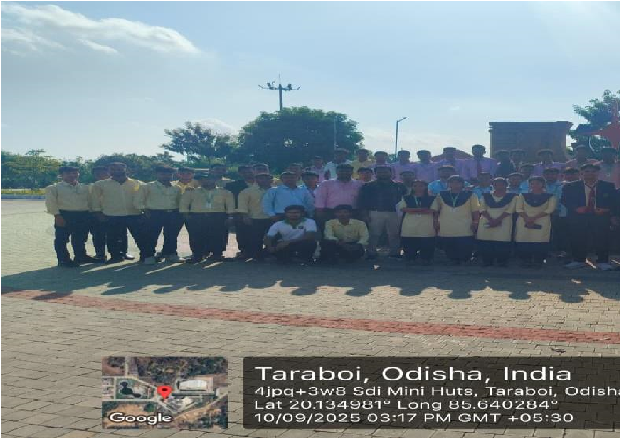 | 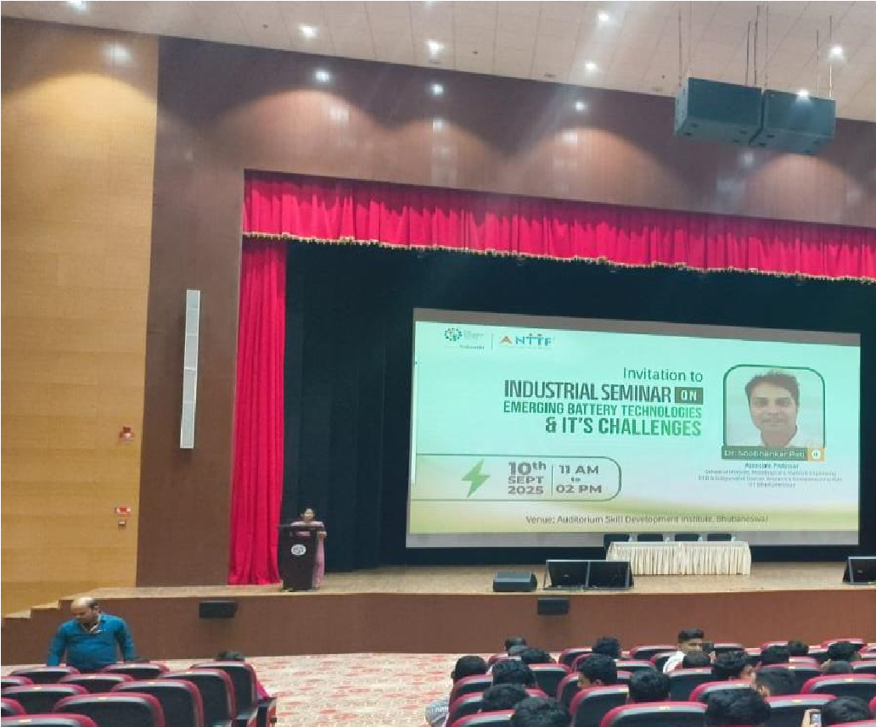
Students attending one day seminar on emerging battery technologies at SDI,TARABOI | Industrial Seminar on emerging battery & IT Challengers.
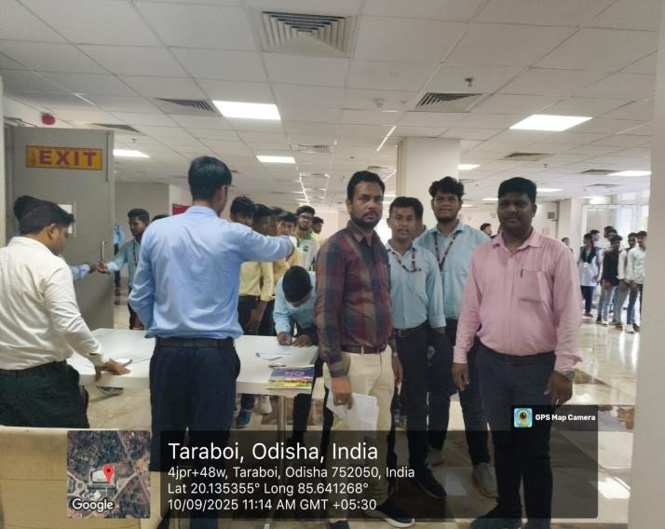 | 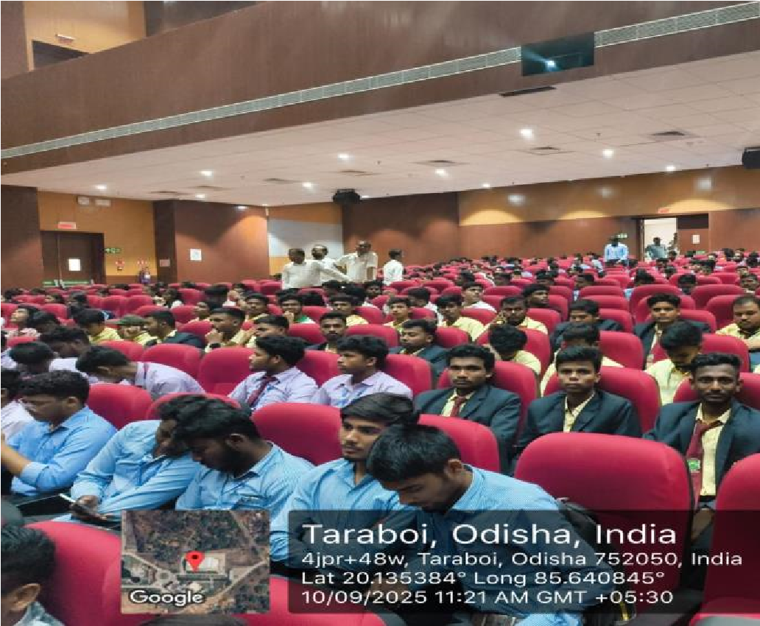
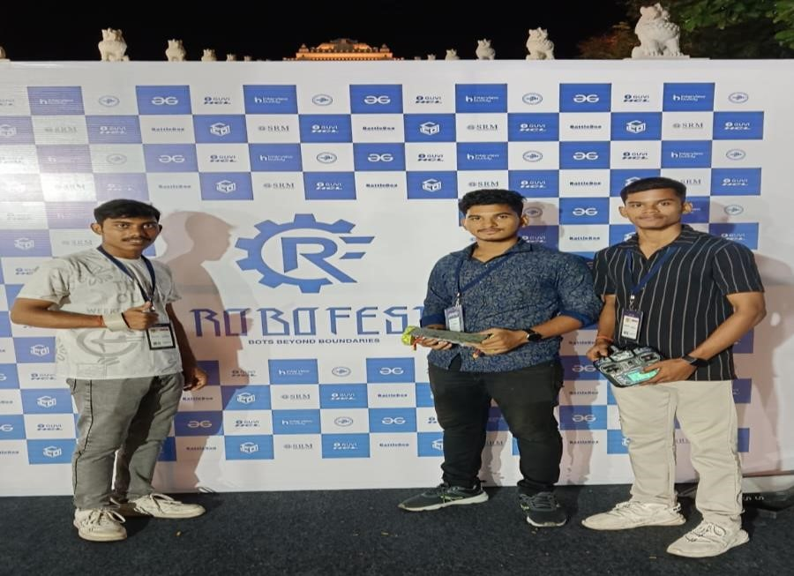 | 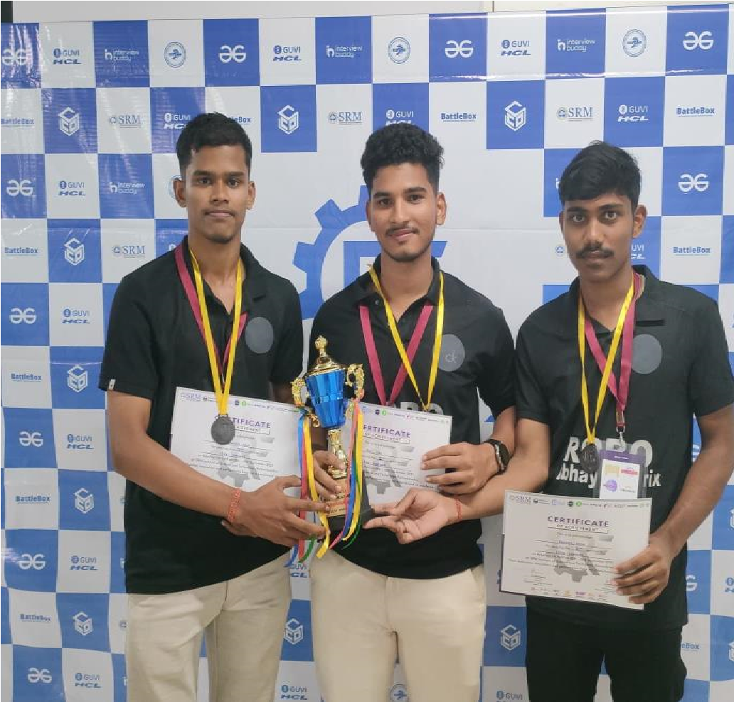

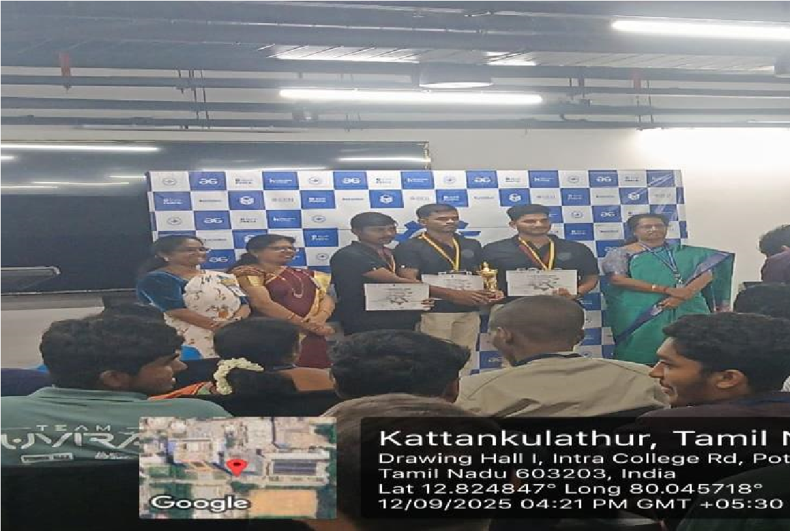 | 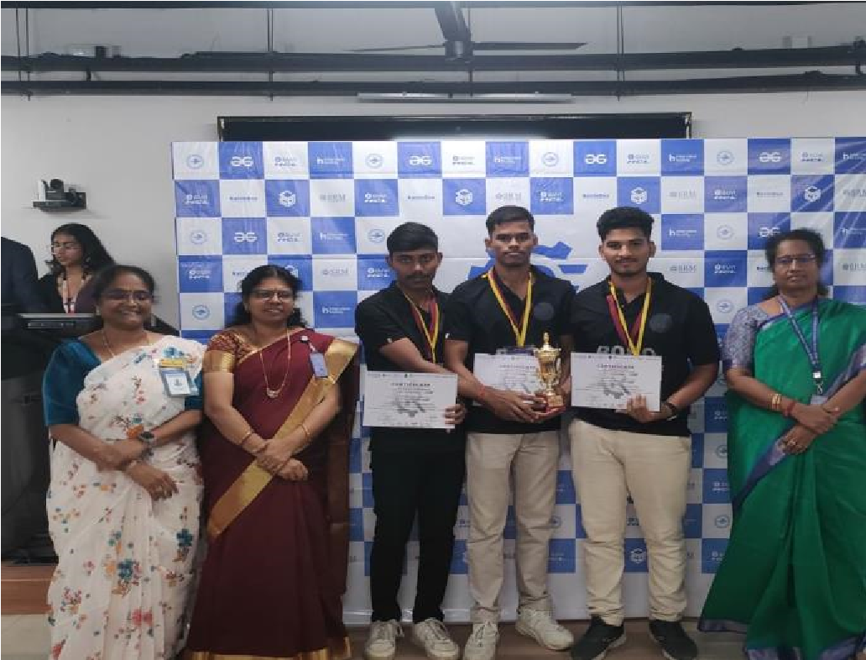
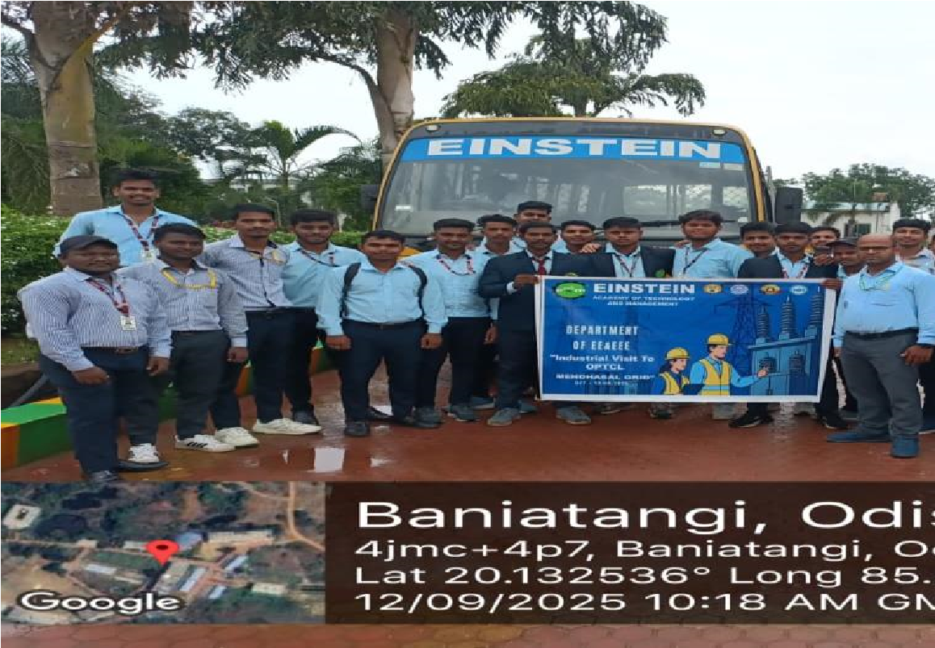 | 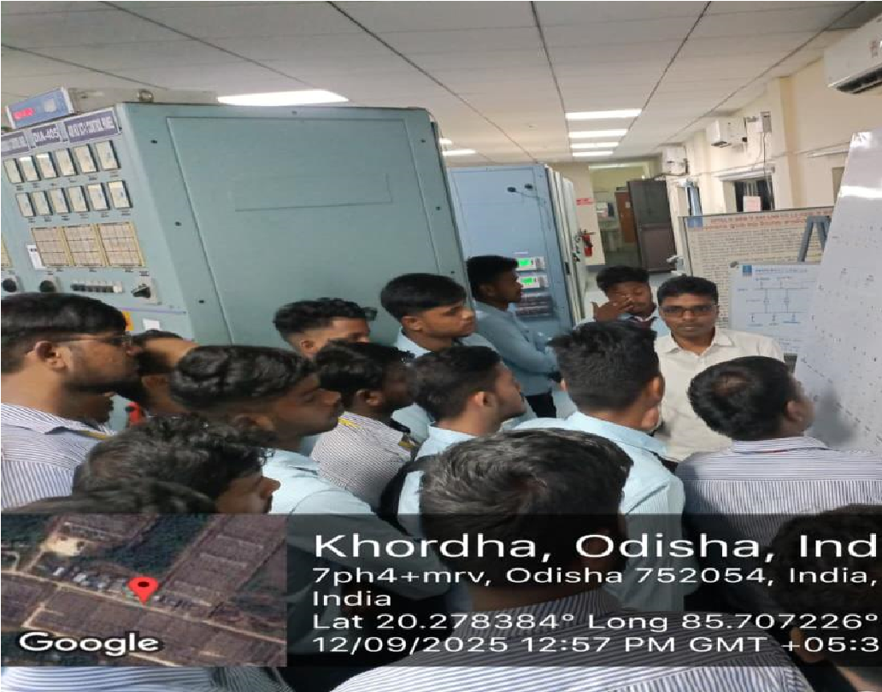
Industrial Visit to OPTCL(400KV) Grid, Mendhasala by EE and EEE Department.  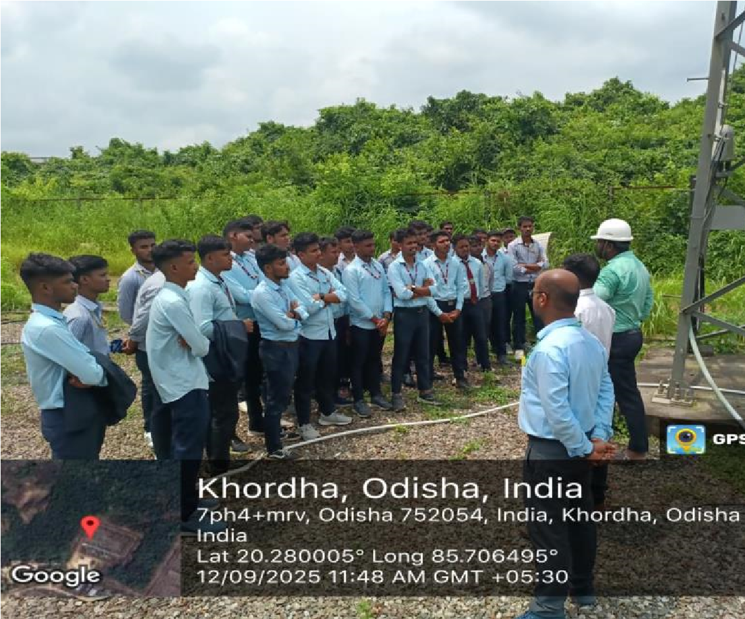 | Students are at Electrical Machine Lab.  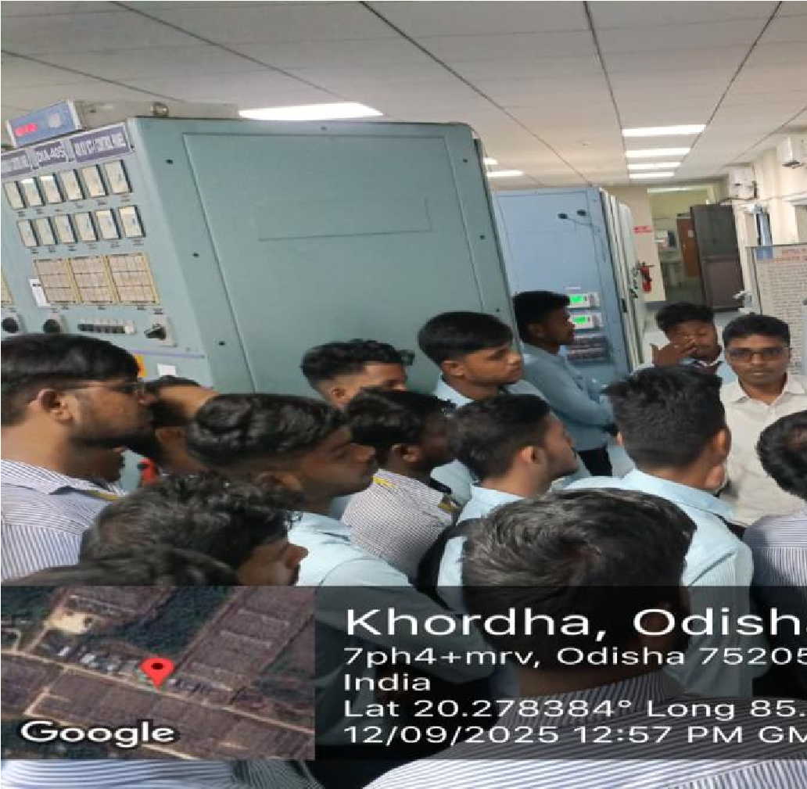

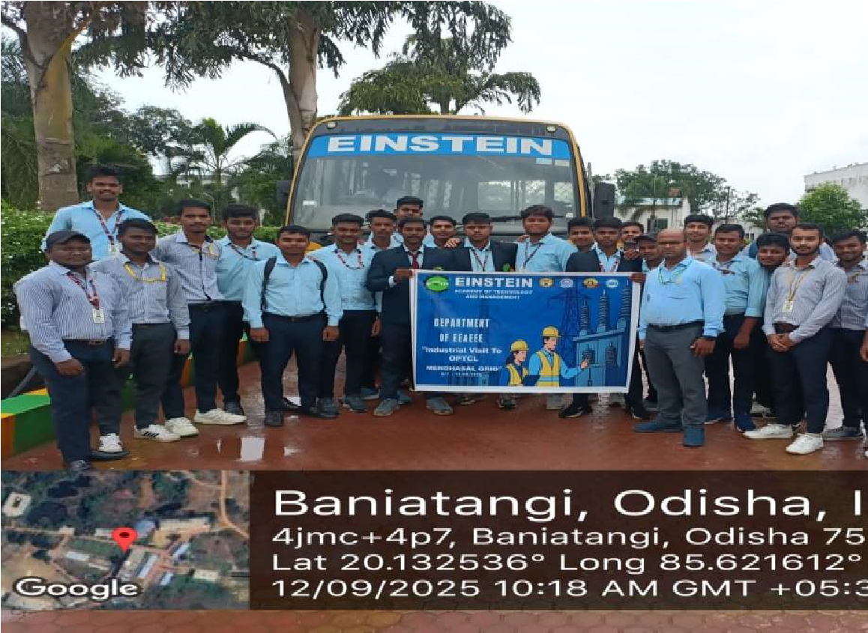 | 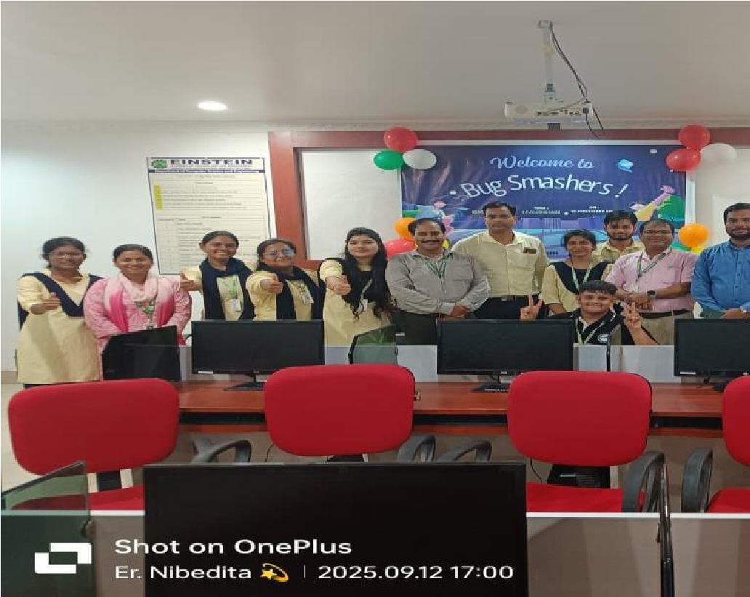
Electrical department Prepare to go Industrial visit to Mendhasala | The Department of CSE proudly inaugurates the Coding Club – “Bug Smashers”.
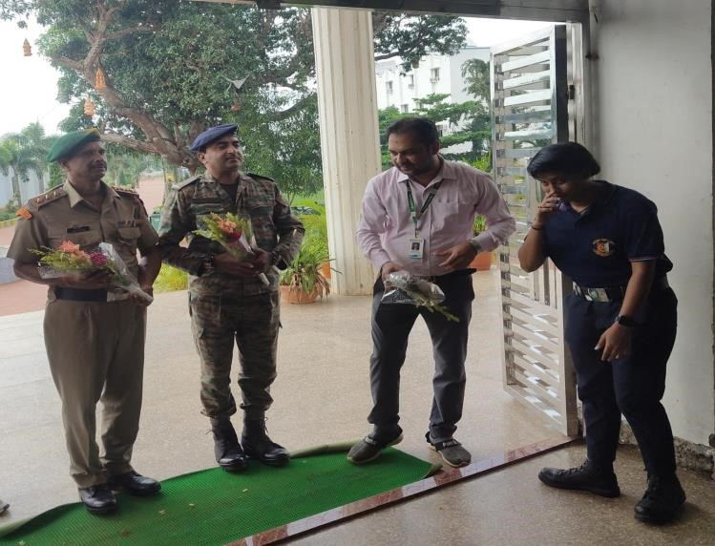 | 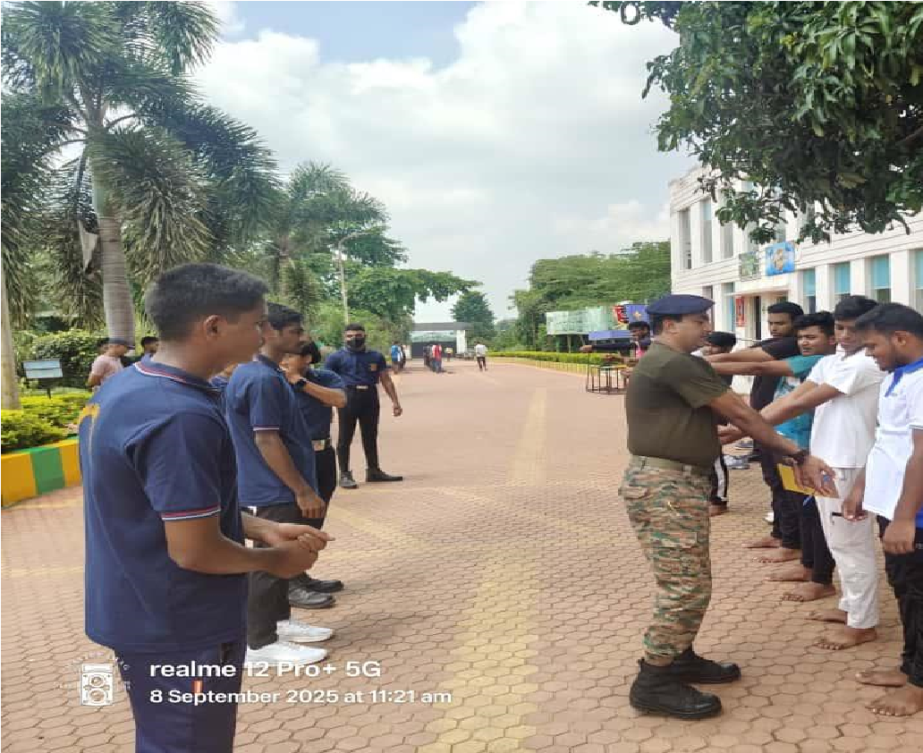
NCC Enrollment for Diploma and B –Tech Organized on EATM campus. | Students are Practice NCC
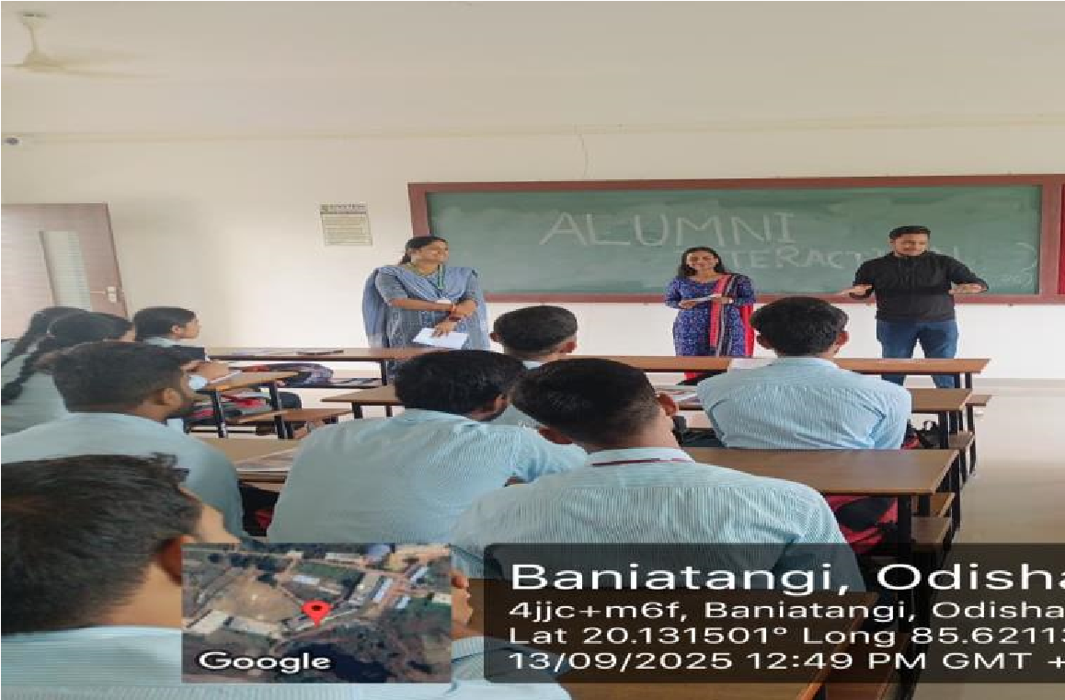 | 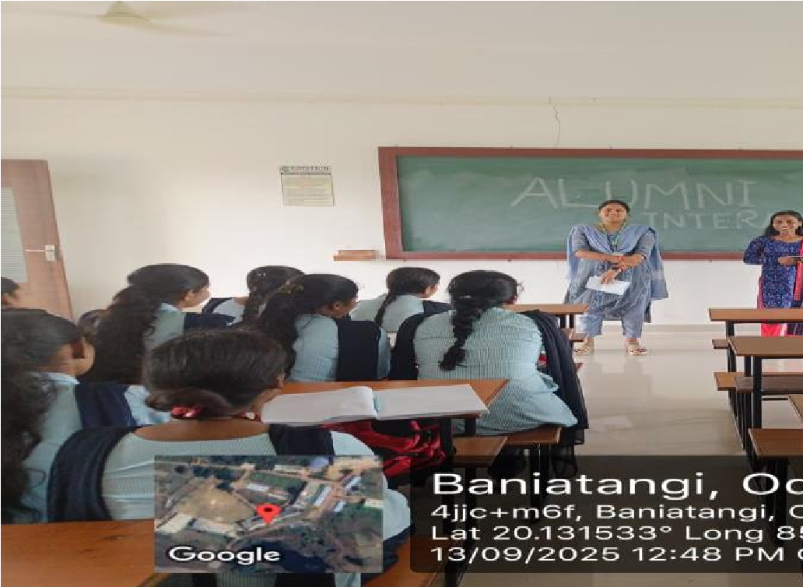
Alumni Interaction with Students | Interaction with students

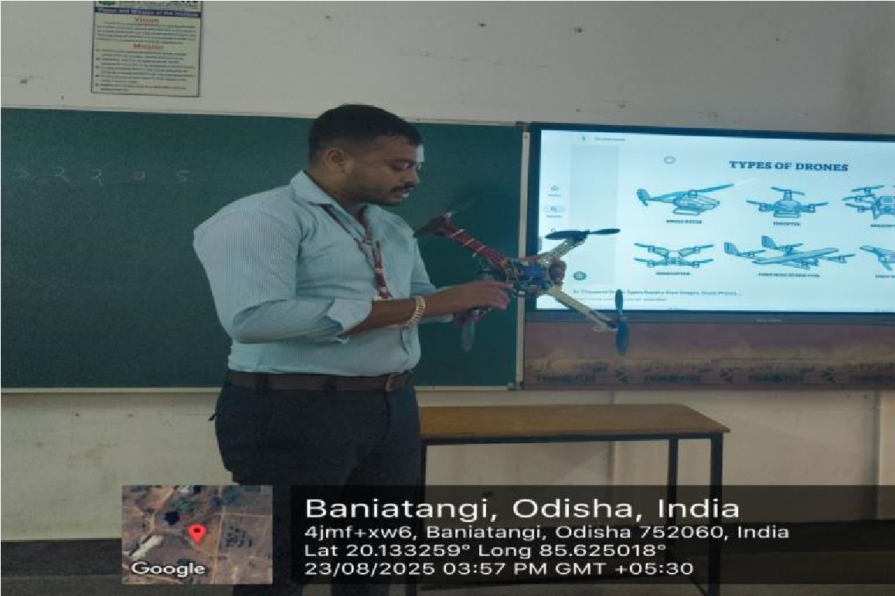 | 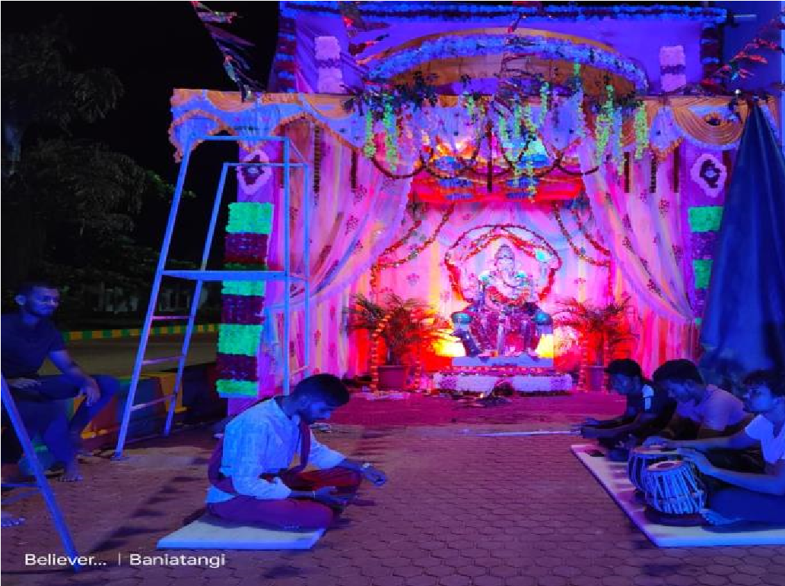
Robotics Technical session organized by old students for new students of Robo club. | Ganesh Chaturthi Celebratio at EATM
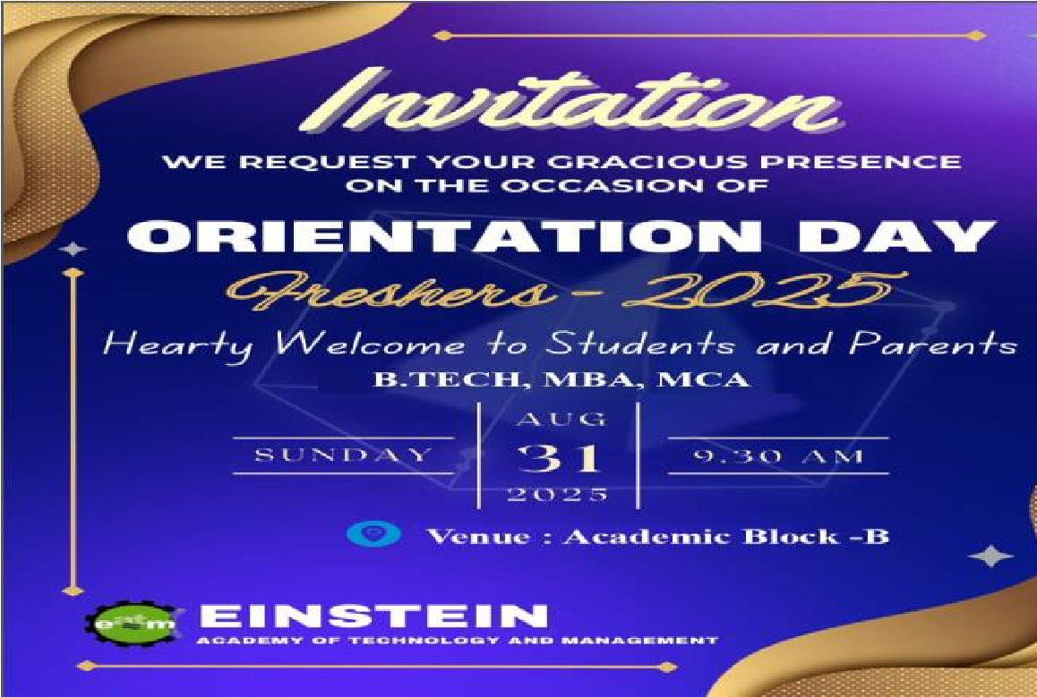 | 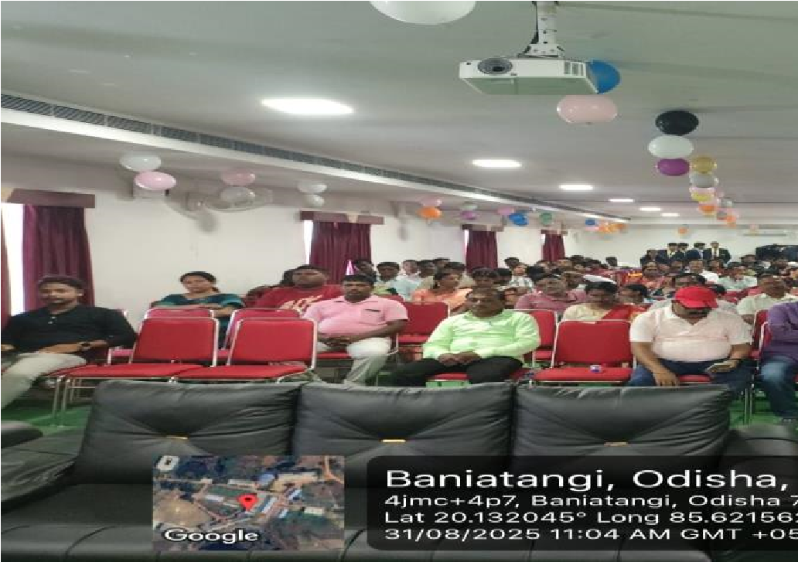
Orientation Program Organized for Newly join students. | Orientation for New Join Students
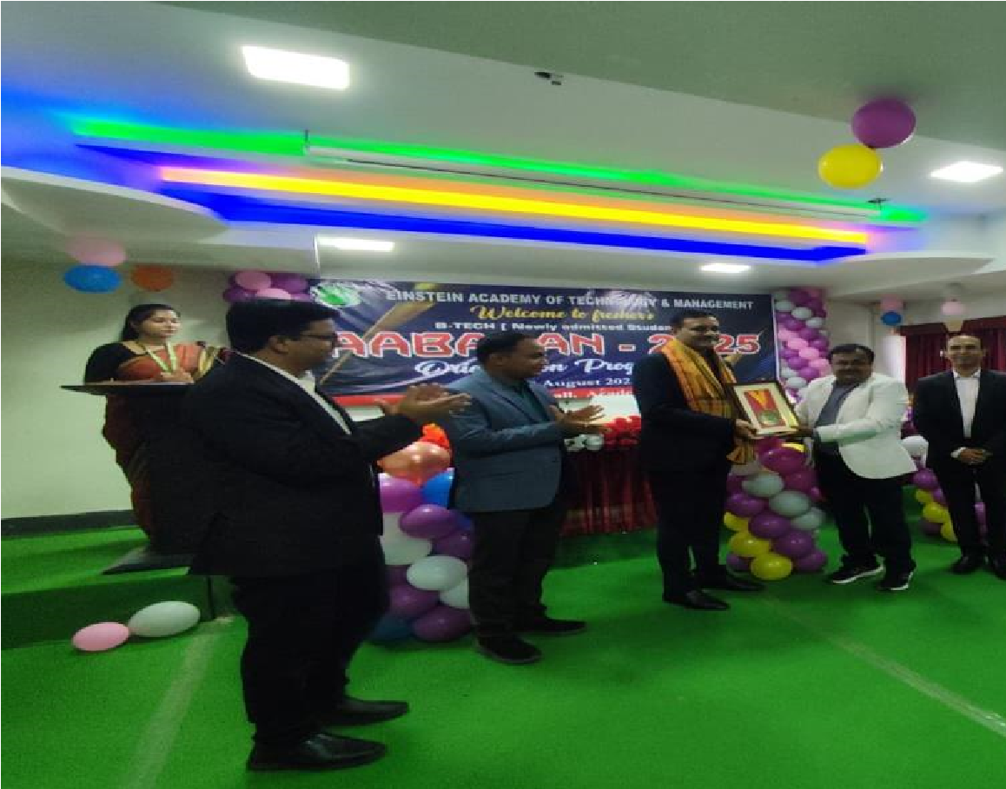 | 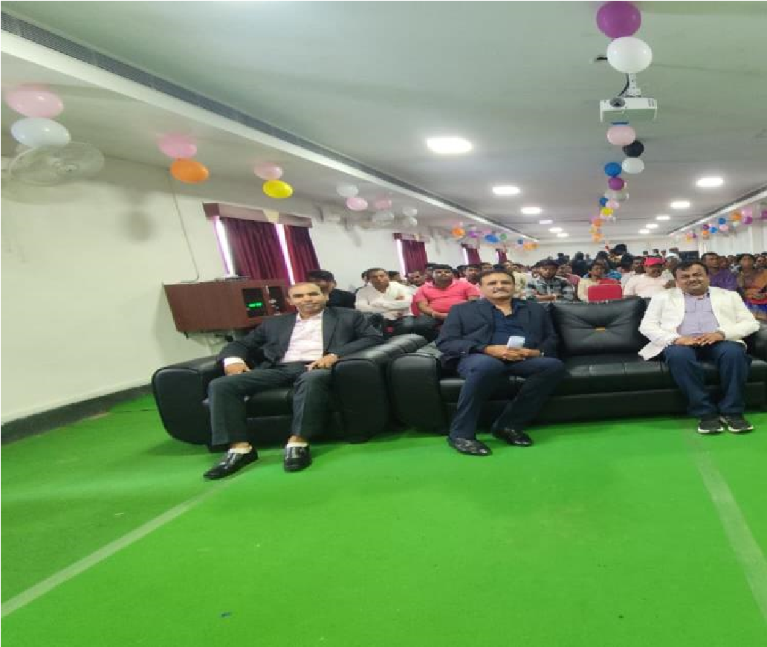
Aabahan - 2025 | For B Tech Newly Admitted students

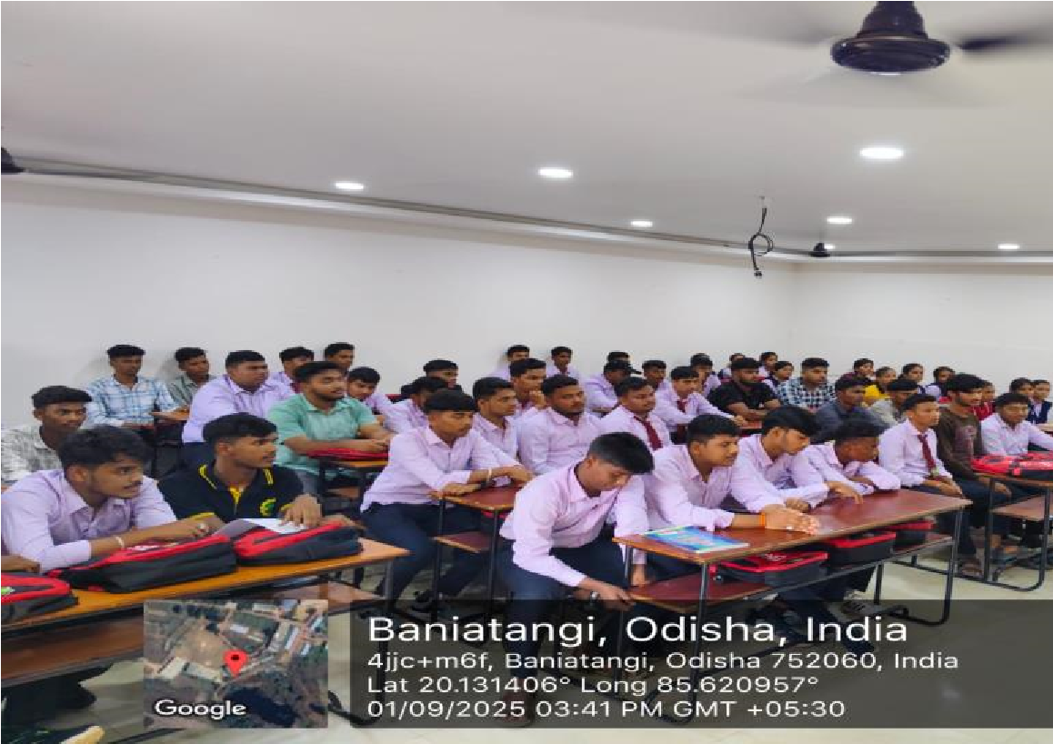 | 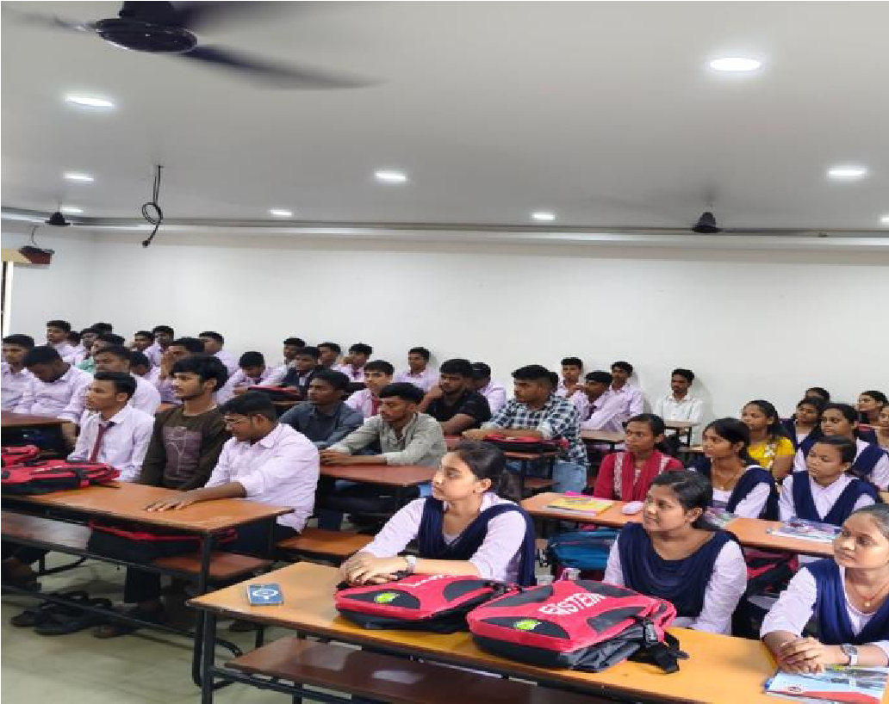
Induction Program Organized for Newly join students | Induction Program
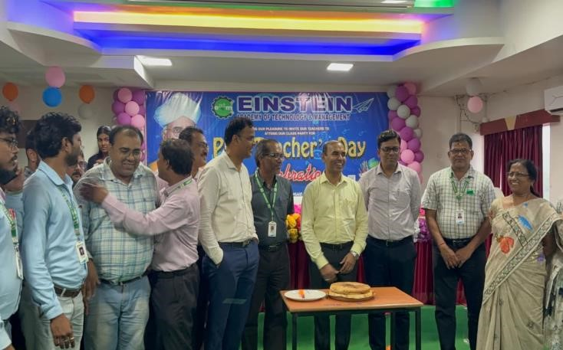 | 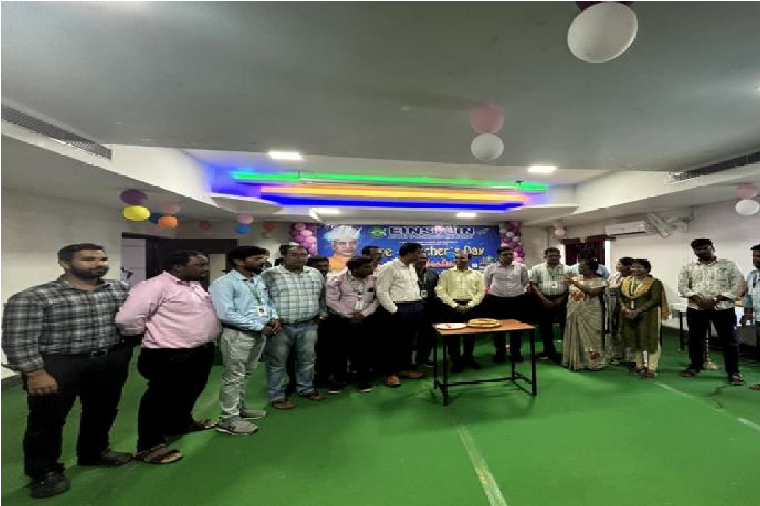
Teacher’s day Celebration in EATM | Teacher’s day Celebration
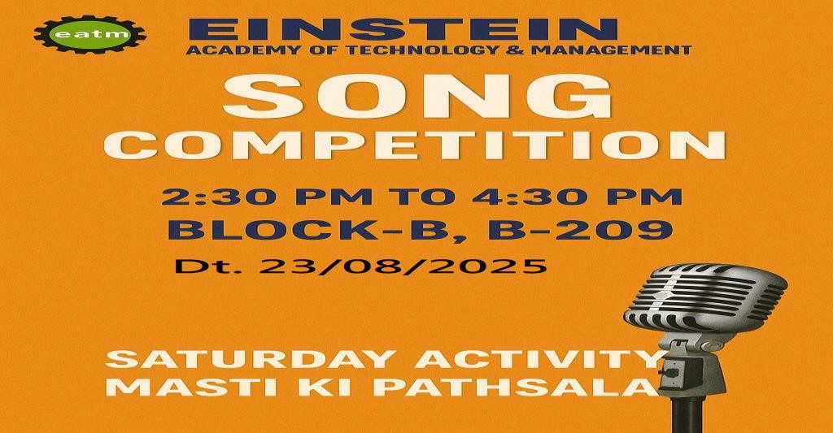 | 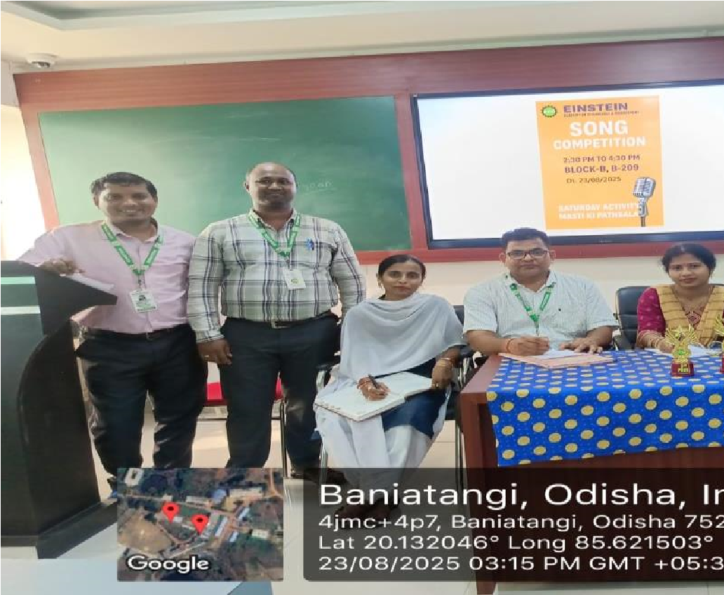
In view of MASTI KI PATSALA movement EATM cultural committee organized a SONG competition for students. | In view of MASTIKI PATSALA

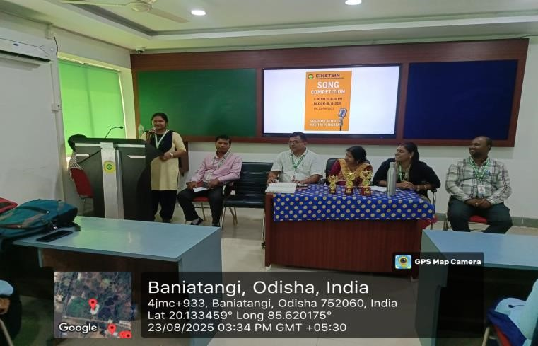 | 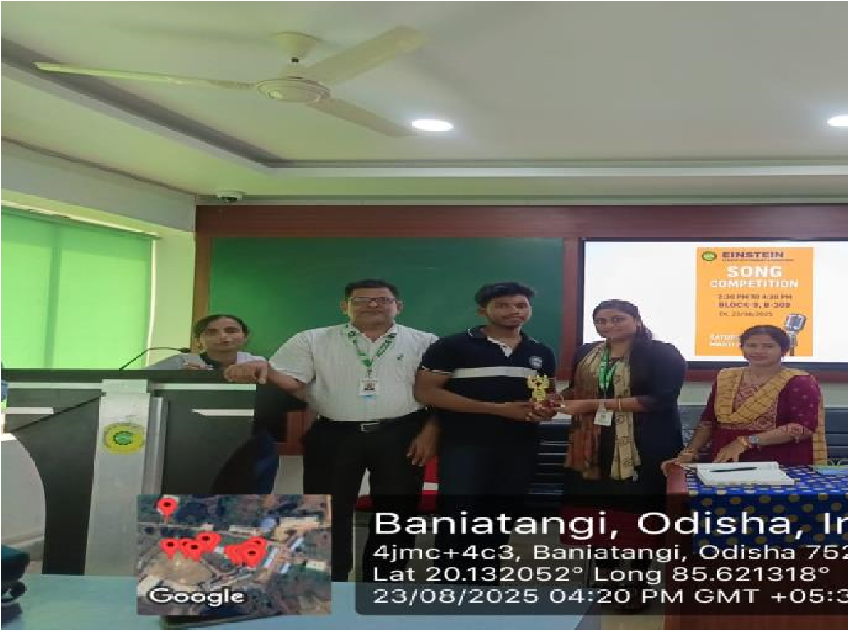
Song Competition | Song Competion
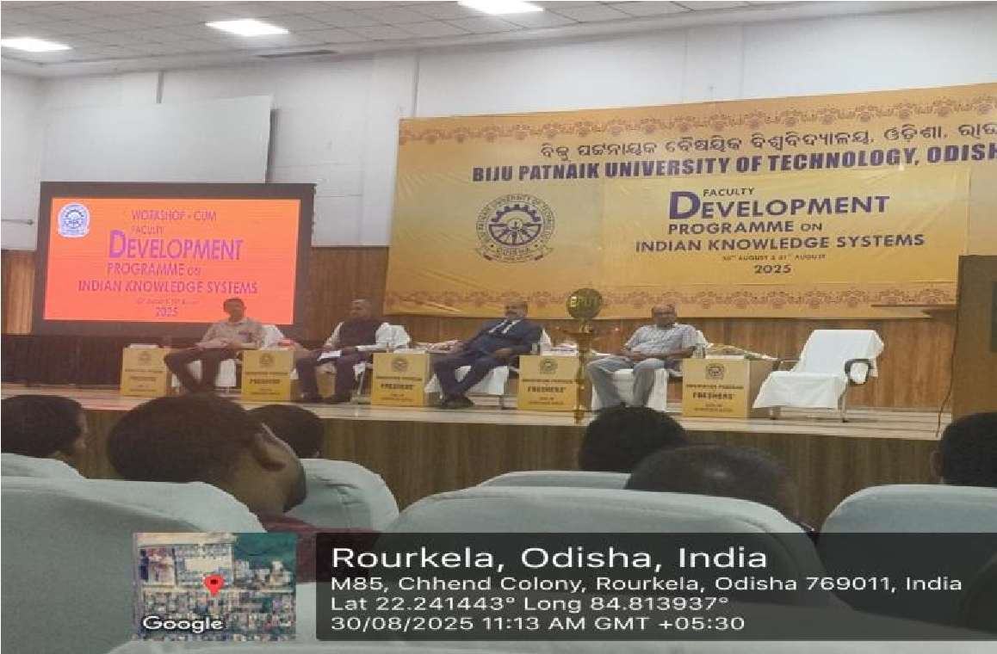 | 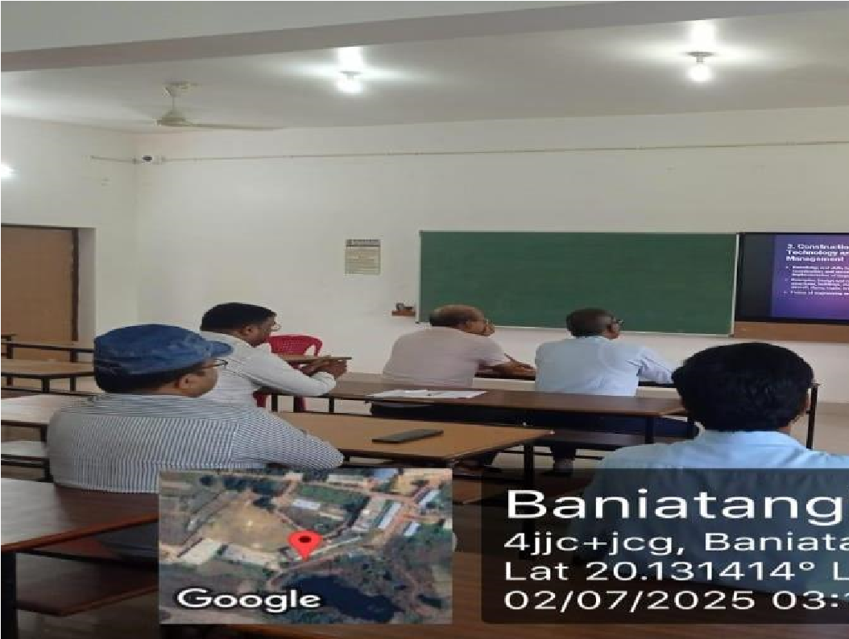
Attending FDP on INDIAN KNOWLEDGE SYSTEMS by Satyajit Nayak in BPUT, ROURKELA | Faculty Orientation Program For  “EffectiveTeaching Learning Strategies
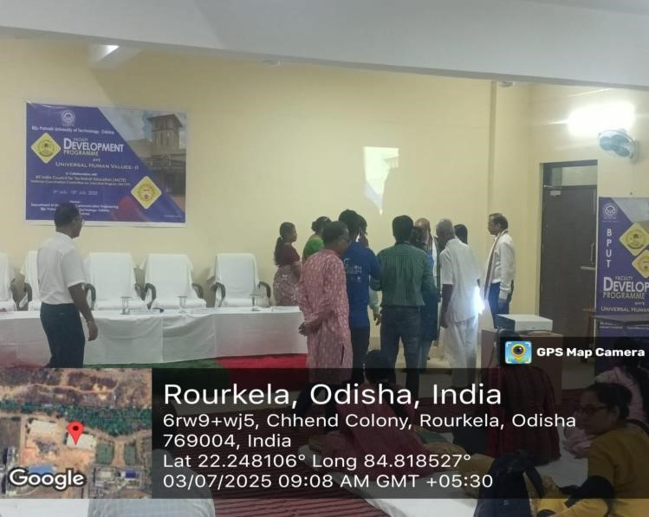 | 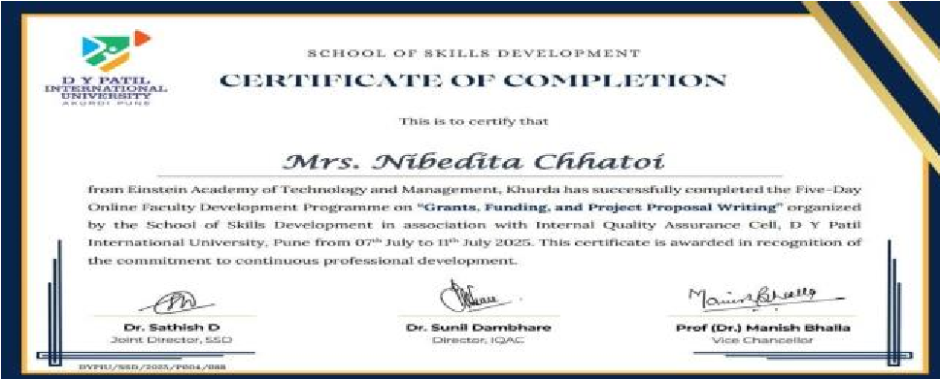  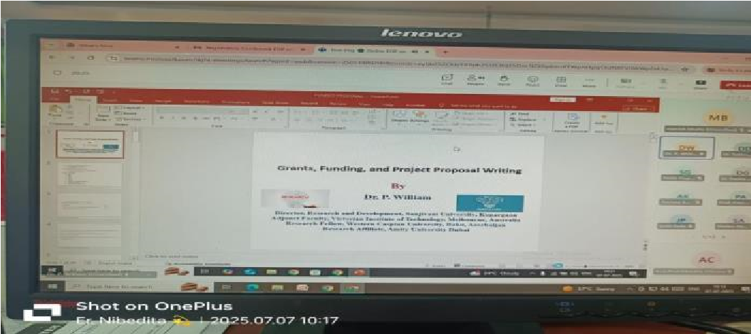

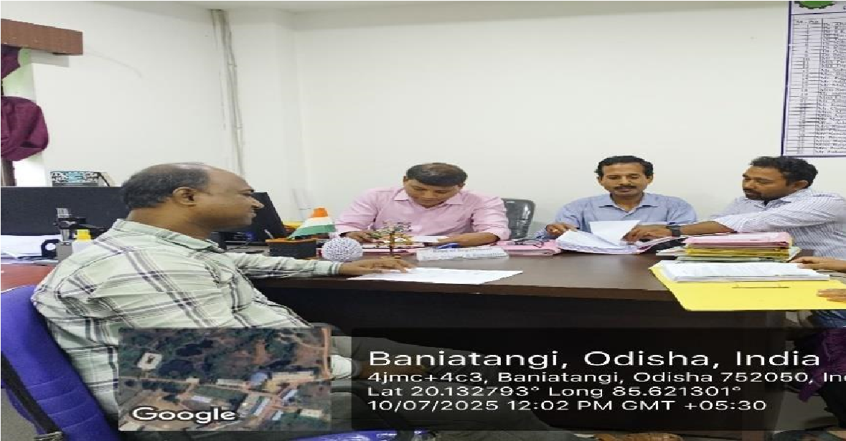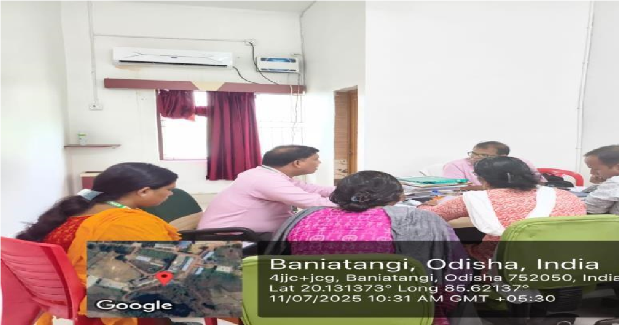  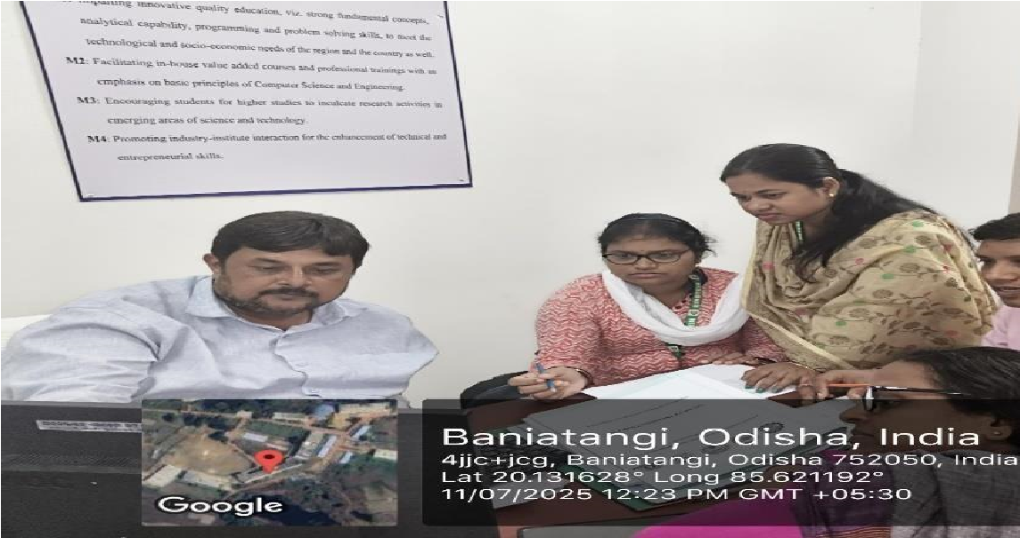  Faculty Development Programme On UNIVERSAL HUMAN  VALUES-II (UHV-II) At BPUT attended By Rajkishor Mahapatra | 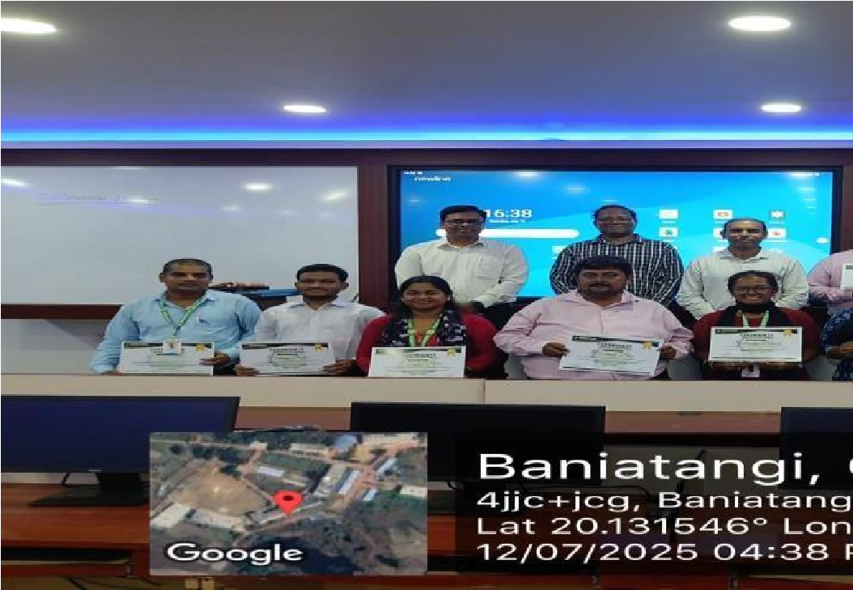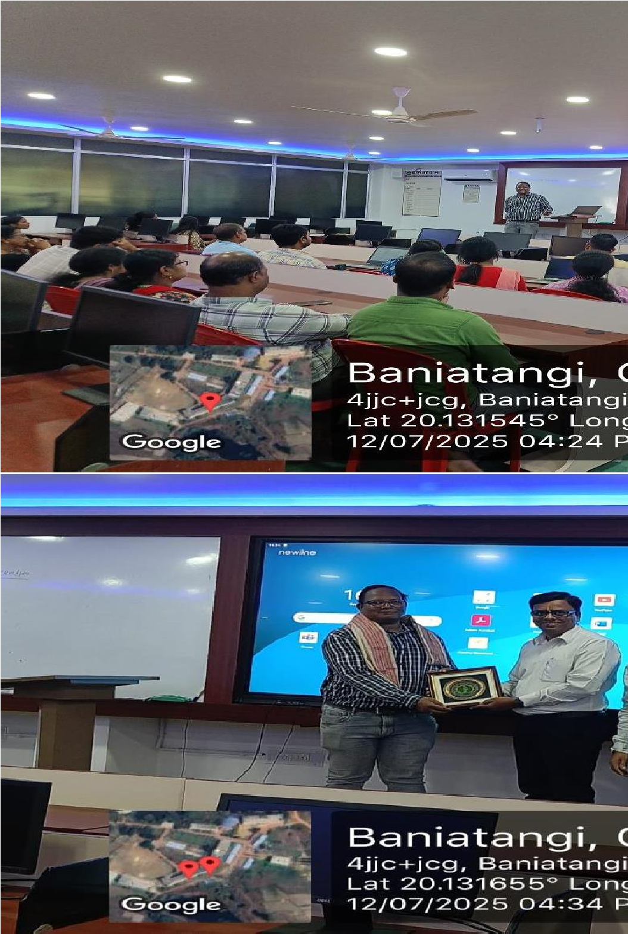  FDP on Grants, Funding & Project Proposal  Writing Certificate from D Y PATIL  INTERNATIONAL UNIVERSITY Attended by  Nibedita Chhatoi
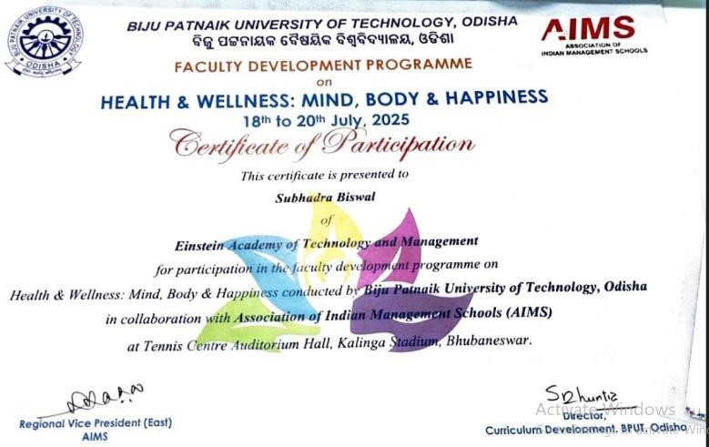 | 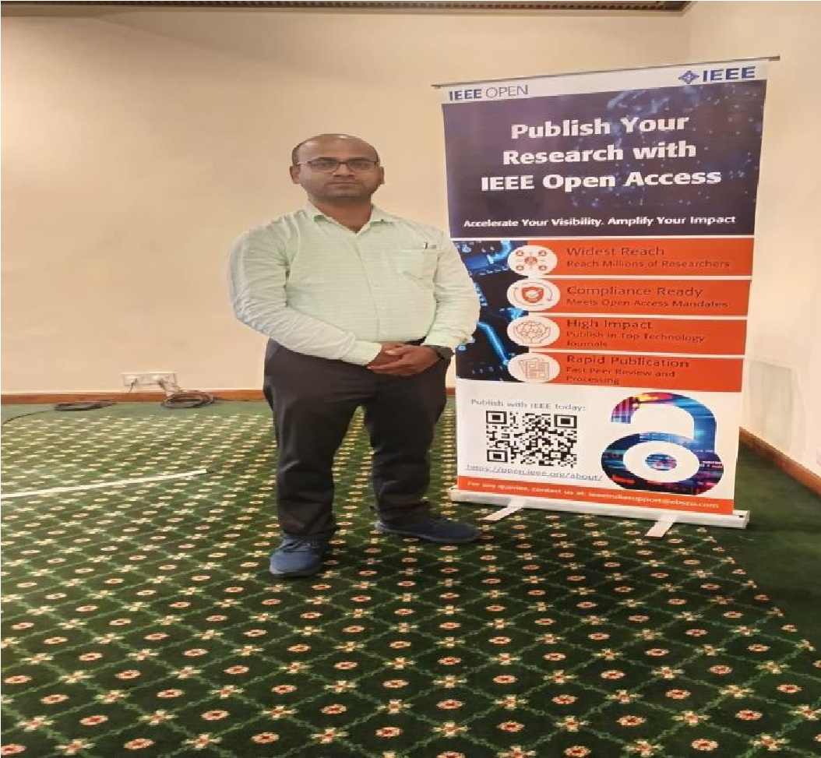
Attending FDP at Kalinga Stadium (Tennis Centre) On Health & Wellness:  Mind, Body & Happiness attended by  Subhadra Biswal | Partition Certificate In The Event  "Transforming The Future Of  Research With IEEE" By Bijaya  Kumar Mahapatra
 | 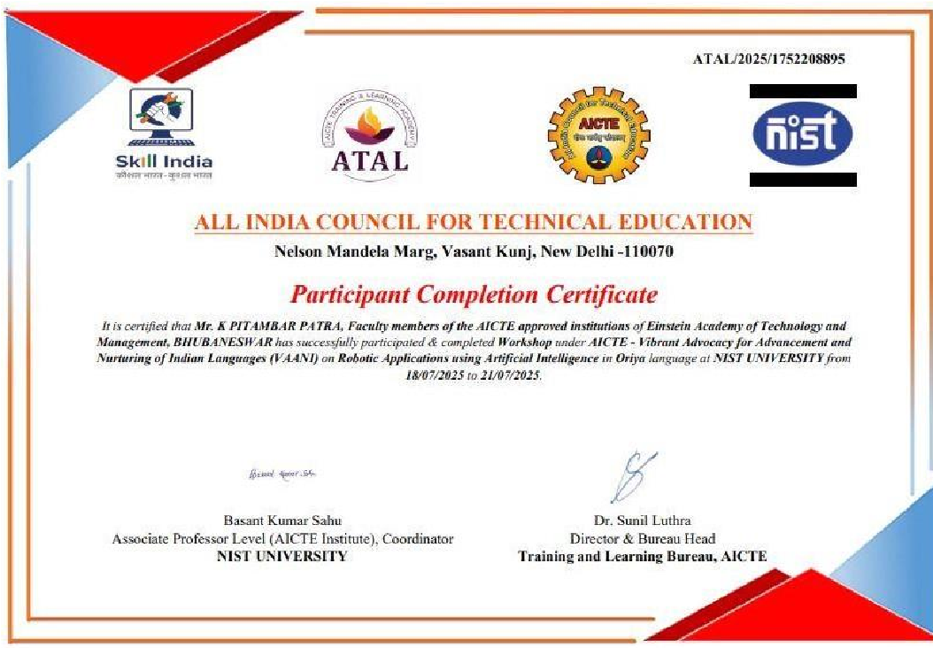
Attending FDP at Kalinga Stadium (Tennis  Centre) On Health & Wellness: Mind, Body &  Happiness attended by Subhadra Biswal | Work shop under (VAANI) at NIST University Attended By K.Pitamber Patra And Simita Rani Pradhan.

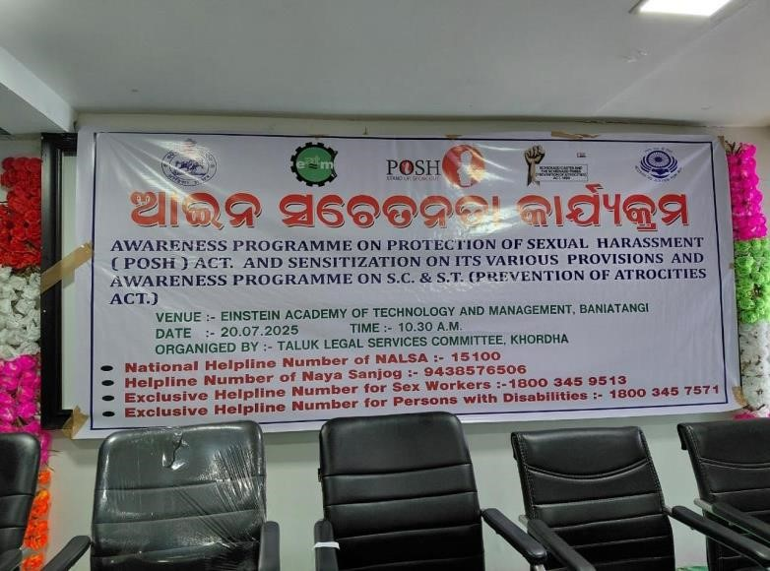  Awareness Programme on Protection of Sexual  Harassment (POSH) Act & Sensitization on its various provisions and Awareness programme on S.C &  S.T(Prevention of Atrocities Act.) | 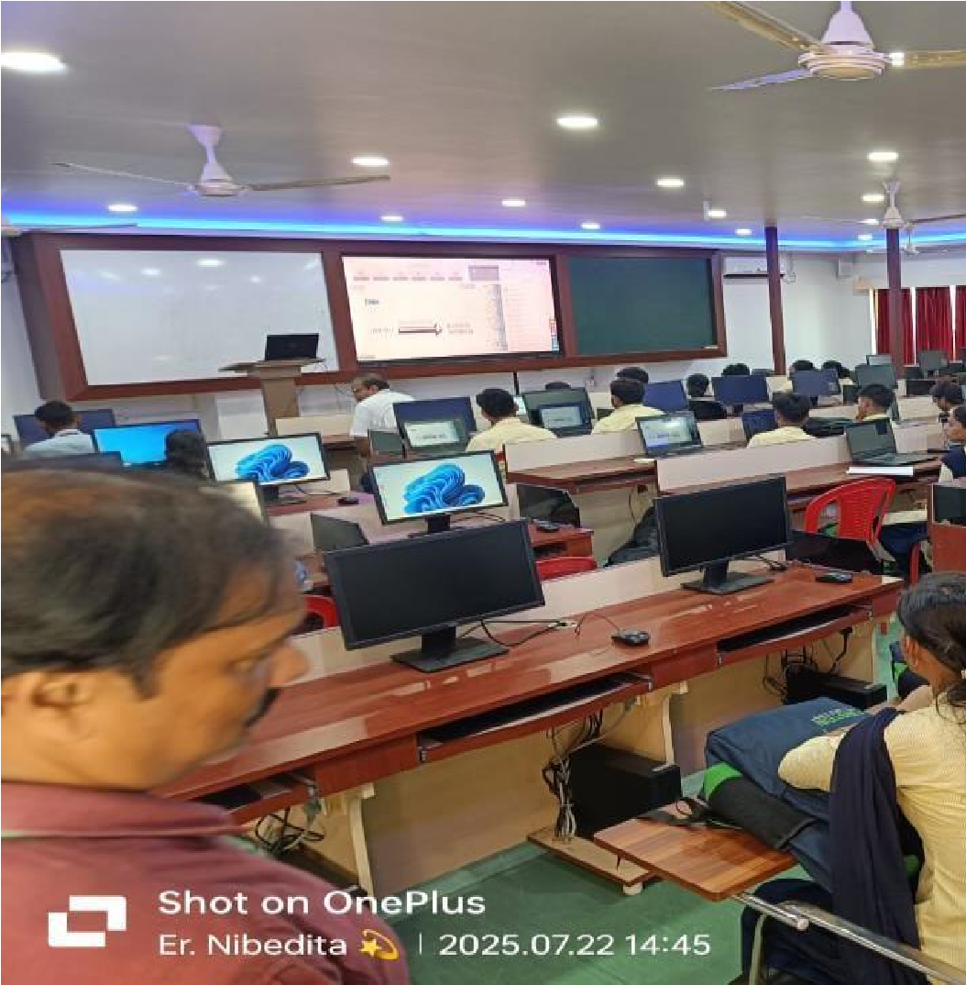
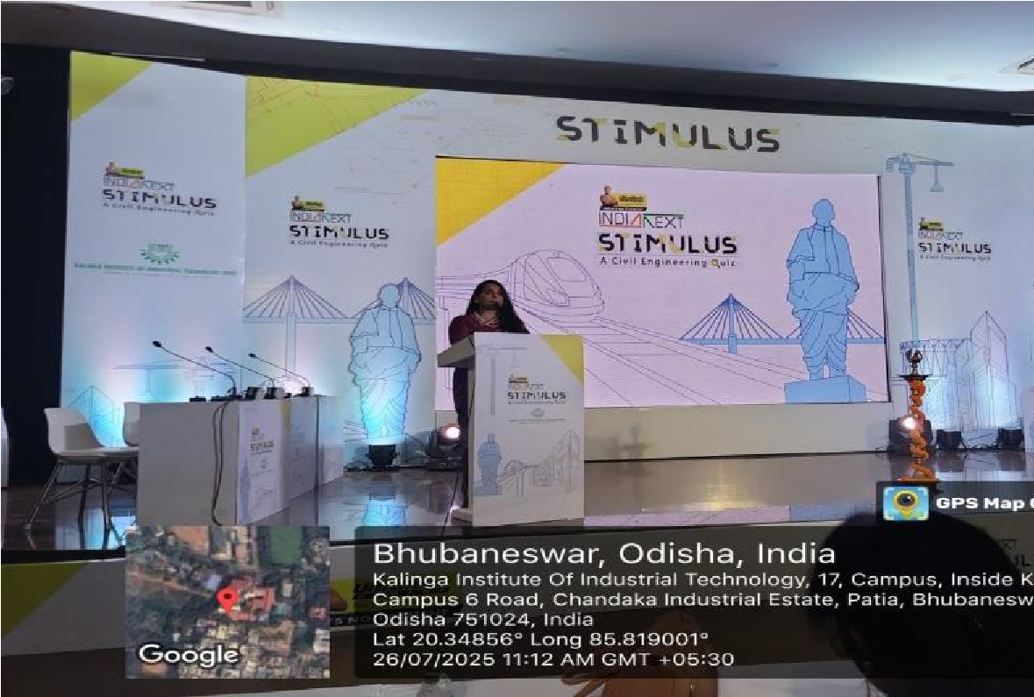  Civil students attending the programme “UltraTech India Next  Stimulus” at KIIT | 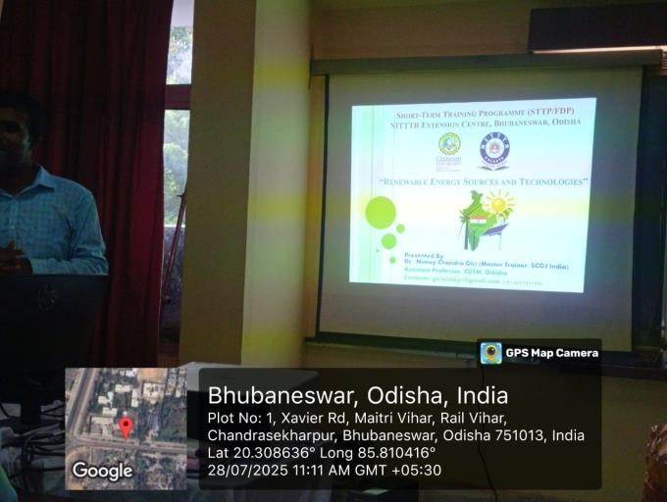  EE & EEE Student Attending STTP on RE, NITR at Bhubaneswar.
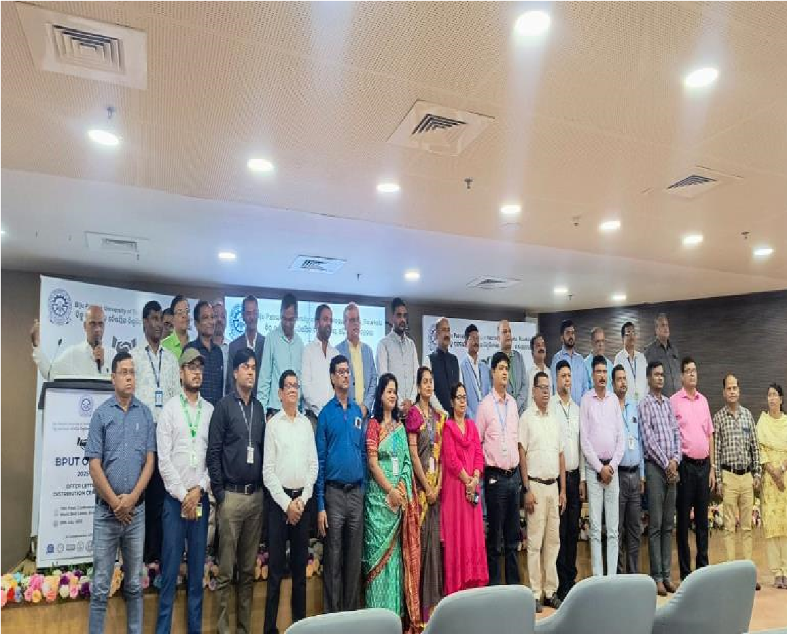 | 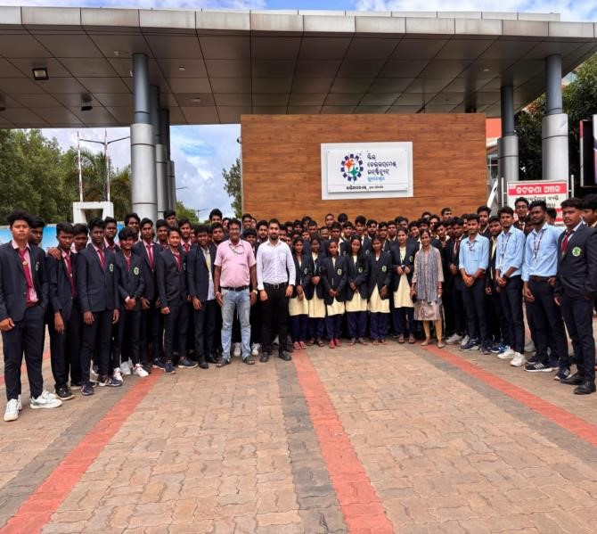
Mr Manish Purohit,T & P Participated for Bput O ojobz at world skill centre, BBSR | ECE, EE, EEE, MECHANICAL (B. TECH &DIPLOMA)  Students attending one-day seminar at Skill Development Institute, BBSR
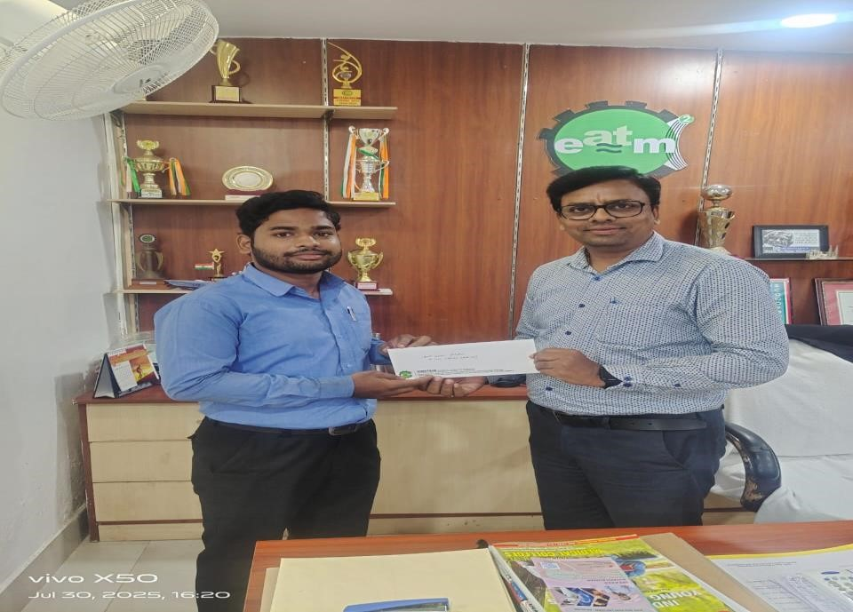 | 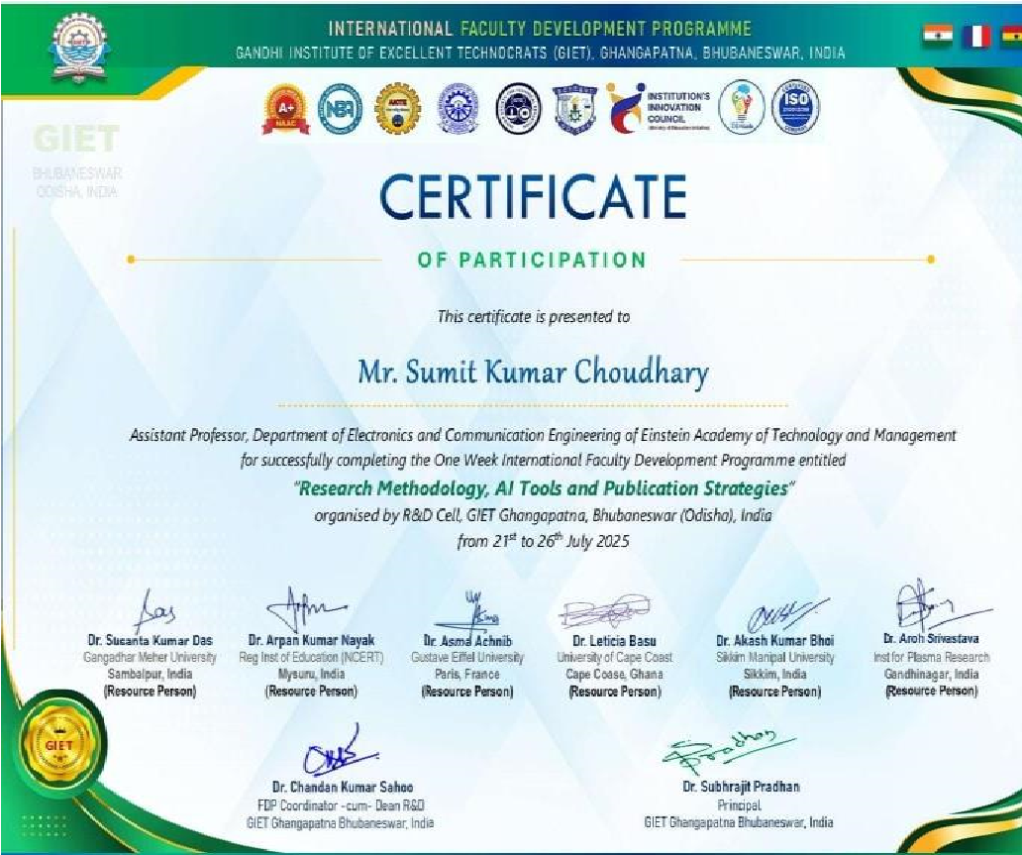
Distribution of offer letter of Jyoti Steel Industries Pvt Ltd to our two deserving candidate by Prinicipal sir. | Attending FDP ON Research Methodology, AI Tools and Publication Stratergies by K.Pitamber Patra, Sumit  Kumar Chaudhary and Dr. Tapas Ranjan Baitharu

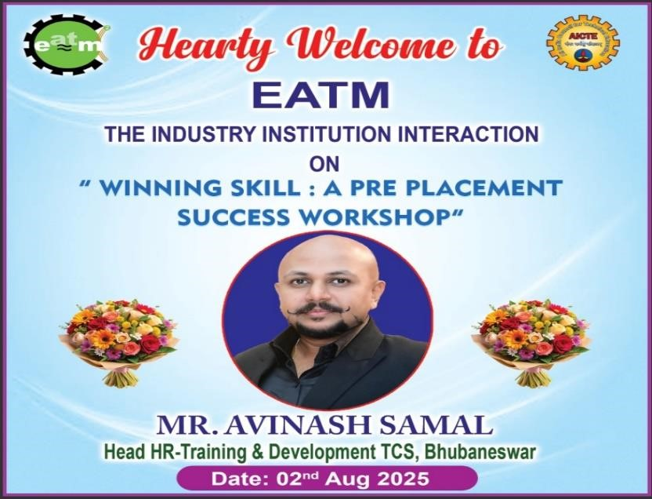 | 
The Industry Institution Interaction on Winning Skill: A Pre Placement Success Workshop by Mr. Avinash Samal,Head HR,TCS,BBSR. | Magic Puppet & Music show by the very popular magician of Odisha.
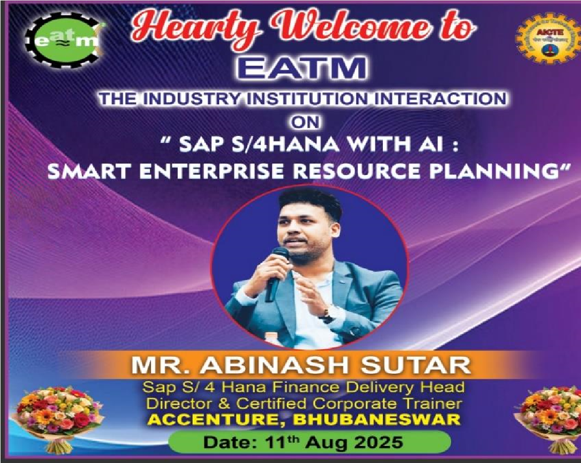 | 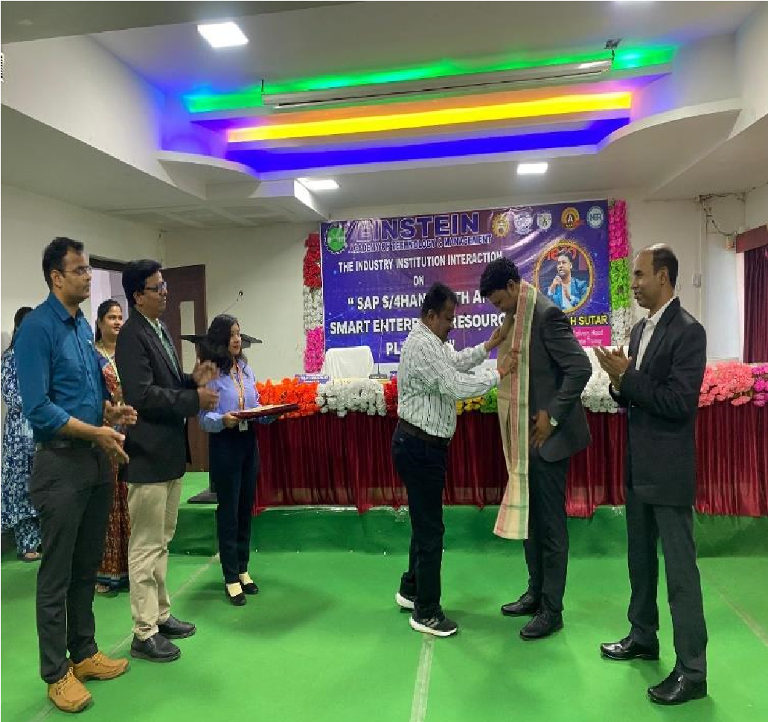
The Industry Institution Interaction on SAP S/4HANA with AI: Smart Enterprise Resource Planning by Mr. Abinash Sutar,  Director & Certified Corporate Trainer, ACCENTURE, BBSR. | The Industry Institute Interaction, Smart Enterprise Resources.
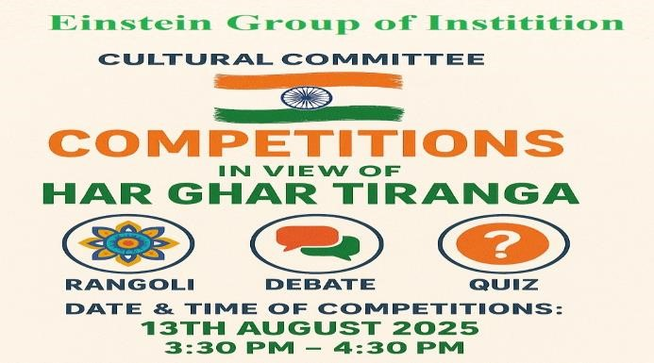 | 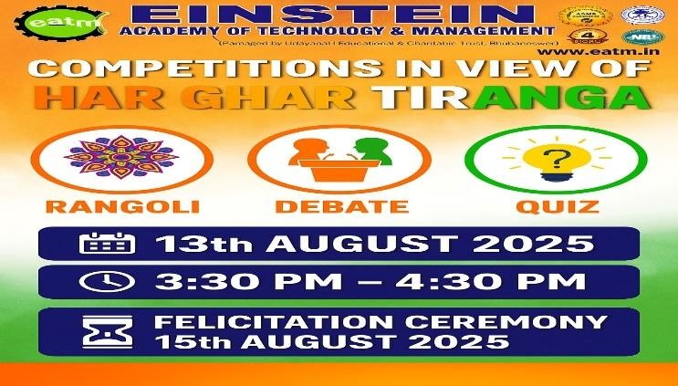
In view of HARGHAT Triranga EATM cultural committtee Organized Competition by Students. | COMPETITION IN VIEW OF HARGHAR “TRIRANGA”

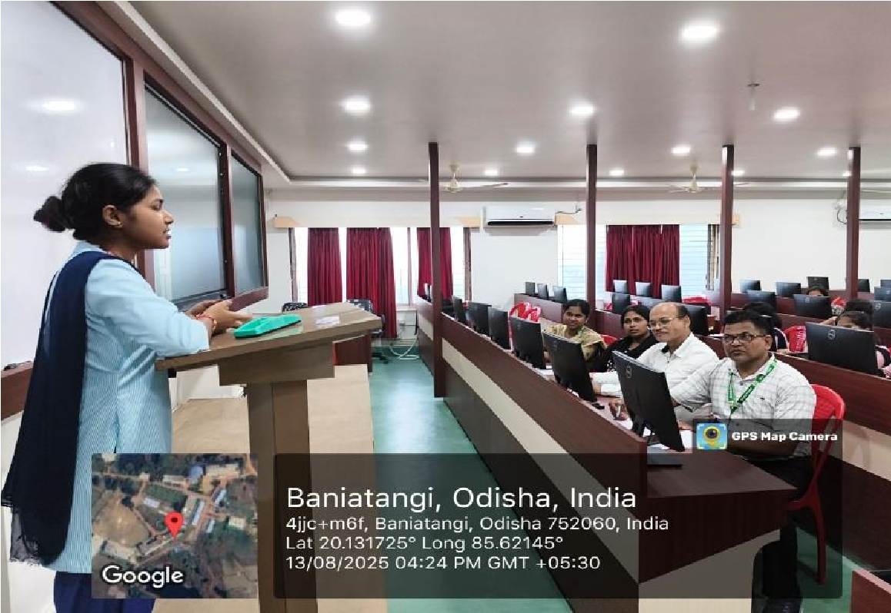 | 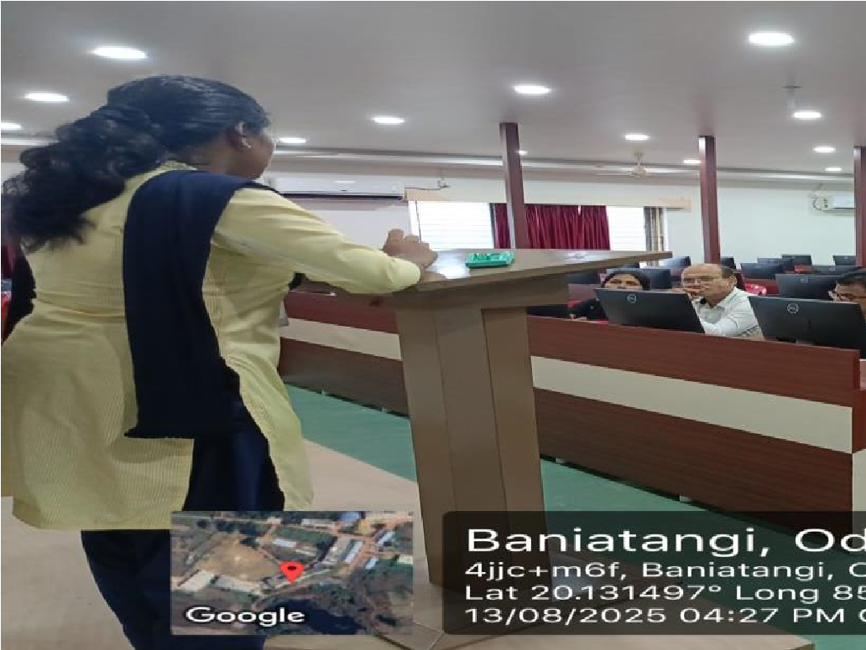
DEBATE COMPETITION | DEBATE COMPETITION
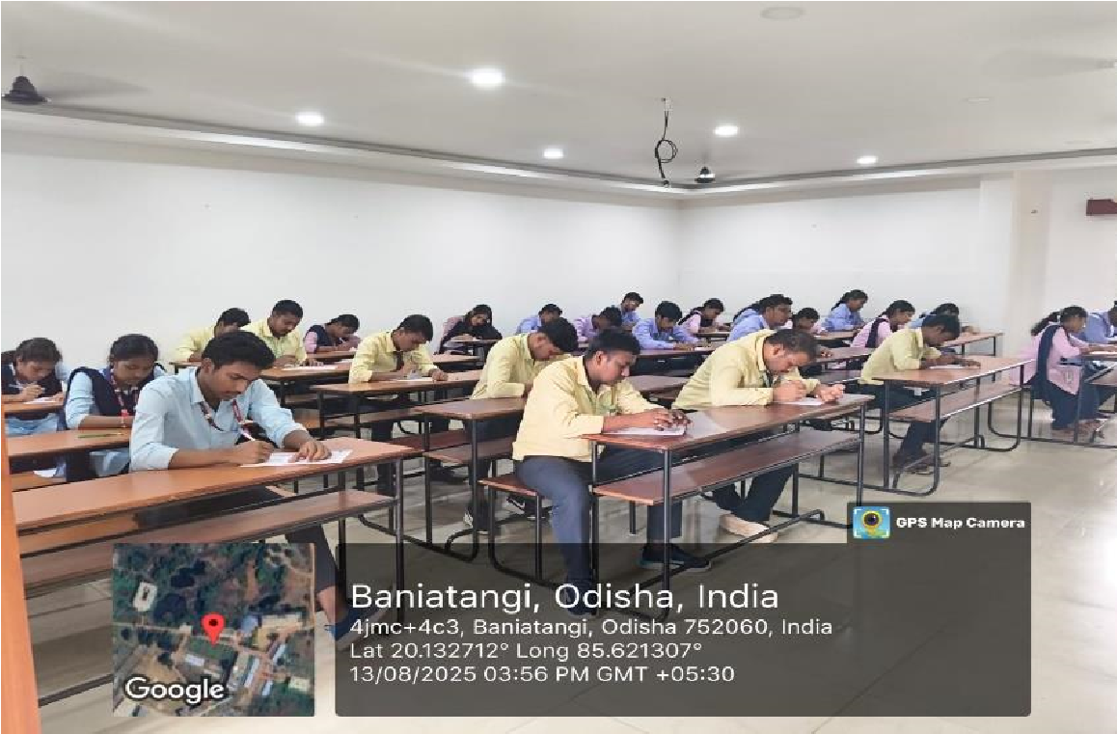 | 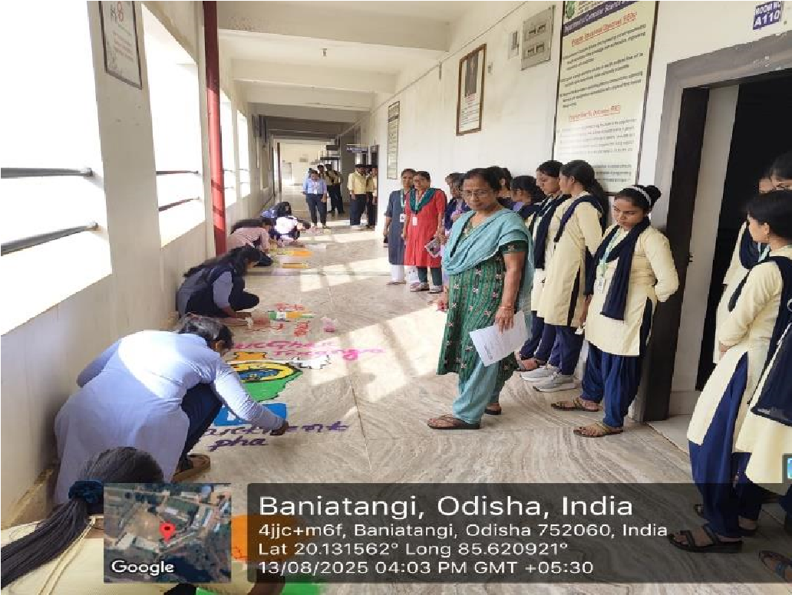
QUIZ COMPETITION | RANGOLI COMPETITION
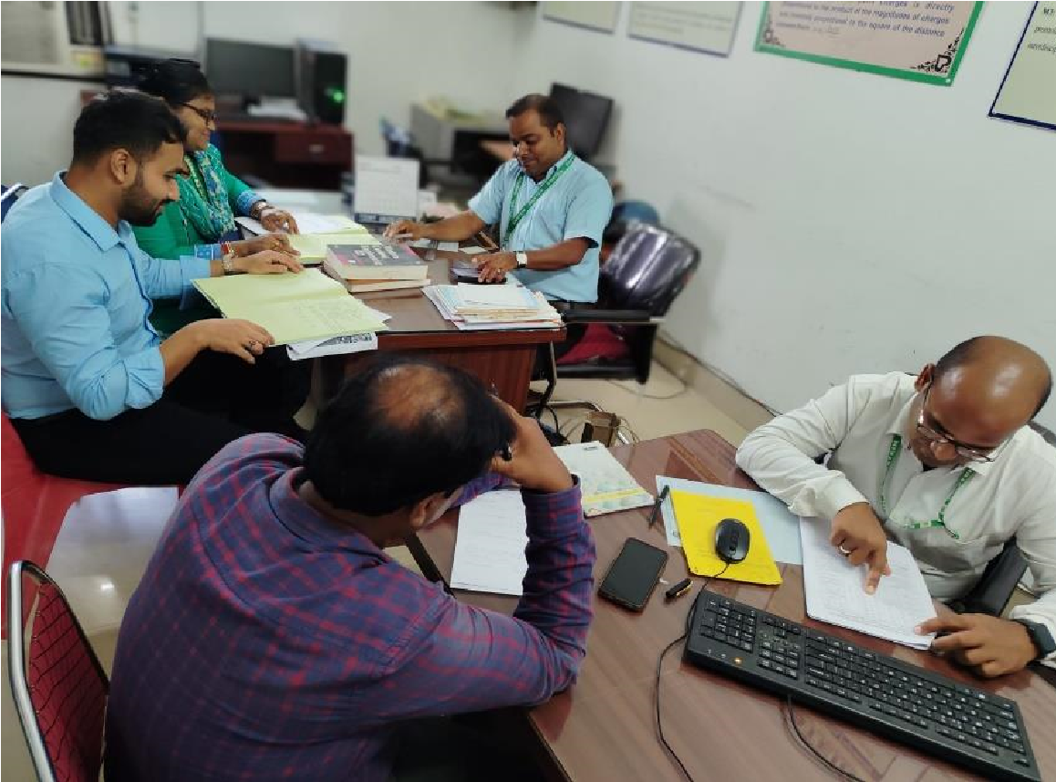 | 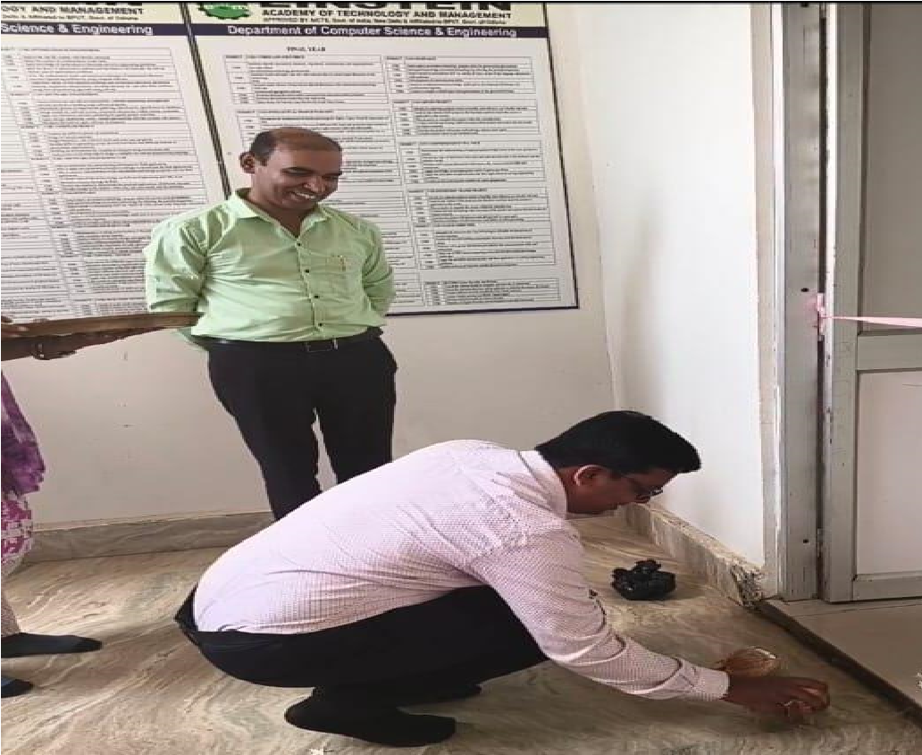
Inter-departmental Proctorial Audit | Inauguration of CSE Dept. Faculty Chamber

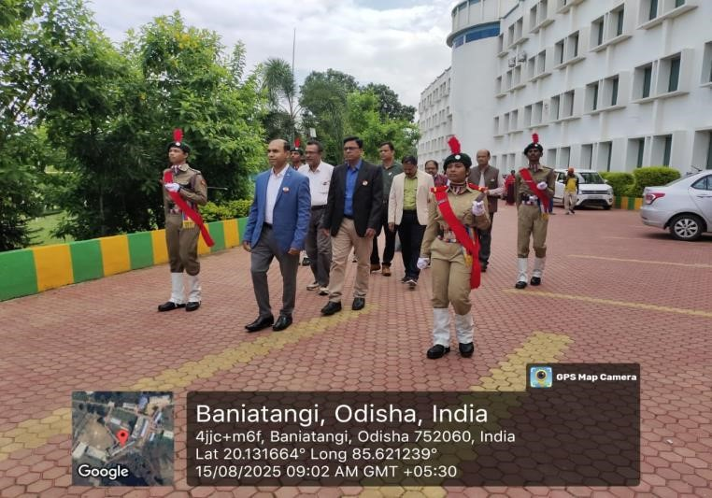 | 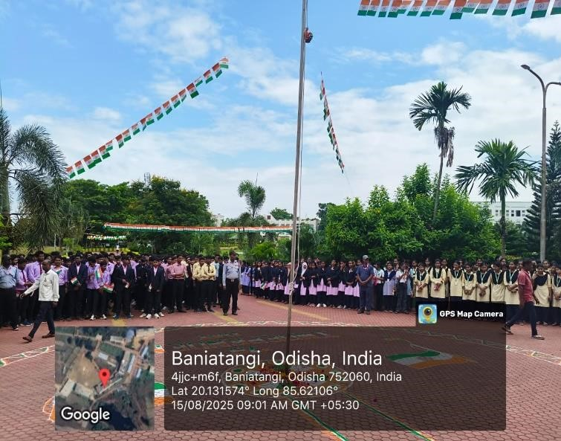
Independence Day Celebration | Independence Day Celebration
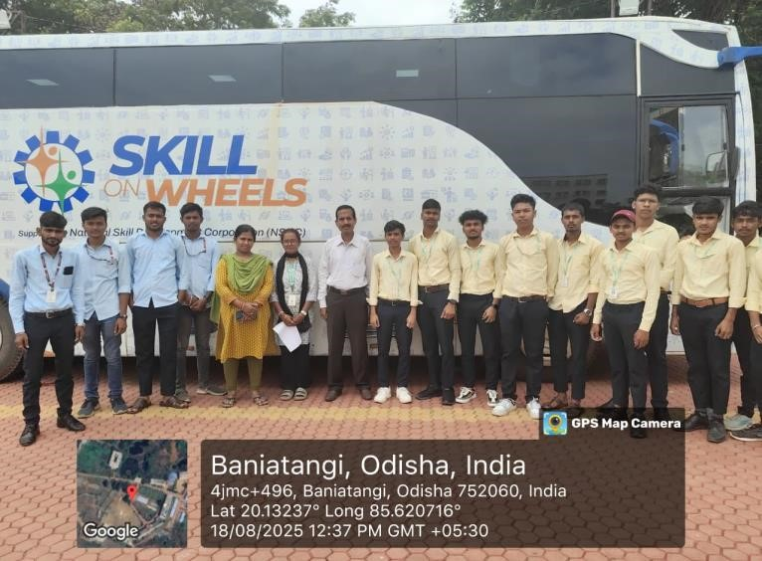 | 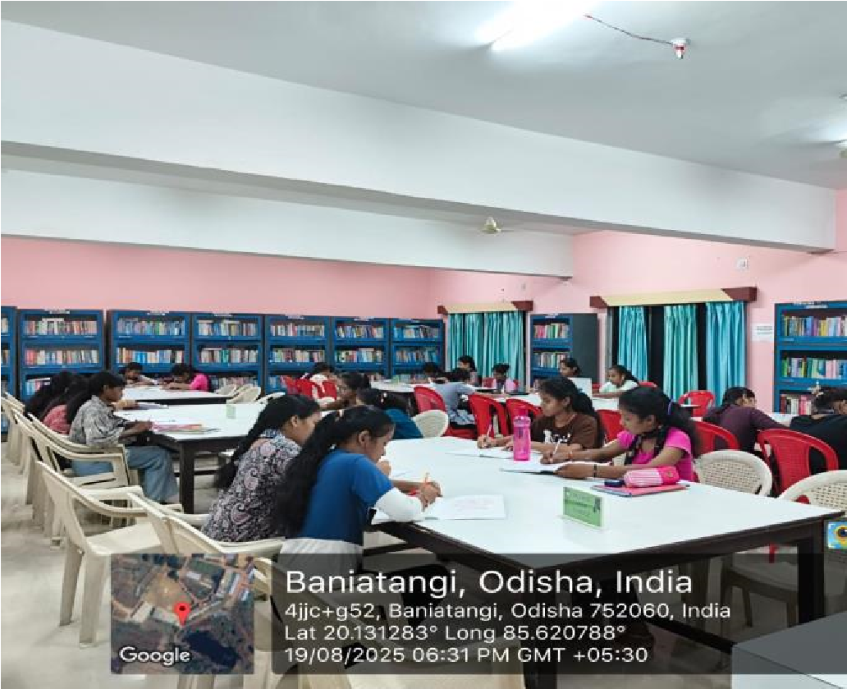
Skill on Wheel program conducted by SDI on EATM | Evening study hours for all students
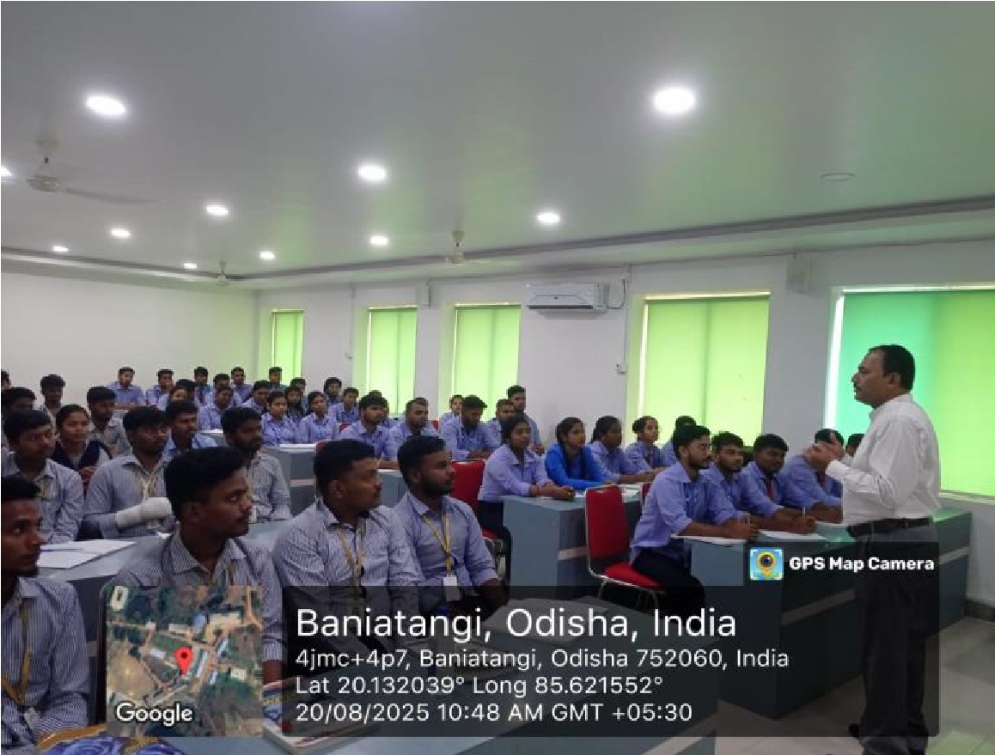 | 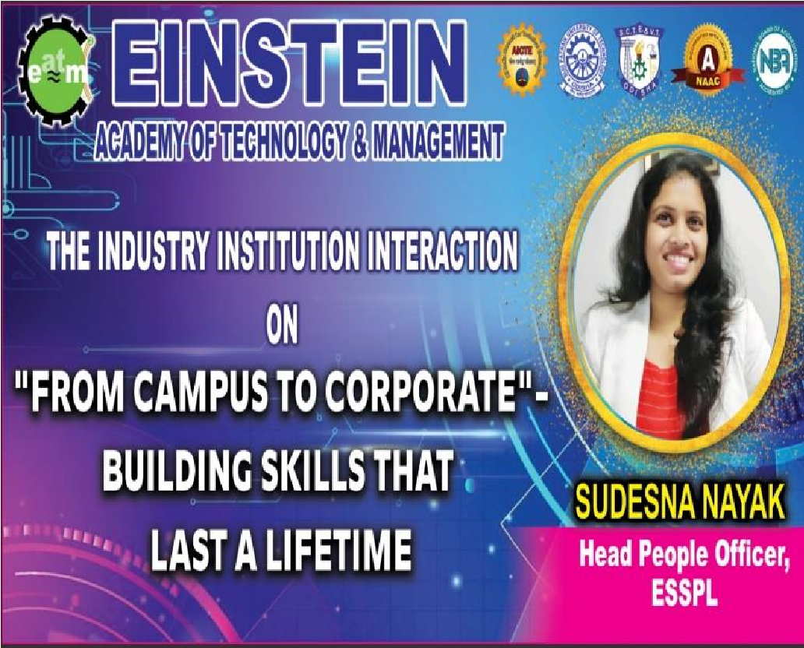
PPT classes for 7th semester students | The Industry Institution Interaction on from Campus to Corporate- Building Skill that last a lifetime by Ms.  Sudeshna Nayak, Head People Officer, ESSPL, BBSR.
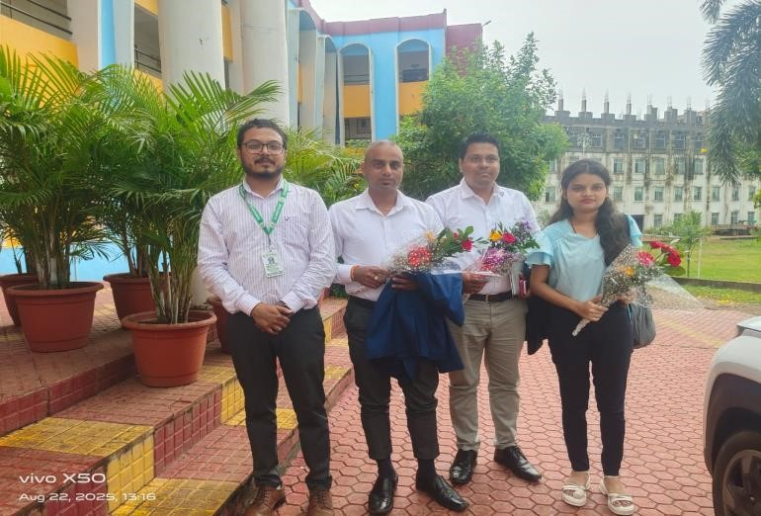 | 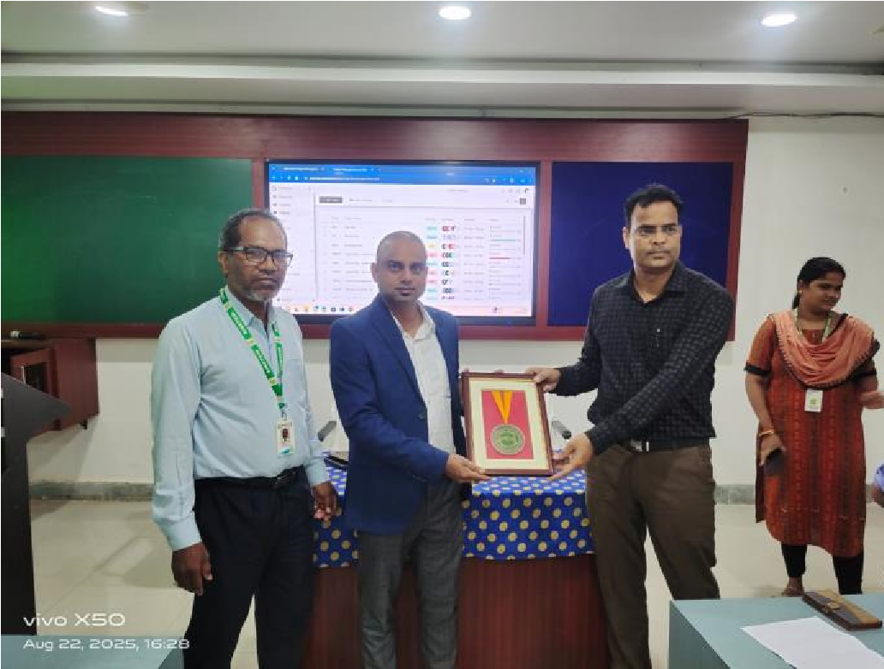

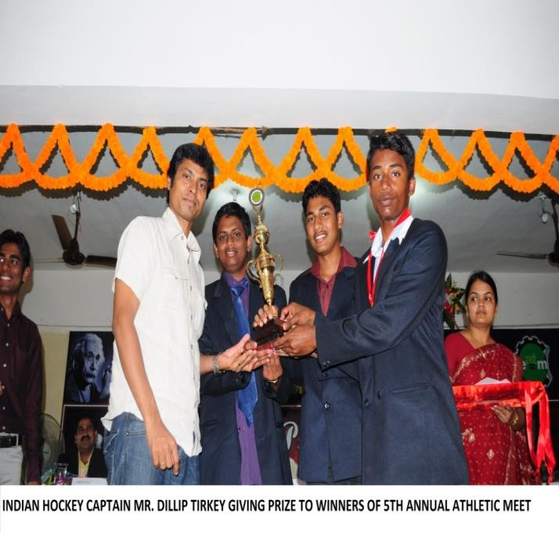 | 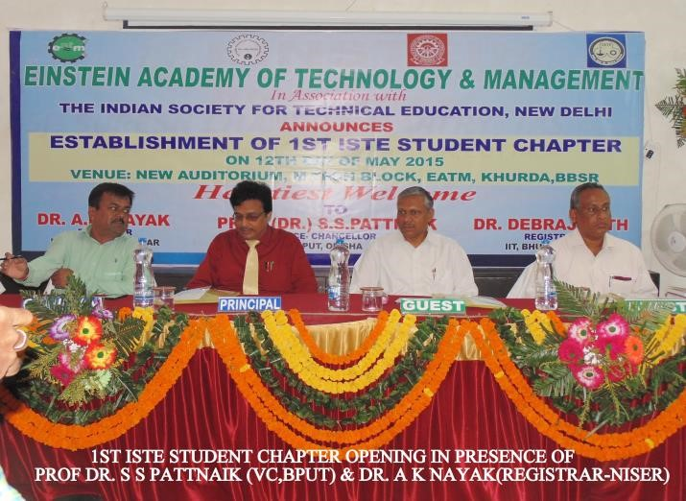
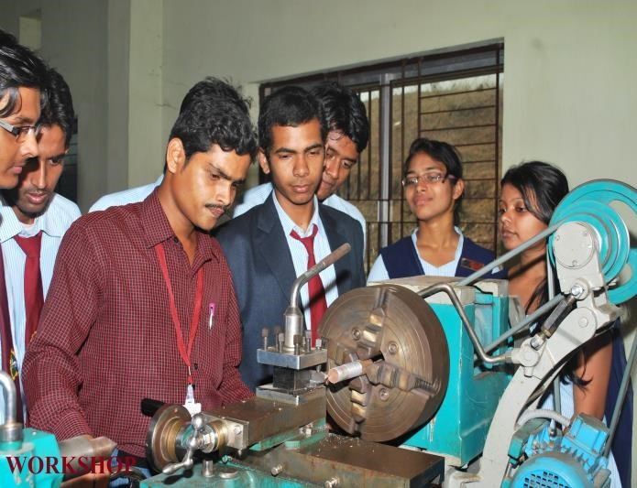 | 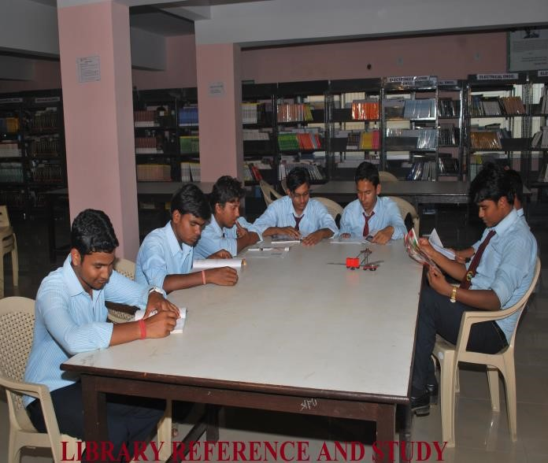

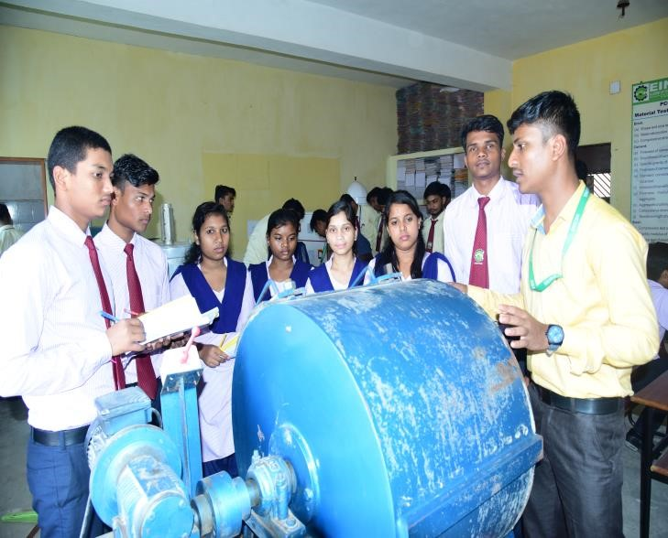 | 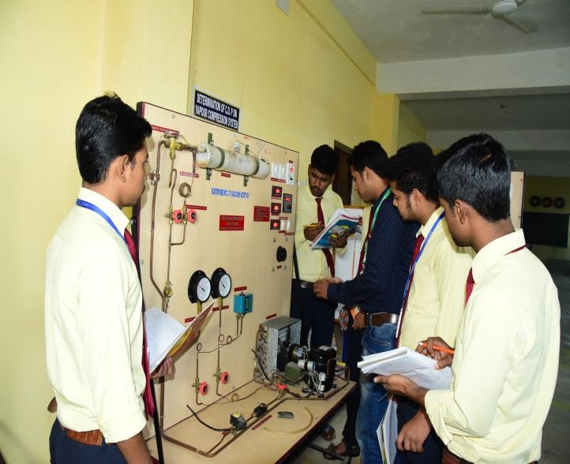
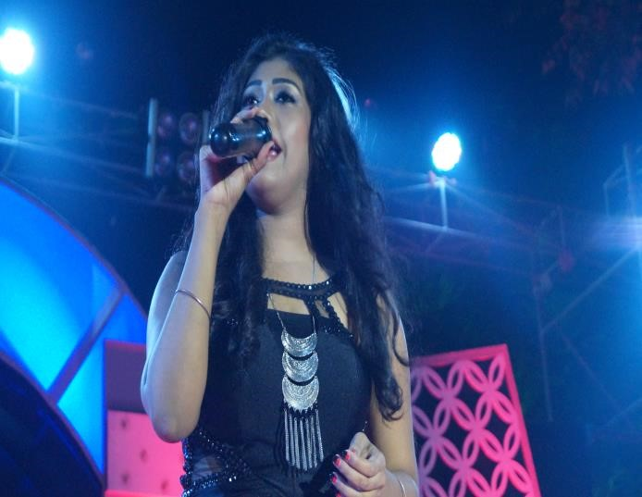 | 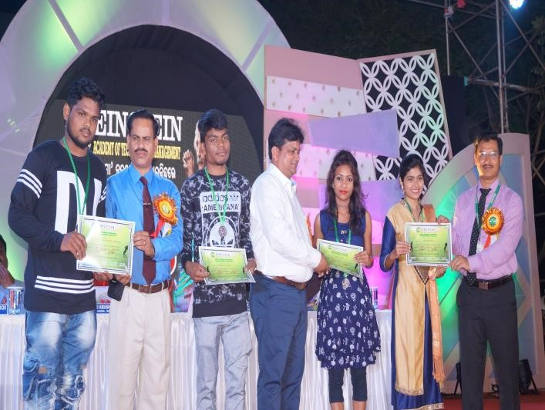
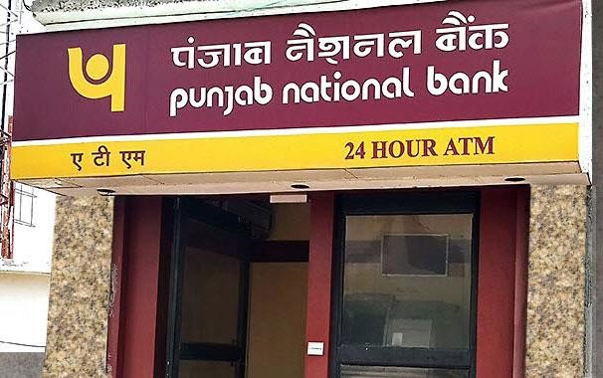 | 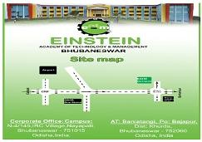

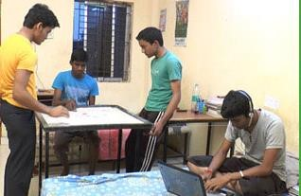 | 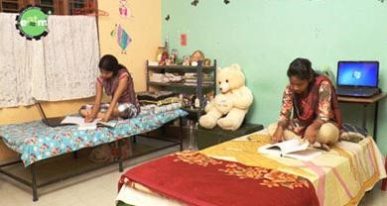
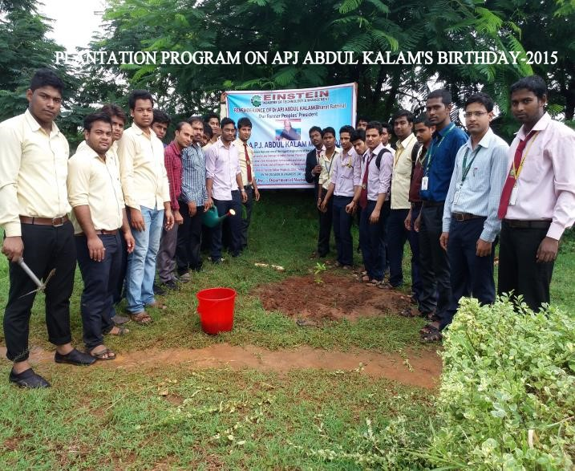 | 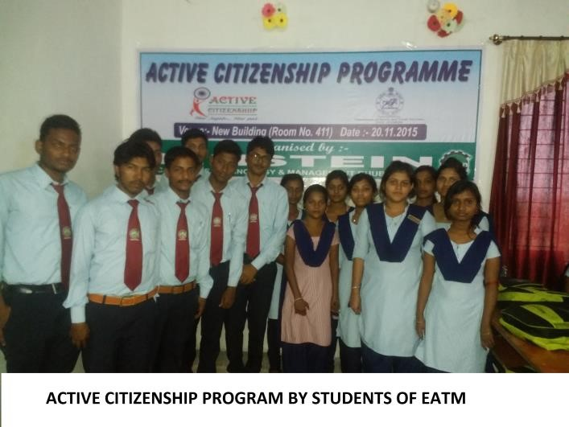
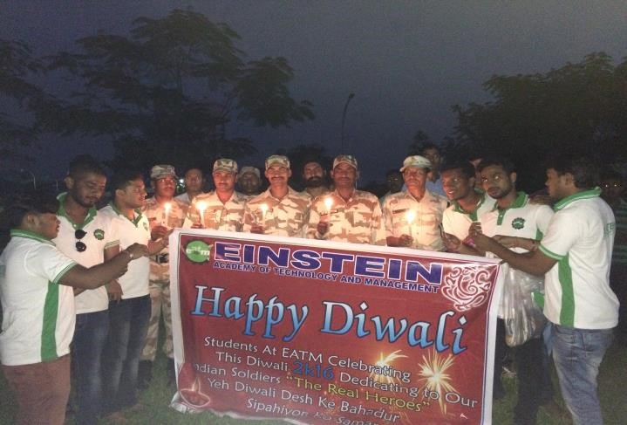 | 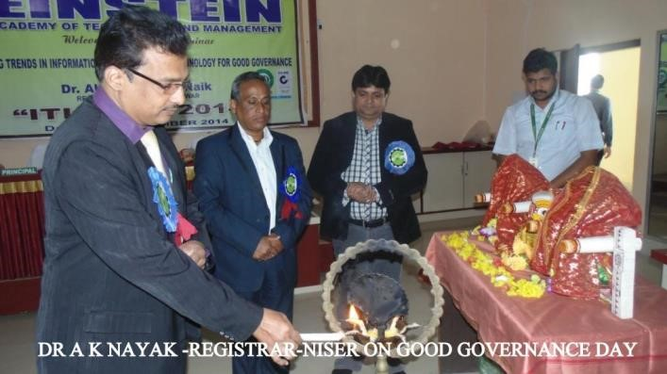

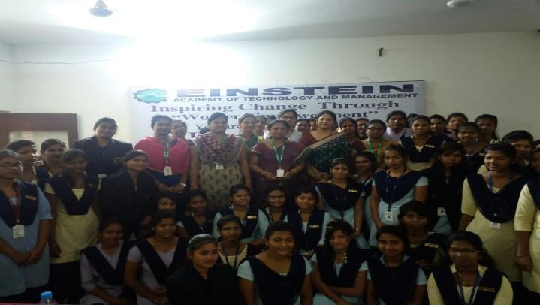 | 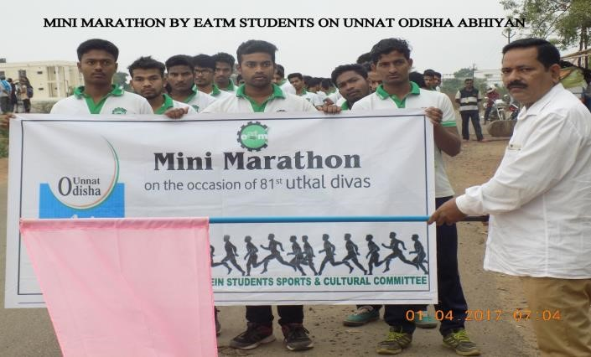
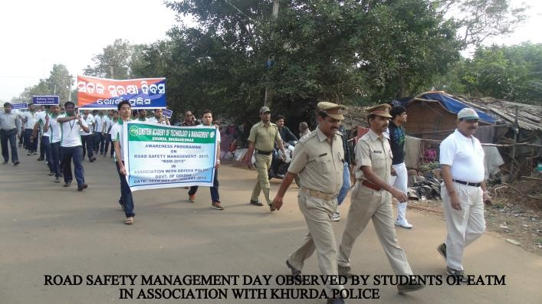 | 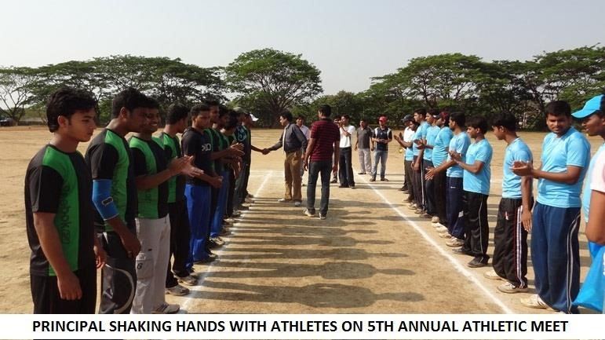
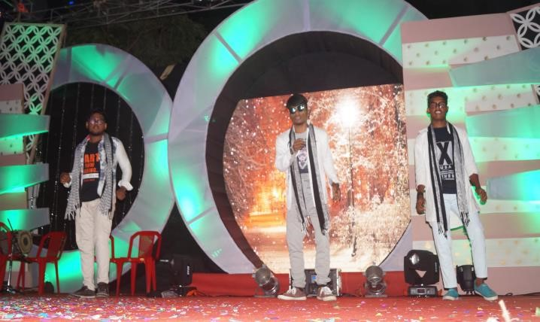 | 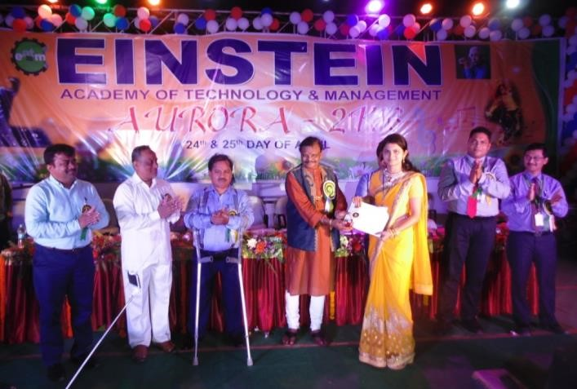
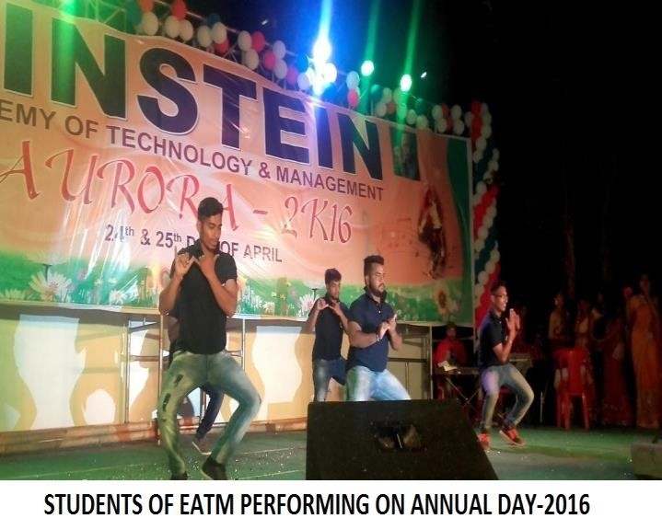 | 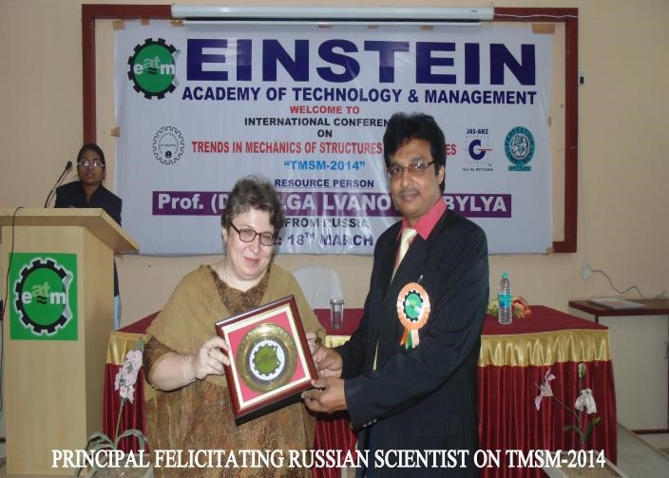
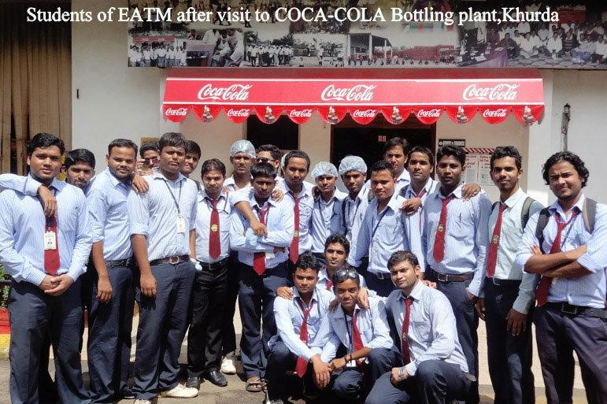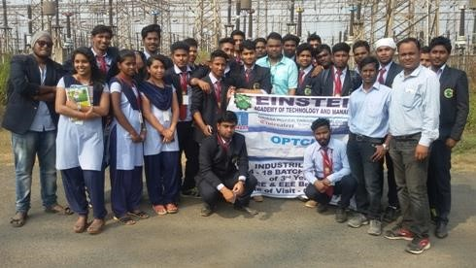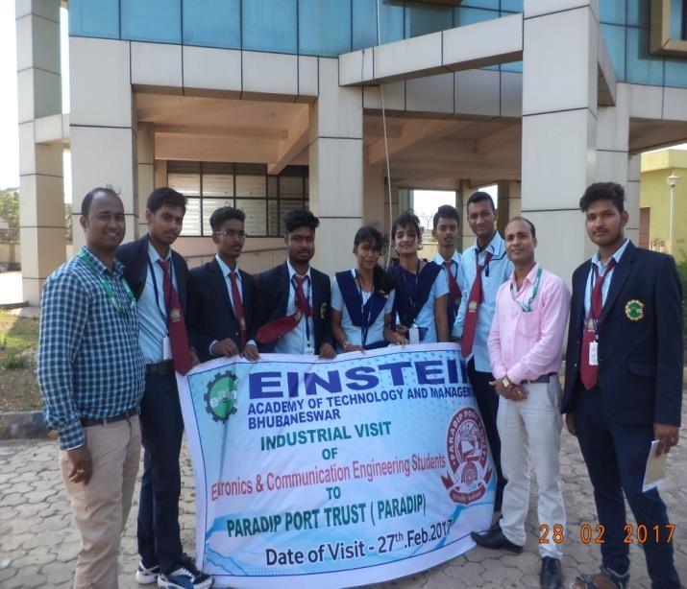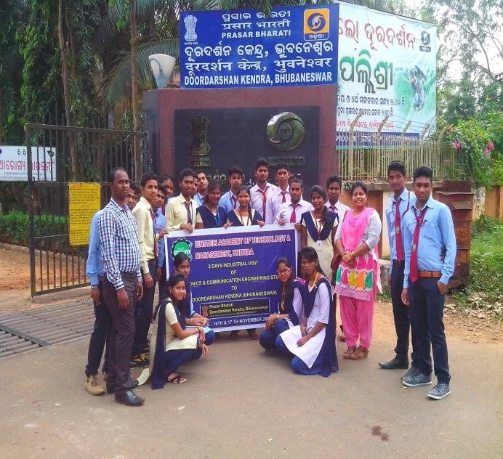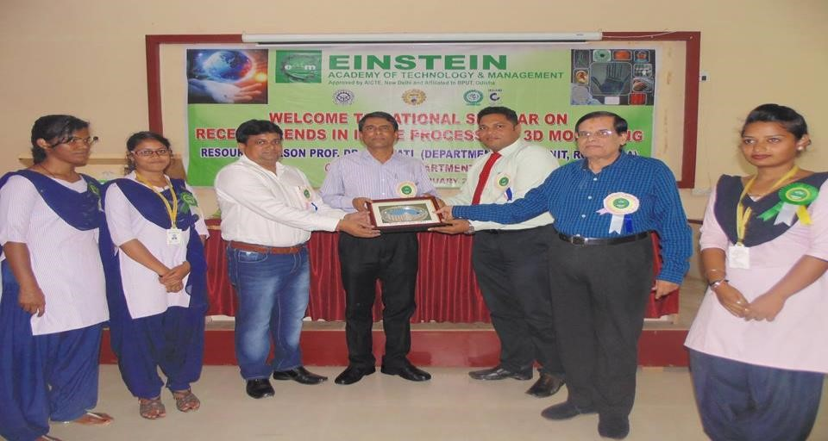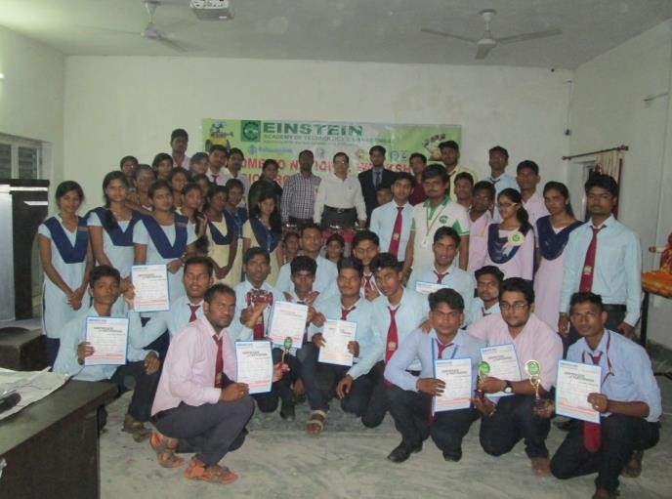

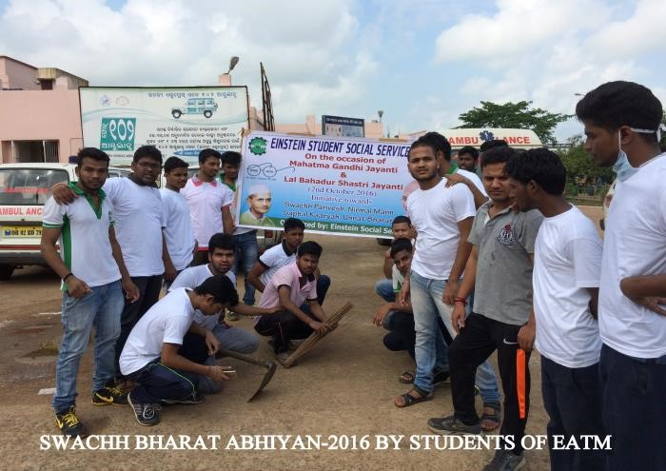 | 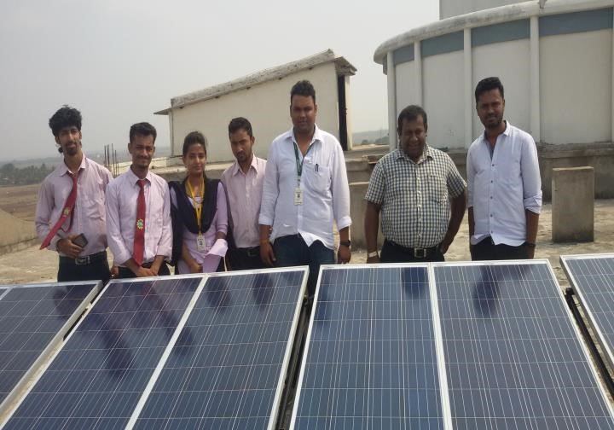
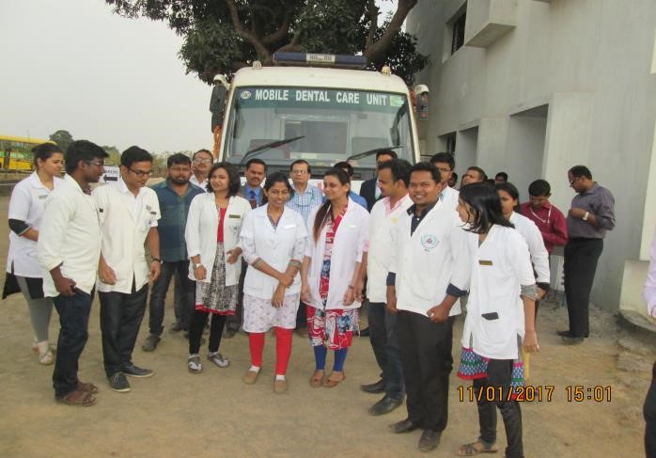 | 



